

ALLIANCE GIRLS’ 2025 PREDICTION
ALL SUBJECTS

(CONFIDENTIAL PREDICTION EXAM - ALLIANCE GIRLS)

This collection is a methodically organised set of practice tests designed specifically
for Alliance Girls KCSE 2025 Candidates.
Every prediction test is painstakingly designed to meet curriculum standards, giving students a comprehensive practice of what to anticipate on the KCSE 2025 exam.

SUBJECTS PREDICTED;
Mathematics, English, Kiswahili, Biology, Chemistry, Physics, CRE, Geography, Business Studies, Agriculture, IRE, History and Government, Computer Studies & Home-science

For Marking Schemes
Mr Isaboke 0746-222-000 /0742-999-000



ALLIANCE GIRLS’ 2025 PREDICTION
POSSIBLE KCSE EXAM
313/1
CHRISTIAN RELIGIOUS EDUCATION
PAPER 1
TIME: 2½ HOURS

NAME……………………………………………………………………………………….
SCHOOL……………………………………………… SIGN………………………..
INDEX NO……………………………………………. ADM NO……………………

Kenya Certificate of Secondary Education.

Instructions to candidates
- Write your name, index number and the name of your school in the spaces provided above.
- Sign and write the date of examination in the spaces provided above.
- This paper consists of SIX questions
- Answer any FIVE questions in this paper

Question | 1 | 2 | 3 | 4 | 5 | 6
Marks

QUESTIONS
Answer any FIVE questions in this paper
1. (a) Describe 7 teachings about human beings from the biblical creation accounts.(7 mks)
(b) Give five causes of the original sin from the book of Genesis. (5 marks)
(c) What are the consequences of breaking taboos in the traditional African society?(8 mks)

2. (a) Describe four ways in which the ordination of church leaders in Kenya is a covenant.
(8 marks)
(b) Outline six moral teachings from the 10 commandments. (6 marks)
(c) Identify seven challenges Christians face while practicing their faith in Kenya today.
(7 marks)

3. (a) Explain the significance of David as an ancestor of Jesus to Christians today. (8marks)
(b) Outline the roles of judges in Israel. (6 marks)
(c) State lessons Christians learn from the leadership of King Saul. (6 marks)

4. (a) Describe how the prophetic messages were written down. (6 marks)
(b) State the differences between Old Testaments prophets and traditional African
prophets. (8 marks)
(c) Outline five methods religious leaders use today to spread the gospel. (5 marks)

5. (a) Give six reasons why Jeremiah was not willing to accept the call of God to become a prophet. (6 marks)
(b) Explain four reasons why Nehemiah introduced the policy of separation of Jews from
foreigners. (8 marks)
- Why do political leaders in Kenya today fail to perform their duties efficiently? (6 mks)

6. (a) What changes have taken place in the rite of initiation in Kenya today? (8 marks)
(b) Identify moral values taught to the youths during initiation to adulthood in traditional
African communities. (6 marks)
(c) Give reasons why female circumcision is being discouraged in Kenya today (6 marks)



ALLIANCE GIRLS 2025 PREDICTION
POSSIBLE KCSE EXAM
313/2
CHRISTIAN RELIGIOUS EDUCATION
PAPER 2
TIME: 2½ HOURS

NAME……………………………………………………………………………………….
SCHOOL……………………………………………… SIGN………………………..
INDEX NO……………………………………………. ADM NO……………………

Kenya Certificate of Secondary Education.

INSTRUCTIONS TO CANDIDATES
- Write your name, index number and the name of your school in the spaces provided above.
- Sign and write the date of examination in the spaces provided above.
- This paper consists of SIX questions
- Answer any FIVE questions in this paper

Question | 1 | 2 | 3 | 4 | 5 | 6
Marks

QUESTIONS
Answer any FIVE questions in this paper
1. (a) With reference to the stories of the birth and infancy of Jesus, describe the occasions when the angel of the Lord appeared. (8 marks)
(b) Describe the visit of the angel of the Lord to the shepherds on the night Jesus was born (7 marks)
(c) State five ways in which Christians celebrate Christmas today. (5 marks)

2. (a) Describe four teachings of John the Baptist. (8 marks)
(b) Identify five teachings of Jesus about John the Baptist. (5 marks)
(c) Identify ways in which the church wins people for the kingdom. (7 marks)

3. (a) Describe the incident in which Jesus forgave the sinful woman in Luke 7:36-50.(8 mks)
(b) Give six reasons why Jesus chose the twelve Disciples. (6 marks)
(c) State ways in which Christians show their belief in God? (6 marks)

4. (a) Explain the unity of believers as expressed by the image of the bride. (7 marks)
(b) How was the life of Peter transformed on the day of Pentecost? (6 marks)
(c) What are the qualities of an evangelist in Kenya today? (7 marks)

5. (a) Discuss the Christian teachings on marriage. (6 marks)
(b) Explain the circumstances under which divorce may be allowed in Traditional
African society. (7 marks)
(c) Identify seven ways through which Christians minimize conflict between
parents and children today. (7 marks)

6 . (a) Discuss the importance of leisure in life of a Christian. (7 marks)
(b) Outline Christian criteria for evaluating the use of leisure. (7 marks)
(c) Give reasons why people abuse alcohol and other drugs. (6 marks)



ALLIANCE GIRLS 2025 PREDICTION
POSSIBLE KCSE EXAM
311/1
HISTORY AND GOVERNMENT
PAPER 1
TIME: 2½ HOURS

NAME……………………………………………………………………………………….
SCHOOL……………………………………………… SIGN………………………..
INDEX NO……………………………………………. ADM NO……………………

Kenya Certificate of Secondary Education.

Instructions to candidates
- Write your name, index number and the name of your school in the spaces provided above.
- Sign and write the date of examination in the spaces provided above.
- This paper consists of THREE sections A, B and C
- Answer ALL questions in section A (25 marks)
- Answer any THREE questions in section B (45 marks)
- Answer any TWO questions in section C (30 marks)
For Examiner’s Use Only
section | Maximum Score | Candidate’s Score
A | 25
B | 45
C | 30
TOTAL SCORE | 100

SECTION A (25 MARKS)
Answer all the questions
1. Distinguish the term pre-history from history. (2mks)
2. Give two characteristics of historical event. (2mks)
3. Which is the main method historian use to obtain historical information about Kenyan communities.
(1mark)
4. In what two ways has the HIV/AIDS pandemic contributed to food shortages in Kenya.(2mks)
5. What was the main reason for the migration of the Eastern Bantu from Shugwaya during
Pre-colonial period. (1mar
6. Name the community classified as southern cushite in Kenya. (1mk)
7. Give the evidence that proofed that the Greeks were amongst the early visitors to the east African coast upto 1500. (1mk)
8. Give two reasons why Kenyan Communities fought against each other during the pre-colonial period. (2 marks)
9. Identify the two main items of trade from the interior of Kenya during the long distance Trade.
(2 marks)
10. Name one treaty that led to the abolition of slave trade in East Africa. (1mark)
11. Give the meaning of the term Human rights. (1mark)
12. Give one negative methods of conflict resolution. (1mk)
13. What constitutional amendment made Kenya return to a multi-party state? (1 mark)
14. Identify two economic benefits of the Kenya-Uganda railway during the colonial period. (2 marks)
15. Stated two powers granted to the Imperial British East Africa Company through the royal charter of 1888. (2mks)
16. Give two ways through which the colonial government acquired land in Kenya during the Colonial period. (2 marks)
17. State one change introduced by the Lyttleton constitution of 1954 that benefitted the Africans in the struggle for independence. (1 mark)

SECTION B 45 Marks
Answer any three questions
18. a) Outline five features of the earliest people who occupied Kenya. (5Marks)
b) Describe the economic organization of the Akamba during the pre-colonial period. (10mks)

19. a) State five factors that facilitated the spread of Christianity in East Africa. (5marks)
b) Discuss five positive effects of slave trade on people of East Africa. (10mks)

20. a) Outline three social factors that contributed to the scramble and partition of East Africa. (3mks)
b) Discuss six factors that facilitated the establishment of the British control over Kenya during the 19th century. (12mks)

21. a) Give three reasons why the Bukusu resisted the British rule. (3mks)
b) Describe the structure of the colonial administration in Kenya. (12mks)

SECTION C 30 Marks
Answer any two questions.
22. a) Outline five Key changes in the New Kenya Constitution 2010. (5 mks)
b) Describe five constitutional reforms agreed by Inter Party Parliamentary Group (IPPG to level the ground before the 1997 general elections. (10mks)

23. a) Outline three consumer rights that are entitled to citizens. (3mks)
b) Explain six factors that undermine national unity in Kenya. (12mks)

24. a) What are the qualifications of a voter in an electoral process in Kenya. (5mks)
b) Describe the role of the speaker of the national assembly. (10mks)



ALLIANCE GIRLS 2025 PREDICTION
POSSIBLE KCSE EXAM
311/2
HISTORY AND GOVERNMENT
PAPER 2
TIME: 2½ HOURS

NAME……………………………………………………………………………………….
SCHOOL……………………………………………… SIGN………………………..
INDEX NO……………………………………………. ADM NO……………………

Kenya Certificate of Secondary Education.

INSTRUCTIONS TO THE CANDIDATES
- This paper consists of three sections A, B, and C.
- Answer all questions in section A, three in section B and two in section C.
- All answers must be written in the answer booklet provided

FOR EXAMINERS’ USE ONLY
SECTION | SECTION A | SECTION  B |  |  |  | SECTION  C |  |  | TOTAL
QUESTIONS | 1-17 | 18 | 19 | 20 | 21 | 22 | 23 | 24
SCORE

SECTION A ( 25 MARKS)
Answer ALL questions in this section
1. Identify two chemical methods of dating fossils (2 marks)
2. State two features of a government. (2 marks)
3. Name one source of information on the creation theory. (1 mark)
4. Give two symbols of authority in pre-colonial Buganda Kingdom. (2 marks)
5. Name two participants of the Trans-Saharan trade apart from the Tuaregs. (2 marks)
6. Apart from scrolls, give one other material on which messages were written in
ancient times. (1 mark)
7. Give two political effects of the Industrial Revolution in Europe. (2 marks)
8. Give one importance of the Odwira Festival in the ancient Kingdom of Asante. (1 mark)
9. Give two factors that determine the form of a constitution. (2 marks)
10. Mention one social factor that led to the African resistance during the
colonial period. (1 mark)
11. State one undiplomatic method used by the Europeans to acquire colonies in Africa. (1 mar
12. Name the underground movement established by African National Congress to fight against apartheid system in South Africa. (1 mark)
13. State two functions of emirs in Northern Nigeria. (2 marks)
14. State the main reason why U.S.A. took a neutral stand at first during the
First World War. (1 mark)
15. State the immediate incident that sparked off the Second World War (1 mark)
16. What is Veto power as adopted by United Nations Security Council? (1 mark)
17. Name one two political parties that fought for independence in Ghana (1 mark)
SECTION B (45 MARKS)
Answer ANY THREE questions in this section
18. (a) Identify five factors that facilitated early agriculture in Mesopotamia. (5 marks)
(b) Explain five causes of food shortage in Africa today . (10 marks)

19 . (a) State three disadvantages of using coal as a source of energy. (3 marks)
(b) Explain six effects of scientific inventions on industry. (12 marks)

20. (a) State three factors that enabled Europeans to colonize Africa in the 19th Century.
(3 marks)
(b) Explain six political effects of partitioning Africa. (12 marks)

21. (a) State five conditions that one had to fulfill in order to be fully assimilated
in Senegal. (5 marks)
(b) Explain the effects of British Direct rule in Zimbabwe. (10 marks)
SECTION C (30 MARKS)
Answer ANY TWO questions in this section
22. (a) Give three parts into which the Asante kingdom was divided into (3 marks)
(b) Explain six aspects of the political organization of Shona kingdom during the
pre-colonial period. (12 marks)

23. (a) Name any three treaties that formed the Treaty of Versailles. (3 marks)
b) Explain six reasons why the League of Nations failed to preserve world Peace and security (12 marks)

24 (a) Identify any three Pan- Africanists from Africa. (3 marks)
(b) Explain six achievements of Pan-Africanism. (12 marks)



ALLIANCE GIRLS 2025 PREDICTION
POSSIBLE KCSE EXAM
312/1
GEOGRAPHY
PAPER 1
TIME: 2¾ HOURS

NAME……………………………………………………………………………………….
SCHOOL……………………………………………… SIGN………………………..
INDEX NO……………………………………………. ADM NO……………………

Kenya Certificate of Secondary Education.

INSTRUCTIONS TO CANDIDATES
- This paper has two sections: A and B.
- Answer all the questions in section A.
- Answer question 6 and any other two questions from Section B.
- Each question in section B must be answered in separate foolscaps.
- Candidates should check the question paper to ascertain that all pages are printed as indicated and that no questions are missing.

QUESTION | A | 6 | 7 | 8 | 9 | 10 | TOTAL
MARKS

QUESTIONS
- (a) Define the term meteorite (2 marks)
(b) Give three reasons why in 360◦ Atlas, Pluto as a planet has been disqualified by the International Astronomical Union (3 marks)
- (a) Differentiate between cleavage and lustre in minerals (2 marks)
(b) Identify three types of iron ore (3 marks)
- (a) Define the term Tsunami (2 marks)
(b) Name three types of earthquakes depending on the depth of focus (3 marks
- The diagram below shows the formation of a lake.
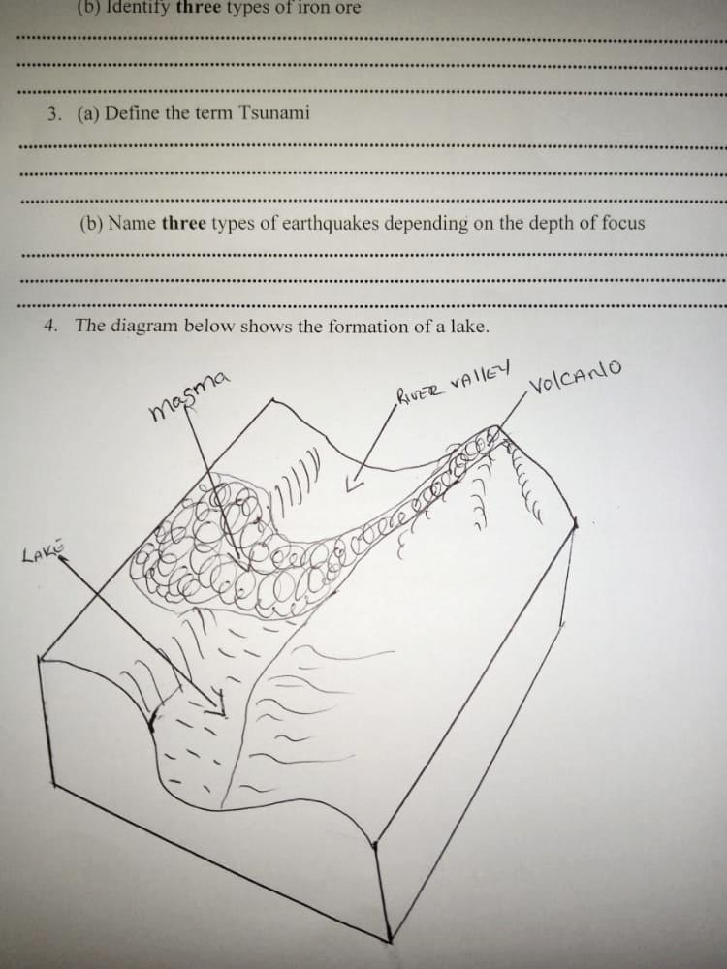

- Identify the type of lake (1mark)
- State two characteristics of such a lake and give one example. (3 marks)
- (a) Identify two soil forming processes. (2 marks)
(b) The diagram below shows soil arrangement.
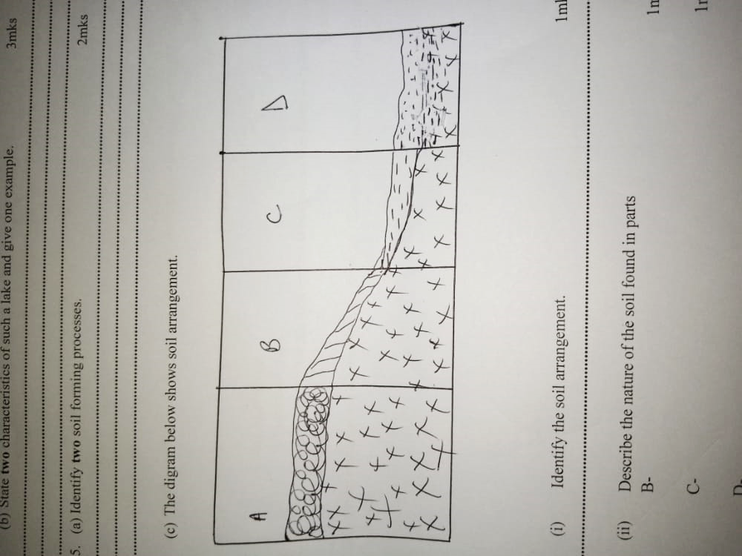
- Identify the soil arrangement. (1 mark)
- Describe the nature of the soil found in parts
B- (1 mark)
C- (1 mark)
D- (1 mark)

SECTION B
Answer question 6 and any other two questions from this section
6) Study the map of Mumias 1:50,000 (Sheet 101/2) provided and answer the following questions.
- i) Identify the two methods used to represent relief on this map. (2mks)
ii) What is the Vertical Interval used on this map? (1mk)

- i) Identify four man-made features found in grid square 6637. (4mks)
(ii) What is the direction of Nyapera market from Buhuyu dam? (2mks)

- i) Giving evidences, identify three social services found in the area covered by the map. (3mks)
ii) Explain two factors influencing settlement in the area covered by the map. (4mks)
iii) Identify three types of natural vegetation in the area covered by the map. (3mks)
- Draw a cross section along Northing 29 from Easting 58 to 64. On the cross section, show the following: (7mks)
- Dry weather road
- River
- Motorable track

7. (a) (i) Define the term folding (2 marks)
(ii) What is an orogeny (2 marks)
(iii) Name two types of orogenies (2 marks)
(b) Describe how the plate tectonics theory contributes to the formation of Fold Mountains. (4 marks)
(c) (i) Identify two factors which influence folding of crustal rocks (2 marks)
(ii) Apart from fold mountains, name three other features formed by folding process (3 marks)
(iii) Using a well-labeled diagrams, describe the formation of fold mountains by the continental drift theory (6 marks)
(d) (i) Your class carried out a field study on a fold mountain region.
(ii) Give two alternative hypotheses that you could have formulated for the study (2 marks)
(iii) Give two reasons the student must have put into consideration before rejecting observation as a method of data collection (2 marks)

8. (a) (i) Define the term karst scenery (2 marks)
(ii) Give three conditions that influence the development of a karst landscape(3 mks)
(b) Describe the formation of a limestone cave (5 marks)
(c) (i) give four reasons why there are few settlement in karst region (4 marks)
(d) (i) Explain three factors that favor existence of underground water (6 marks)
(ii) Give the significance of ground water (5 marks)

9. (a) (i) Define weather (2 marks)
(ii) Give three reasons why weather forecasting is important (3 marks)
(b) (i) Using a well-labeled diagram, describe the formation of convectional rainfall (5 marks)
(ii) Name the instrument shown below and describe how it is used (5 marks)
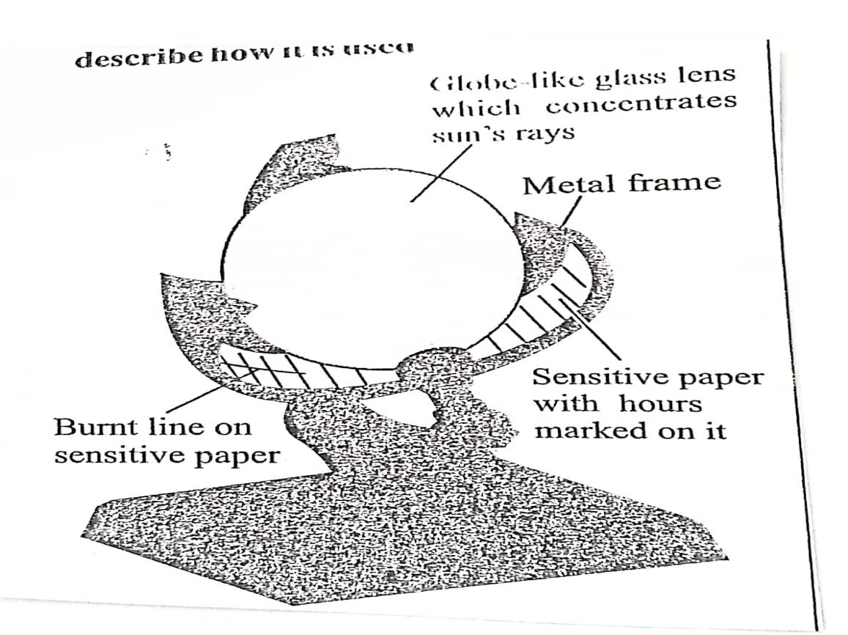
(c) (i) Differentiate between mist and fog (2 marks)
(ii) Give four causes of temperature inversion (2 marks)
(iii) Your geography class carried out a field study on weather in a school weather station. Give four reasons why it would be difficult to obtain accurate data from school weather station. (4 marks)
10. (a) (i) Define the term glaciation. (2 marks)
(ii) Give two processes of glaciation movement (2 marks)
(b) Explain three factors that influence glacial erosion (6 marks)
(c) Describe the formation of cirque lake (6 marks)
d. (i) Apart from rock pedestal name two other erosion feature formed by wind in desert. (2 marks)
(ii) With well labeled diagrams describe the formation of a rock pedestal. (7 marks)



ALLIANCE GIRLS 2025 PREDICTION
POSSIBLE KCSE EXAM
312/2
GEOGRAPHY
PAPER 2
TIME: 2¾ HOURS

NAME……………………………………………………………………………………….
SCHOOL……………………………………………… SIGN………………………..
INDEX NO……………………………………………. ADM NO……………………

Kenya Certificate of Secondary Education.

INSTRUCTIONS TO CANDIDATES
- This paper has two sections: A and B.
- Answer all the questions in section A.
- Answer question 6 and any other two questions from Section B.
- Each question in section B must be answered in separate foolscaps.
- Candidates should check the question paper to ascertain that all pages are printed as indicated and that no questions are missing.

QUESTION | A | 6 | 7 | 8 | 9 | 10 | TOTAL
MARKS

SECTION A
Answer ALL Questions in This Section
Q1. Use the map of East Africa below to answer question 1.
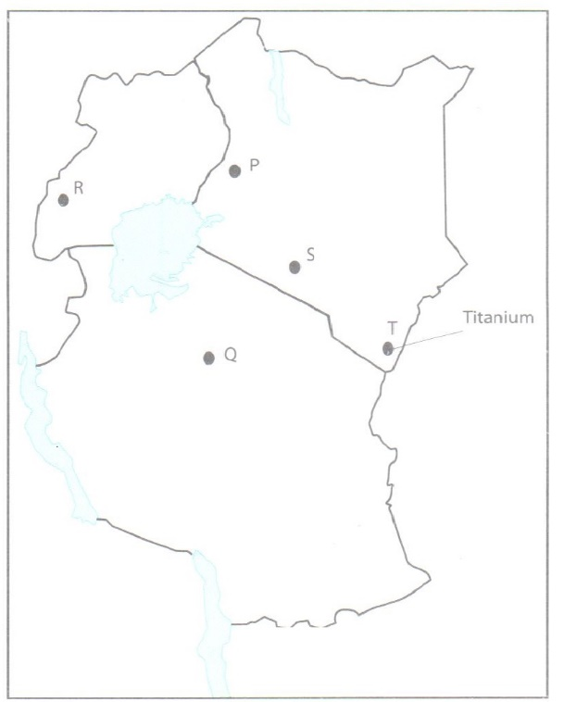

(a) Name the minerals found in the areas labelled P,Q,R,S and T. (5mks).
Q
R
S
T
(b) Identify the method of mining for the minerals labelled S and T (2mks)
S
T
2. (a) Define the term ‘Forest management’. (2 marks)
(b) Explain three measures taken by the Kenya government to conserve forest. (6 marks)
3. Name three areas in Kenya where sugar cane is grown. (3 marks)
4. (a) Define the term fisheries. (2 marks)
(b) State three ways in which marine fisheries in Kenya can be conserved. (3 marks)
5 . Name two methods used in deep sea fishing. (2 marks)

SECTION B
6. Study the photograph below and use it to answer question (a) and (b).
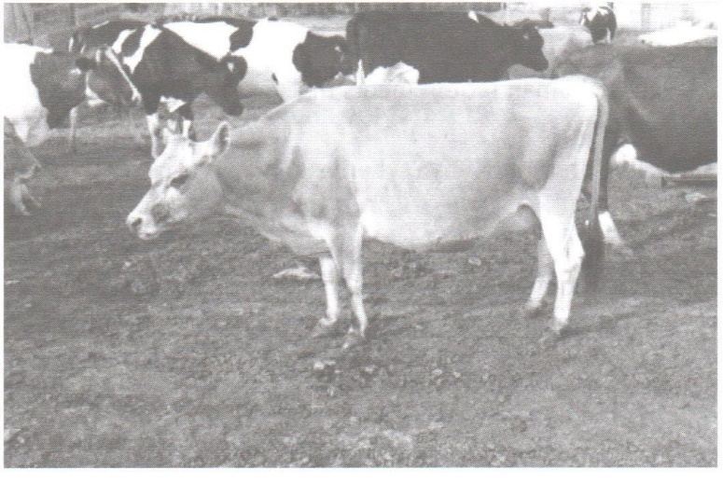
(a) Identify the type of photograph above. (1 marks)
(b) (i) Identify the type of farming shown in the photograph . (1 mark)
(ii) Name two main areas in Kenya where the type of farming identified in (i) above is practiced. (2 marks)
(c) Explain three human factors that influence the type of farming in the photograph in the Kenya
highlands. (6 marks)
(d) Explain five factors that favour horticulture in Kenya. (10 marks)
(e) (i) Name two areas where horticulture is practiced in The Netherlands. (2 marks)
(ii) Give three difference between horticulture in Kenya and the Netherlands. (3 marks)
7. (a) (i) What is agroforestry? (2 marks)
(ii) Give four reasons why agroforestry is encouraged in Kenya. (4 marks)
(b) Use the map of Kenya to answer questions (b) (i) and (ii).
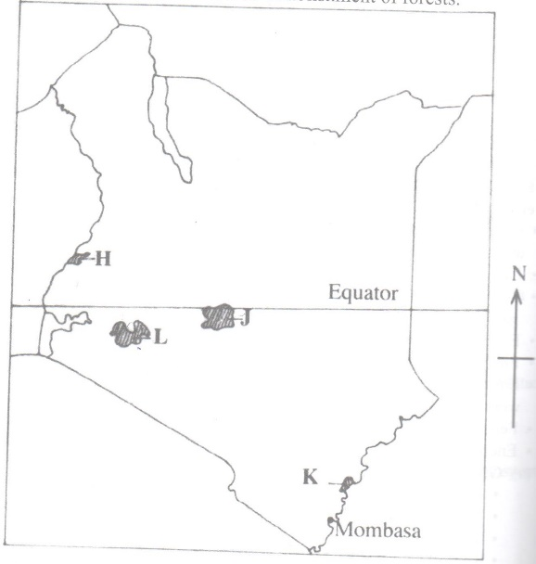
(i) Name the forest reserves marked H, J and K. (3 marks)
H
J
K
(ii) Explain four factors that favour the growth of natural forests in the area marked L.
(8 marks)
(c) Explain four problems facing forestry in Kenya. (8 marks)

8. (a) Describe the stages in the reclamation of land from the sea in the Netherlands. (6 marks)
(b) Explain four benefits of land reclamation in Netherlands. (8 marks)
(c) (i) Explain three conditions that face irrigation farming in Kenya. (6 marks)
(ii) State five problems experienced in irrigation farming in Kenya. (5 marks)

9. The map below shows some major fishing grounds in the world. Use it to answer question
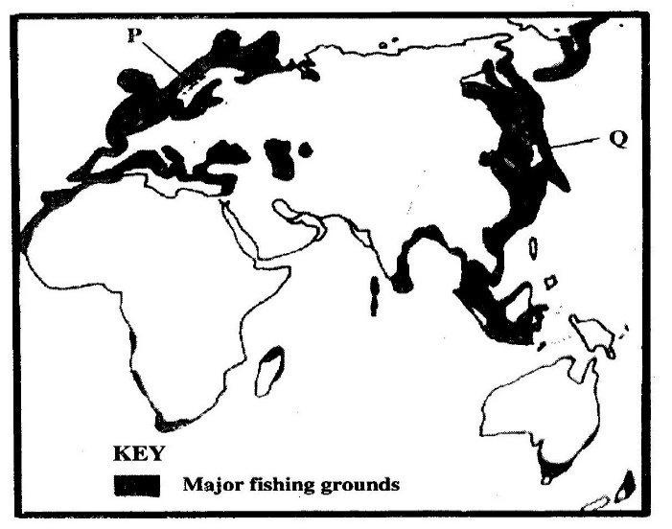(a).

(a) (i) Name the countries marked P and Q. (2 marks)
P
Q
(ii) Explain four conditions that favour fishing in the shaded coastal waters. (8 marks)
(b) The diagram below represents some fishing methods.
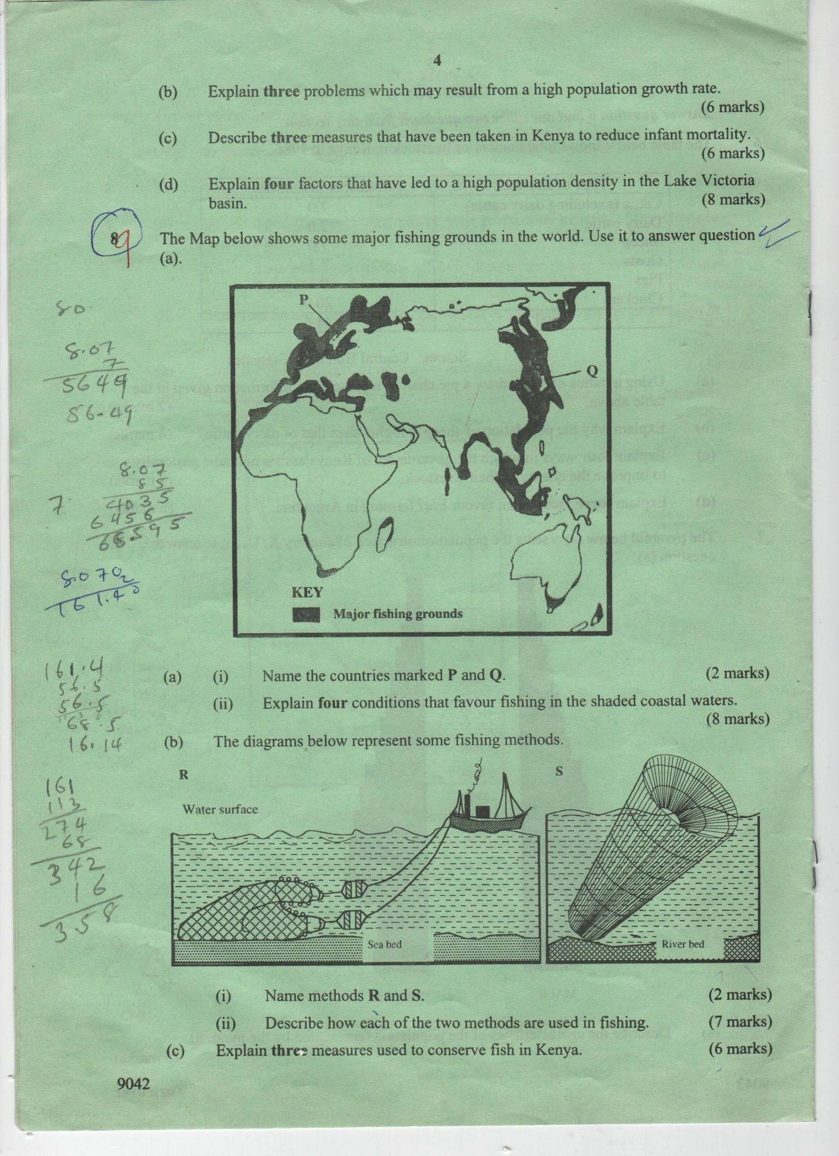
(i) Name methods R and S. (2 marks)
R
S
(ii) Describe how each of the two methods are used in fishing. (7 marks)
(c) Explain three measures used to conserve fish in Kenya. (6 marks)

10. (a) (i) Distinguish between a game sanctuary and a national park. (2 marks)
(ii) Draw a map of Kenya and on it mark and name Sibiloi National park, Maasai Game Reserve and Tsavo National park. (4 marks)
(b) (i) Give three factors that favour the establishment of the national Parks in the semi-arid areas of East Africa. (3 marks)
(ii) Explain two effects of drought on wildlife in Kenya. (4 marks)
(c) Explain four measures that the government of Kenya has taken to conserve wildlife other than establishing national parks and game reserves. (8 marks)
(d) State four ways in which wild animals are of significance to the economy of Kenya.(4 mks)



ALLIANCE GIRLS 2025 PREDICTION
POSSIBLE KCSE EXAM
BIOLOGY
231/1
(THEORY)
PAPER 1
TIME: 2 HOURS

NAME……………………………………………………………………………………….
SCHOOL……………………………………………… SIGN………………………..
INDEX NO……………………………………………. ADM NO……………………

Kenya Certificate of Secondary Education.

INSTRUCTIONS TO CANDIDATES
- Write your name, class and admission number in the space provided above.
- Write the date of the examination and sign in the space provided above.
- Answer all the questions in the spaces provided.
- You may be penalized for wrong spelling especially technical terms.

FOR EXAMINER’S USE ONLY
QUESTION | MAXIMUM SCORE | CANDIDATE’S SCORE
1-33 | 80

Answer all the questions in the spaces provided.
1. Below is an image of a biological vector. Use it to answer questions that follow.
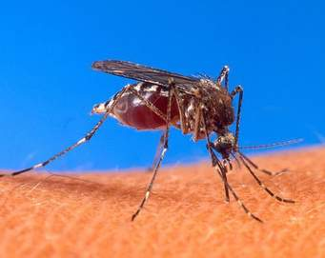
(a) Identify the parasite transmitted into human blood by the organism. (1 mark)
…………………………………………………………………………………………………………

(b) Name the blood cells that are destroyed by the parasite in (a) above. (1 mark)
…………………………………………………………………………………………………………

(c) State one biological method used to eradicate the larvae of this organism. (1 mark)
…………………………………………………………………………………………………………
2. Give the structural adaptations of the following in an insect pollinated plant.
(a) Pollen grain. (1 mark)
……………………………………………………………………………………………………………………………………………………………………………………………………………………
(b) Stigma. (1 mark)
……………………………………………………………………………………………………………………………………………………………………………………………………………………
3. State the causative agents of the following diseases
(i) Tuberculosis. (1 mark)
……………………………………………………………………………………………………………………………………………………………………………………………………………………
(ii) syphilis (1 mark)
……………………………………………………………………………………………………………………………………………………………………………………………………………………

- a) What do you understand by the term ecologically balanced ecosystem? (1mk)
……………………………………………………………………………………………………………………………………………………………………………………………………………………

b) Give two reasons for loss of energy from one trophic level to another in a food web (2mks)
…………………………………………………………………………………………………………………………………………………………………………………………………………………………………………………………………………………………………………………………………………………………………………………………………………………………………………
5. Identify the following types of responses:
(a) Pollen tube growing towards the ovary (1 mark)
……………………………………………………………………………………………………………………………………………………………………………………………………………………
(b) Maggots moving away from light. (1 mark)
……………………………………………………………………………………………………………………………………………………………………………………………………………………
6. State two activities of the cell that are controlled by the nucleus. (2 marks)
……………………………………………………………………………………………………………………………………………………………………………………………………………………
7. Distinguish between botany and zoology. (1 mark)
…………………………………………………………………………………………………………………………………………………………………………………………………………………………………………………………………………………………………………………………………………………………………………………………………………………………………………
8. The field of view of a light microscope appeared as shown below in diagram A and the diameter in A was occupied by cells as shown in B.
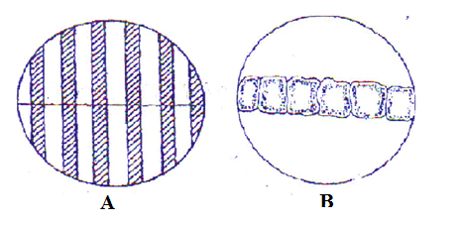
Calculate the length of one cell. (2 marks)
………………………………………………………………………………………………………………………………………………………………………………………………………………………………………………………………………………………………………………………………
9. State two importance of water in germination of seeds. (2 marks)
………………………………………………………………………………………………………………………………………………………………………………………………………………………………………………………………………………………………………………………………
10. Why is sexual reproduction advantageous in flowering in plants? (2 marks)
………………………………………………………………………………………………………………………………………………………………………………………………………………………………………………………………………………………………………………………………
11. Below is an illustration of an organism captured by students during a practical lesson.
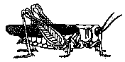
(a) Identify two features that enable the organism to be placed in the phylum Arthropoda. (2 marks)
………………………………………………………………………………………………………………………………………………………………………………………………………………………………………………………………………………………………………………………………
(b) Explain why the organism will die when Vaseline is applied on its thorax. (1 mark)
………………………………………………………………………………………………………………………………………………………………………………………………………………………………………………………………………………………………………………………………
12. Name two properties of enzyme amylase. (2 marks)
……………………………………………………………………………………………………………………………………………………………………………………………………………………
13. State the significance of natural selection. (2 marks)
………………………………………………………………………………………………………………………………………………………………………………………………………………………………………………………………………………………………………………………………

14. Explain why a plant shoot develops lateral branches when its tip is removed. (2 marks)
………………………………………………………………………………………………………………………………………………………………………………………………………………………………………………………………………………………………………………………………

15. Why is eating a lot of biscuits harmful to the teeth. (2 marks)
………………………………………………………………………………………………………………………………………………………………………………………………………………………………………………………………………………………………………………………………

16. a) Name the part of the chloroplast where each of the following activities take place.
i) Light stage…………………………………………………………………………………..(1mk)
ii) Dark stage………………………………………………………………………………….(1mk)

b) Name two types of cells in a leaf that carry out photosynthesis (2mks)
………………………………………………………………………………………………………………………………………………………………………………………………………………………………………………………………………………………………………………………………

17. State any three disorders due to Gene mutation in human beings (3 marks)
………………………………………………………………………………………………………………………………………………………………………………………………………………………………………………………………………………………………………………………………

18. Why is it important that the radicle develops first during germination? (2 marks)
………………………………………………………………………………………………………………………………………………………………………………………………………………………………………………………………………………………………………………………………

19. (a) Explain one event of mitosis that restores the genetic constitution of an organism. (1 mark)
………………………………………………………………………………………………………………………………………………………………………………………………………………………………………………………………………………………………………………………………
(b) Identify the following types of cell division:
(i) Division of generative nucleus into male nuclei. (1 mark)
…………………………………………………………………………………………………………

(ii) Division of cells lining the seminiferous tubules. (1 mark)
…………………………………………………………………………………………………………

20. State two observable characteristics that show discontinuous variations in Drosophila melanogaster (2 marks)
………………………………………………………………………………………………………………………………………………………………………………………………………………………………………………………………………………………………………………………………

21. Explain why athletes breathe quickly and deeply after a 100 meters sprint. (2 marks)
………………………………………………………………………………………………………………………………………………………………………………………………………………………………………………………………………………………………………………………………

22.(a) State two proteins that determine human blood groups. (1 mark)
………………………………………………………………………………………………………………………………………………………………………………………………………………………………………………………………………………………………………………………………

(b)(i) What is the role of blood capillary? (1 mark)
……………………………………………………………………………………………………………………………………………………………………………………………………………………

(ii) Explain why blood does not clot in undamaged blood vessels. (1 mark)
………………………………………………………………………………………………………………………………………………………………………………………………………………………………………………………………………………………………………………………………
23.(a) List one type of chromosomal aberrations. (1 mark)
…………………………………………………………………………………………………………

(a) State one advantage of polyploidy in modern farming. (1mark)
……………………………………………………………………………………………………………………………………………………………………………………………………………………

24. Explain:
(a) Why insulin is not administered orally. (1 mark)
……………………………………………………………………………………………………………………………………………………………………………………………………………………

(b) Why stomach wall is lined with mucus (1 mark)
……………………………………………………………………………………………………………………………………………………………………………………………………………………

25.(a) What is homeostasis? (1 mark)
……………………………………………………………………………………………………………………………………………………………………………………………………………………

(b) State two behavioral mechanisms used by snakes to increase their body temperature. (2 marks)
………………………………………………………………………………………………………………………………………………………………………………………………………………………………………………………………………………………………………………………………

26. Explain why only a small amount of food materials taken up by herbivores is passed on to secondary consumers. (2 marks)
………………………………………………………………………………………………………………………………………………………………………………………………………………………………………………………………………………………………………………………………
27. Below is a diagram of a respiratory surface. Use it to answer questions that follow.
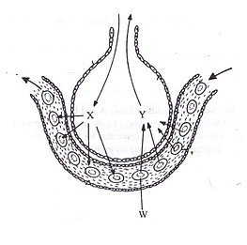
(a) Name the physiological process involved in the exchange of gases in the structure above. (1 mark)
………………………………………………………………………………………………………….
(b) Identify the substance in cell labeled w that has high affinity for gas X. (1 mark)
……………………………………………………………………………………………………………………………………………………………………………………………………………………

(c) State the advantage of gas Y being transported in cells labeled W (1 mark)
……………………………………………………………………………………………………………………………………………………………………………………………………………………

28. (a)Explain why when transplanting a young plant, it is advisable to remove some leaves. (2 marks)
………………………………………………………………………………………………………………………………………………………………………………………………………………………………………………………………………………………………………………………………

(b) Give one role of xylem vessels other than transport (1 mark)
……………………………………………………………………………………………………………………………………………………………………………………………………………………
29. Study the diagram below and answer the question that follows:

(a) Name the kingdom from which the organism belongs to. (1 mark)
.................................................................................................................................................
(b) State the function of the structure labelled C. (1 mark)
.................................................................................................................................................
30. State two characteristics of a bony fish which enable it to reduce friction in water. (2 marks)
………………………………………………………………………………………………………………………………………………………………………………………………………………………………………………………………………………………………………………………………

31. (a) Identify the structural difference between the wing of a bird and the wing of an insect(1 mk) ……………………………………………………………………………………………………………………………………………………………………………………………………………………

(b) Identify the type of evolution exhibited by the wings of birds and insects and state the name given to such structures. (2 marks)
………………………………………………………………………………………………………………………………………………………………………………………………………………………………………………………………………………………………………………………………

32. Name two characteristics that are controlled by the gene located on:
i) Y chromosomes (2mks)
……………………………………………………………………………………………………………………………………………………………………………………………………………………

ii) X chromosomes (2mks)
……………………………………………………………………………………………………………………………………………………………………………………………………………………

33. (a) What is the role of a pollen tube. (1 mark)
………………………………………………………………………………………………………………………………………………………………………………………………………………………………………………………………………………………………………………………………

(b) Identify the role of the following hormones in males:
(i) Follicle stimulating hormone. (1 mark)
……………………………………………………………………………………………………………………………………………………………………………………………………………………
(ii) Testosterone. (1 mark)
……………………………………………………………………………………………………………………………………………………………………………………………………………………



ALLIANCE GIRLS 2025 PREDICTION
POSSIBLE KCSE EXAM
BIOLOGY
231/2
PAPER 2
TIME: 2 HOURS

NAME……………………………………………………………………………………….
SCHOOL……………………………………………… SIGN………………………..
INDEX NO……………………………………………. ADM NO……………………

Kenya Certificate of Secondary Education.
INSTRUCTIONS TO CANDIDATES
- Write your name and Admission number in the space provided above.
- This paper has two sections A and B.
- Answer ALL the questions in section A in the spaces provided on the question paper.
- In section B answer question 6(compulsory) and either question 7 or 8
For Examiner’s Use Only.
SECTION | QUESTIONS | MAXIMUM  SCORE | CANDIDATES  SCORE
 | 1 | 8
 | 2 | 8
 | 3 | 8
 | 4 | 8
 | 5 | 8
 | 6 | 20
 | 7 | 20
 | 8 | 20
TOTAL SCORE |  | 80

QUESTIONS
- The diagram below shows a portion of a lower epidermis of a sukuma wiki leaf.
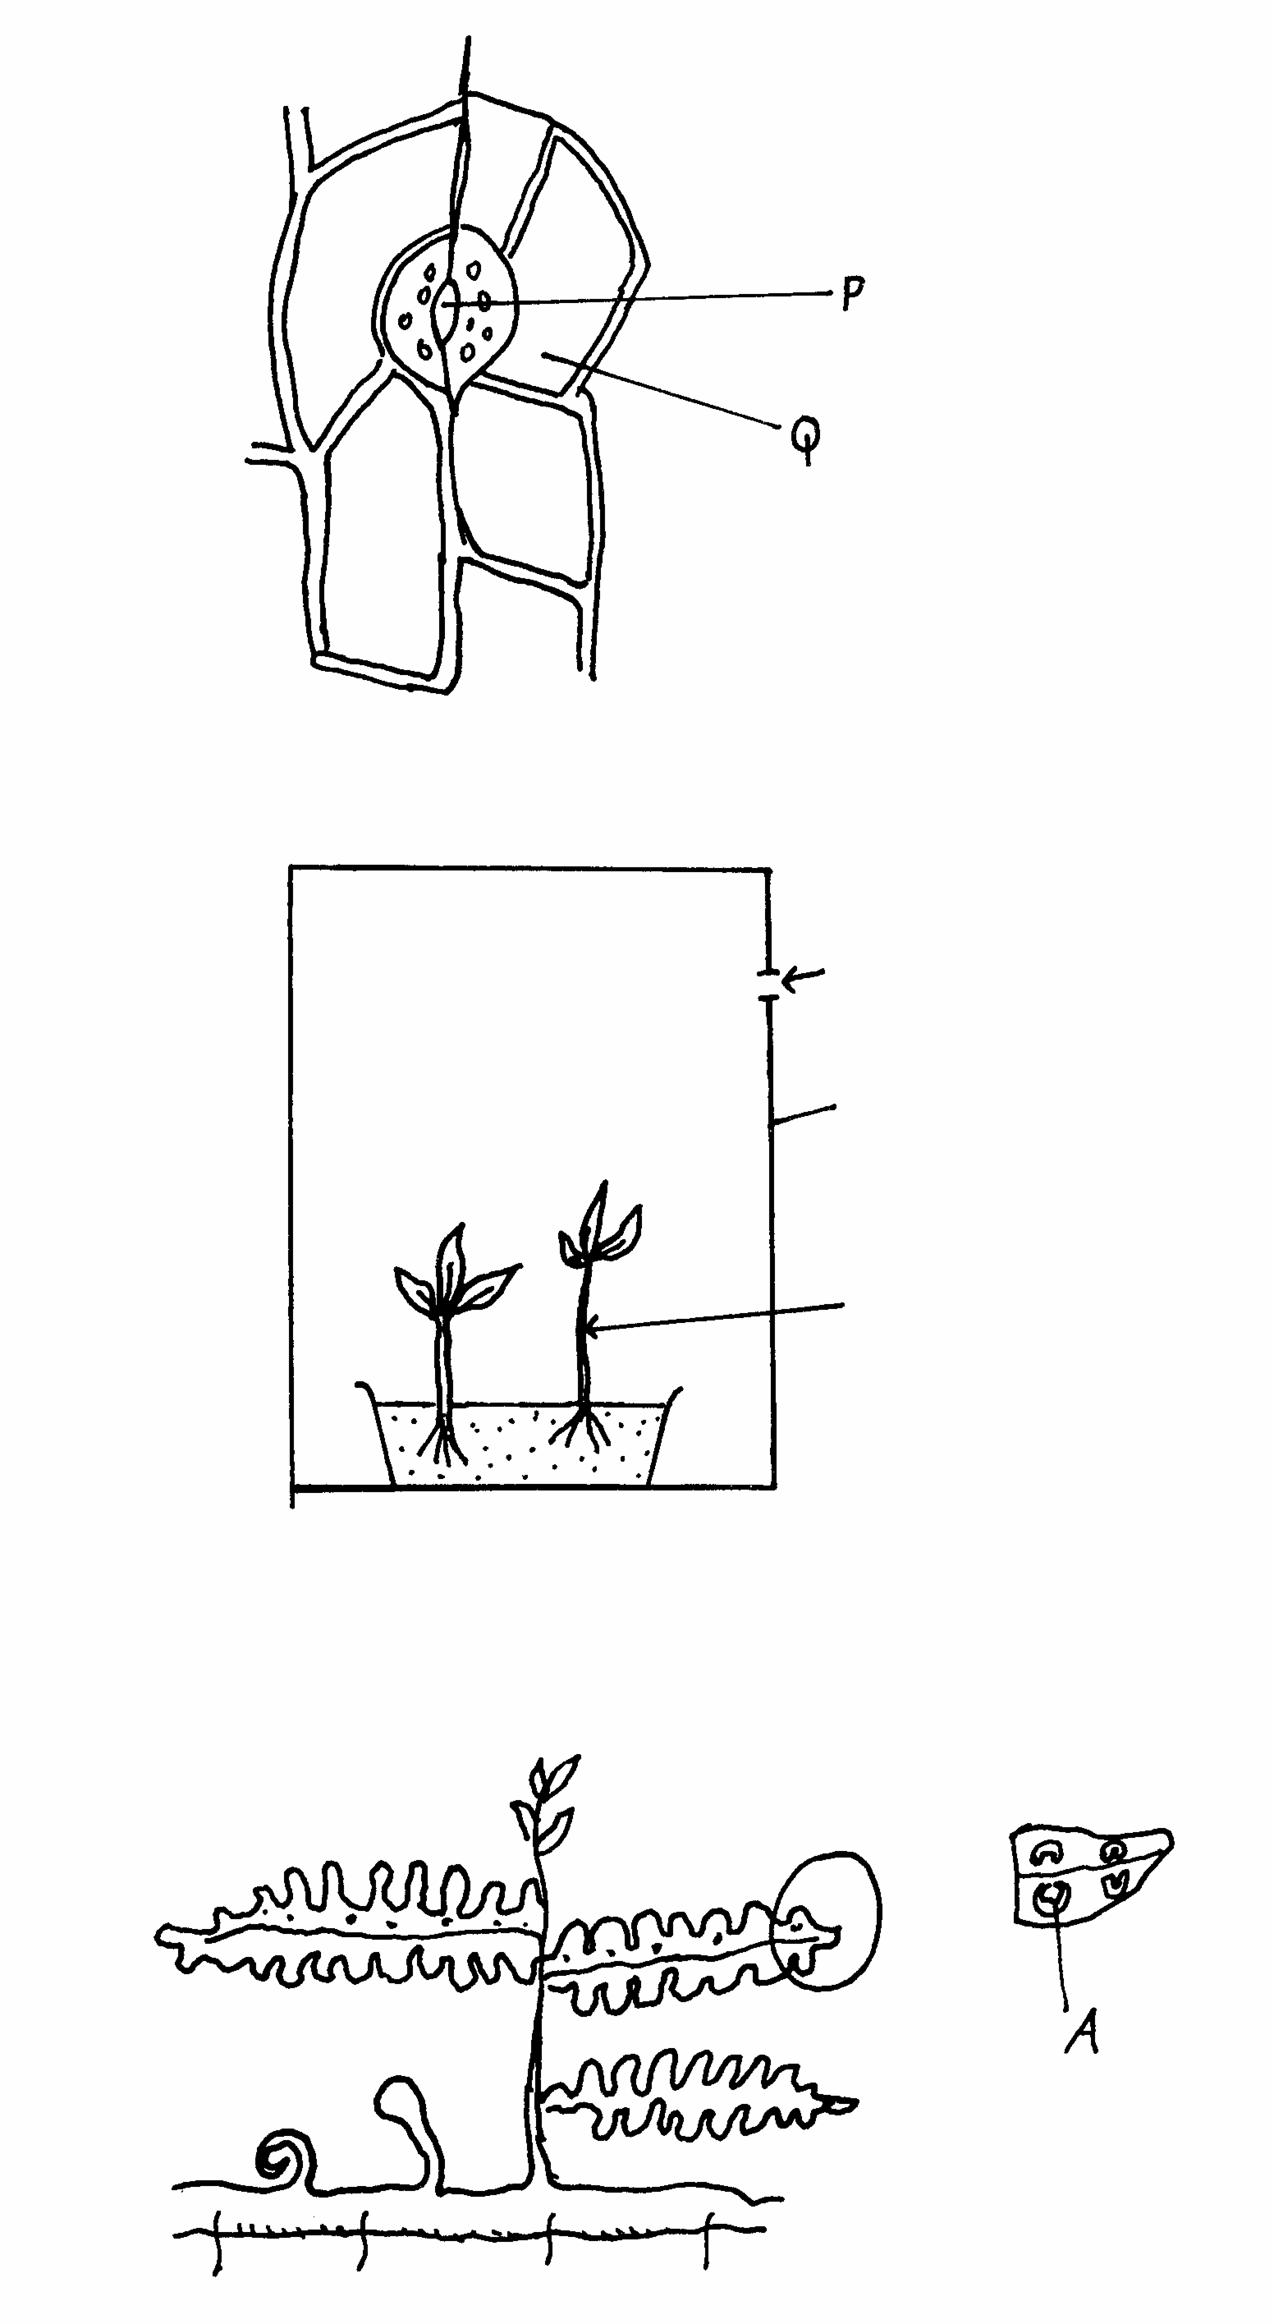
a) Name the parts labeled P and Q. (2mks)

P ___________________

Q ____________________

b) Briefly describe the photosynthetic theory of stomata opening. (5mks)
…………………………………………………………………………………………………………………………………………………………………………………………………………………………………………………………………………………………………………………………………………………………………………………………………………………………………………………………………………………………………………………………………………………………………………………………………………………………………………………………………………………………………………………………………………………………………………

c) State one modification in the stomata of xerophyte plant other than being sunken and hairy. (1mk)
………………………………………………………………………………………………………………………………………………………………………………………………………………………………………………………………………………………………………………………………

- The diagram below represents an experimental set-up to investigate an aspect of photosynthesis.
The set up was placed in darkness for 24 hrs and then exposed to light for 5 hrs.
  - What was the aim of the experiment? (1mark)
…………………………………………………………………………………………………………

(b) Leaves A and B were tested for starch.
(i) What would be the expected results? (2marks)
……………………………………………………………………………………………………………………………………………………………………………………………………………………

(ii) Give reasons for your answer in (b) (i) above. (2marks)
……………………………………………………………………………………………………………………………………………………………………………………………………………………

- What was the role of leaf B in the experiment (1mark)
………………………………………………………………………………………………

(d) Why was the set – up placed in darkness for 24 hours? (1mark)
………………………………………………………………………………………………

(e) Name the organelle in a plant where photosynthesis takes place (1mark)
………………………………………………………………………………………………

- The diagram below illustrates an experiment to demonstrate a certain biological process.
Before adding yeast suspension in tube A, the glucose solution was first boiled and cooled.
  - What biological process was being demonstrated? (1mark)
…………………………………………………………………………………………………………

(b) (i) What observation would be made in tube B after 20 minutes of the experiment? (2marks)
……………………………………………………………………………………………………………………………………………………………………………………………………………………

(ii) Account for the observations made in (b) (i) above (2marks)
……………………………………………………………………………………………………………………………………………………………………………………………………………………
…………………………………………………………………………………………………………

(c) Write down an equation to summarize the reaction taking place in tube A. (1mark)

- State two industrial applications of the chemical reaction taking place in tube A. (2marks)
……………………………………………………………………………………………………………………………………………………………………………………………………………………

- The diagram below represents a flower.
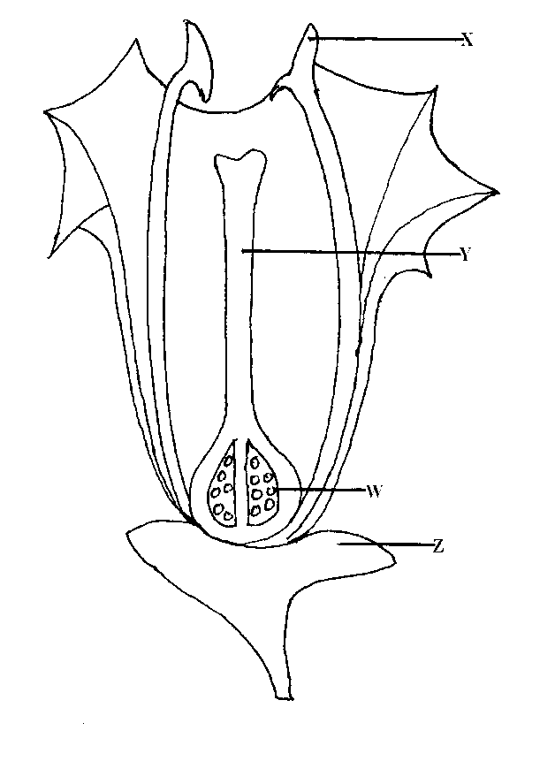
- Name the parts labeled X and Y. (2mks)
X ………………………………………………………………………………………
Y ………………………………………………………………………………………
- Describe the ovary position. (1mk)
………………………………………………………………………………………………
- (i) Suggest an agent of pollination of the flower above (1mk)
………………………………………………………………………………………………
(ii) Give a reason for your answer above. (1mk)
………………………………………………………………………………………………
- On the diagram above, which part do you expect to find haploid nucleus after meiosis? (1mk)
………………………………………………………………………………………………
- In the flower above its sepals cell was found to have 20 chromosomes. What would be the number of chromosomes found in the endosperm cell of the flower embryo sac after fertilization? (1mk)
………………………………………………………………………………………………

- State one way in which flowers prevent self – pollination. (1mk)
………………………………………………………………………………………………

- When the offspring of purple and white flowered pea plants were crossed, they produced purple and white flowered plants in the ratio of 3: 1
Using letter H to represent the gene for purple colour
(a) State the genotype of:
(i) Parents ( 2 mks)
………………………………………………………………………………………………………………………………………………………………………………………………
(ii) F₁ Generation ( 1 mk)
………………………………………………………………………………………………
(b) Work out the cross between plants in the F₁ generation ( 4 mks)

(c) Account for the colour the flowers in plants of the F₁ generation (1 mk)
……………………………………………………………………………………………………………………………………………………………………………………………………………………
…………………………………………………………………………………………………………

SECTION B (40 marks)
Answer question 6 (compulsory) in the space provided and either question 7 or 8 in the spaces provided after question 8.
6. In an experiment to investigate the effect of temperature on the activity of salivary amylase enzyme, test tubes containing 5 cm³ of starch solution were placed in water baths maintained at different temperatures. After 30 minutes, 0.1cm³ amylase solution was added into each of the tubes.
At one minute intervals, a drop of the mixture in each tube was tested for presence of starch. The time taken for all the starch to be digested was taken and recorded. The results were as shown in the table below.
Temperature (⁰c) | 5 | 10 | 15 | 20 | 25 | 30 | 35 | 40 | 45
Time taken to digest all starch (mins) | 80 | 60 | 48 | 26 | 18 | 9 | 3 | 14 | 75
- On the grid provided plot a graph of time taken to digest all the starch against temperature.
(6 marks

- What was the optimum temperature range for this enzyme? (1mark)
………………………………………………………………………………………………………………………………………………………………………………………………………………

(c) Account for the results obtained at
  - 5⁰C (2marks)
……………………………………………………………………………………………………………………………………………………………………………………………………………………
……………………………………………………………………………………………………………………………………………………………………………………………………………………
…………………………………………………………………………………………………………

  - 45⁰C (2marks)
……………………………………………………………………………………………………………………………………………………………………………………………………………………
……………………………………………………………………………………………………………………………………………………………………………………………………………………
…………………………………………………………………………………………………………

(d) Apart from temperature name three other factors that would affect the above reaction.(3marks)
………………………………………………………………………………………………………………………………………………………………………………………………………………………………………………………………………………………………………………………………
…………………………………………………………………………………………………………

(e) Name two regions in a human body where digestion of starch occurs. (2marks)
………………………………………………………………………………………………………………………………………………………………………………………………………………………………………………………………………………………………………………………………

(f) (i) Give three metallic ions that act as enzyme co- factors in a human body. (2marks)
………………………………………………………………………………………………………………………………………………………………………………………………………………………………………………………………………………………………………………………………
…………………………………………………………………………………………………………

(ii) What is the role played by enzyme co- factors in the physiology of human body? (1mark)
……………………………………………………………………………………………………………………………………………………………………………………………………………………

(g) Name the major respiratory substrate in a mammalian body during severe starvation. (1mark)
…………………………………………………………………………………………………………

7. How are leaves of mesophytes suited to their function? (20mks)
8. Describe the adaptations of the mammalian skin to its functions. (20mks)



ALLIANCE GIRLS 2025 PREDICTION
POSSIBLE KCSE EXAM
BIOLOGY
231/3
(PRACTICAL)
PAPER 3
TIME: 1¾ HOURS

SCHOOL……………………………………………… SIGN………………………..

Kenya Certificate of Secondary Education.
CONFIDENTIAL
- Each candidate should be supplied with the following.
- 4 test tubes in test tube rack.
- 1 boiling tube
- Iodine solution – supplied with a dropper
- Adequate distilled water
- Benedict solution– supplied with a dropper
- Means of heating
- 10% Sodium Hydroxide– supplied with a dropper
- 1% Copper (II) Sulphate– supplied with a dropper
- DCPIP– supplied with a dropper
- 10cm³ of solution W in a boiling tube labeled as solution W
NB: measure 30gms of glucose and 15gms of egg albumen in a 500ml beaker, add 200cm³ of distilled water and stir to dissolve. Top up with distilled water to make 500cm³solution. Label this solution as solution W



ALLIANCE GIRLS 2025 PREDICTION
POSSIBLE KCSE EXAM
BIOLOGY
231/3
(PRACTICAL)
PAPER 3
TIME: 1¾ HOURS

NAME……………………………………………………………………………………….
SCHOOL……………………………………………… SIGN………………………..
INDEX NO……………………………………………. ADM NO……………………

Kenya Certificate of Secondary Education.

INSTRUCTIONS TO CANDIDATES
- Write your name, Admission number and name of your school in the spaces provided above
- Sign and write the date of examination in the spaces provided.
- Answer all the questions in the spaces provided.
- You are required to spend the first 15 minutes of the 1³/₄ Hours allowed for this paper reading through all the questions before commencing your work.
For Examiners Use Only
Question | Maximum score | Candidate’s score
1 | 14
2 | 13
3 | 13
Total Score | 40

- You are provided with solution W in a boiling tube. Using the provided reagents, carry out possible food tests to identify food substances present in solution. (14marks)
FOOD SUBSTANCE | PROCEDURE | OBSERVATION | CONCLUSION

- Examine the photographs I and II of seedling specimen shown below and answer the questions that follows;
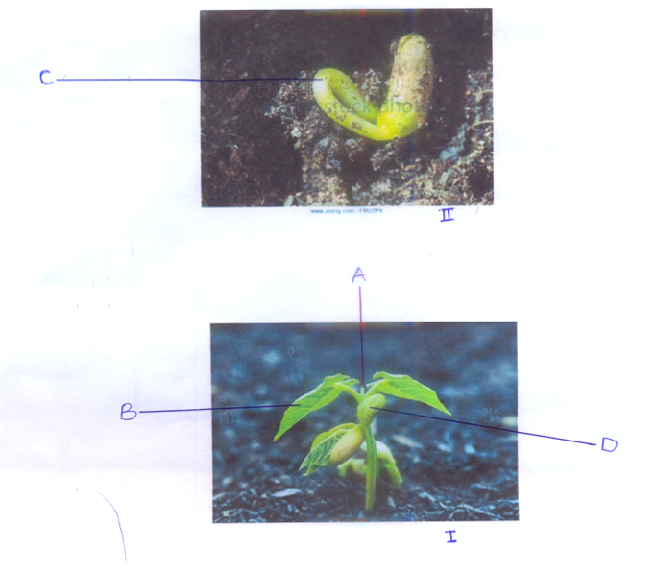
a) Name the parts labelled A, C and D. (3 marks)
A______________________________________
C______________________________________
D_______________________________________
b)(i) Name the class to which the specimen belongs. (l mark)
______________________________________________________________________________
(ii) Give two reasons, using observable features to support your answer in (b) (i) above (2 marks)
______________________________________________________________________________
______________________________________________________________________________
(c) Give two functions of the structure labeled D. (2 marks)
______________________________________________________________________________
______________________________________________________________________________
d) Explain how the curvature labeled C is formed (3marks)
______________________________________________________________________________
______________________________________________________________________________
______________________________________________________________________________
______________________________________________________________________________
______________________________________________________________________________

e) Name the type of germination exhibited by the seedlings. Give a reason for your answer. (2marks)
Type
______________________________________________________________________________
Reason
______________________________________________________________________________
______________________________________________________________________________

- Below are photographs labelled J and K of organs obtained from different animals. The organs perform similar functions. Examine them.
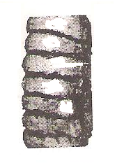
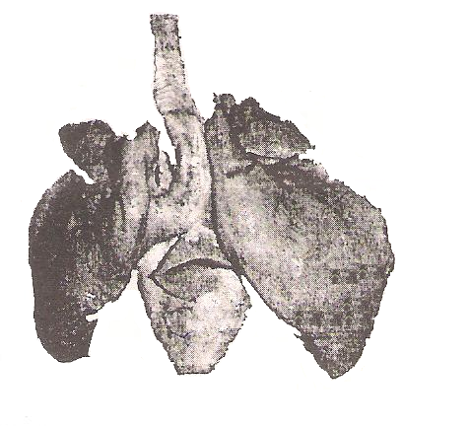
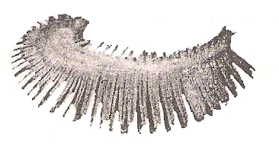
1
W
X
Y
Z
Part labelled W Enlarged
Photograph J
Photograph K
3
2

- Name the phylum to which the organs were obtained from (1 mark)
______________________________________________________________________________
______________________________________________________________________________

- Identify the organs. (2 marks)
J__________________________________________________________________________

K_________________________________________________________________________

- State the function performed by the organs. (1 mark)
_____________________________________________________________________________
_____________________________________________________________________________

- Name the parts labelled X, Y and Z in photograph J (3 marks)
X_______________________________________________________________________
Y_______________________________________________________________________
Z_______________________________________________________________________
- Identify the parts labelled 1, 2 and 3 in photograph K. (3 marks)
1___________________________________________________________
2___________________________________________________________
3___________________________________________________________

- Using observable features, state how the parts labelled 1 and 3 you identified in (d) above
are adapted to their functions (3 marks)
______________________________________________________________________________
______________________________________________________________________________
______________________________________________________________________________
______________________________________________________________________________
______________________________________________________________________________



ALLIANCE GIRLS 2025 PREDICTION
POSSIBLE KCSE EXAM
CHEMISTRY
233/1
(THEORY)
PAPER 1
TIME: 2 HOURS

NAME……………………………………………………………………………………….
SCHOOL……………………………………………… SIGN………………………..
INDEX NO……………………………………………. ADM NO……………………

Kenya Certificate of Secondary Education.

INSTRUCTIONS TO CANDIDATES
- Write your name and index number in the spaces provided above.
- Sign and write the date of examination in the spaces provided above.
- Answer ALL the questions in the spaces provided.
- Mathematical tables and electronic calculators may be used.
- All working MUST be clearly shown where necessary.

Questions | Maximum Score | Candidate’s Score
1 – 31 | 80
FOR EXAMINERS USE ONLY

- State and explain the observation made when excess ammonia gas reacts with chlorine gas. (2 marks) …………………………………………………………………………………………………
…………………………………………………………………………………………………
……………………………………………………………………………………………………………………………………………………………………………………………………
- Hydrogen gas reacts with ethene to form ethane. Calculate the volume of hydrogen required to convert 14g of ethene to ethane at S.T.P. (3 marks)
C₂H_{2 (g)} + H_{2 (g)} C₂H₆
(C = 12, H = 1, molar gas volume at S.T.P. is 22.4 litres)
……………………………………………………………………………………………………………………………………………………………………………………………………
……………………………………………………………………………………………………………………………………………………………………………………………………
- The table below shows the relative molecular masses and boiling points of propan-l-ol and
Ethanoic acid.
 | Relative Molecular Mass | Boiling point (ºC)
Propan –l-ol | 60 | 36
Ethanoic acid | 60 | 118

Explain why the boiling point of Ethanoic acid is higher than that of propan –l-ol and yet they have same molecular mass. (2 marks)
……………………………………………………………………………………………………………………………………………………………………………………………………
……………………………………………………………………………………………………………………………………………………………………………………………………
4. In an experiment an equal amount of iron fillings and sulphur powder was heated in a test tube. The mixture was left to cool then dilute hydrochloric acid added to it.
a) State the observations that were made;
(i) In the test tube. (1 mark)
……………………………………………………………………………………………………………………………………………………………………………………………………
(ii) Dilute hydrochloric acid was added to the mixture after cooling. (1 mark)
……………………………………………………………………………………………………………………………………………………………………………………………………
b) Write an equation for the reaction which occurred in a) (ii) above. (1 mark)
…………………………………………………………………………………………………

5. a) What is meant by double decomposition? (1 mark)
……………………………………………………………………………………………………………………………………………………………………………………………………
b) Starting with 1M sodium sulphate solution, describe how you would prepare dry lead II
sulphate. (2 marks)
…………………………………………………………………………………………………………………………………………………………………………………………………………………………………………………………………………………………………………………………………………………………………………………………………………
6. 6.84g of aluminium sulphate were dissolved in 200cm³ of water. Calculate the Molar
concentrations of the sulphate ions in the solution.(Relative formula mass of aluminium
sulphate is 342) (3 marks)
……………………………………………………………………………………………………………………………………………………………………………………………………………………………………………………………………………………………………………………………………………………………………………………………………………………………………………………………………………………………………………
7. The diagram below shows the set-up that was used to prepare and collect sulphur (iv) oxide gas.
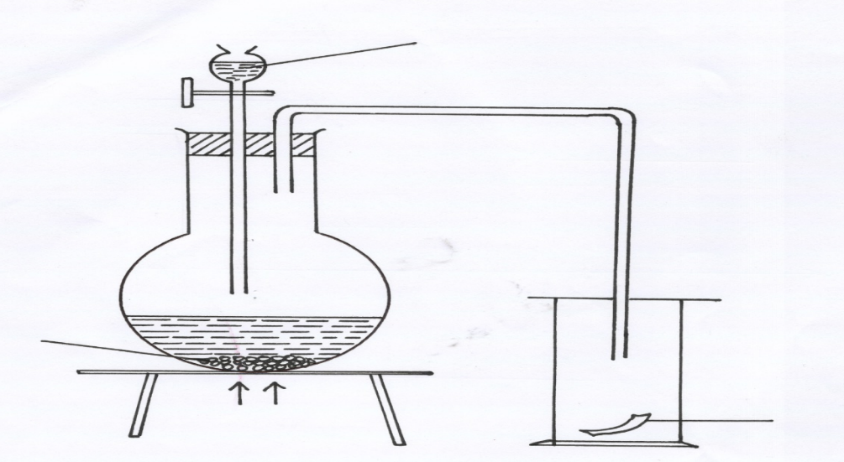
Hydrochloric acid

Solid P
moist red flower
Heat

(a) Identify solid P (1 mark)
…………………………………………………………………………………………………..
(b) (i) Why is it possible to collect sulphur (IV) Oxide as shown? (1 mark)
…………………………………………………………………………………………………………
…………………………………………………………………………………………………………
(ii) What happened to the red flower. (1 mark)
…………………………………………………………………………………………………………

8. The set-up show how small pieces of red phosphorous are heated in Nitrogen (I) Oxide.
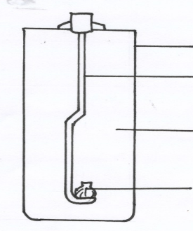
Gas jar
Deflagrating spoon
Nitrogen (I) oxide

Burning Phosphorous

a) Write an equation for the reactions which occur in the gas jar. (1 mark)
…………………………………………………………………………………………………..
b) Give one use of Nitrogen (I) oxide. (1 mark)
…………………………………………………………………………………………………..

9. Study the following reactions scheme and answer the questions that follow.
SOLUTION C
Drops of NaOH _{(aq)}
Drops of NH_{3 (aq)}

White ppt. D
White ppt. E

Excess NaOH _{(aq)}
Excess NH_{3 (aq)}

Colourless solution F
Colourless solution G

a) Identify
(i) The cations in solution C. (1 mark)
……………………………………………………………………………………..…………
(ii) The white precipitate E. (1 mark)
…………………………………………………………………………………………………
b) Why does precipitate E dissolve in excess sodium hydroxide solution. (1 mark)
……………………………………………………………………………………………………………………………………………………………………………………………………
c) Write the formula of the complex ion formed. (1 mark)
……………………………………………………………………………………………………………………………………………………………………………………………………
10. Starting with copper metal, describe how a sample of crystals of copper (II) sulphate is
prepared in Laboratory. (3 marks)
…………………………………………………………………………………………………………………………………………………………………………………………………………………………………………………………………………………………………………………………………………………………………………………………………………
11. The Set up below shows an experiment where hydrogen gas was passed over heated copper (II) Oxide.
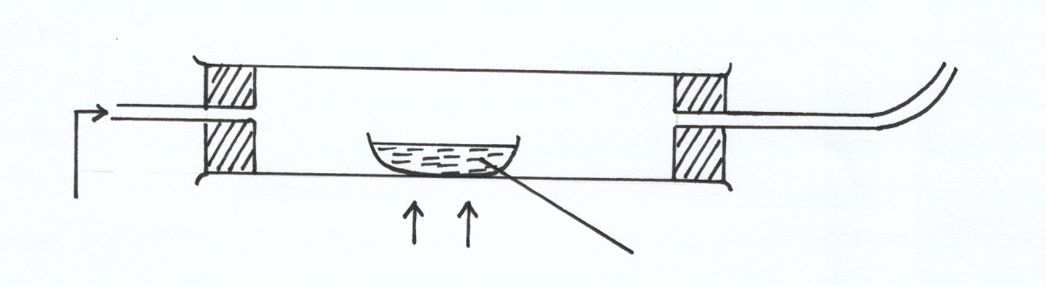
Copper (II) oxide
Dry hydrogen
Heat

a) State and explain the observations made in the combustion tube during the
experiment. (3 marks)
……………………………………………………………………………………………………………………………………………………………………………………………………
……………………………………………………………………………………………………………………………………………………………………………………………………
b) Explain why heat is necessary in this experiment. (1 mark)
……………………………………………………………………………………………………………………………………………………………………………………………………
12. a) State Boyle’s law (1 mark)
……………………………………………………………………………………………………………………………………………………………………………………………………
b) 3 litres of oxygen gas at one atmosphere pressure were compressed to two atmospheres at constant temperature. Calculate the volume occupied by the oxygen gas . (2 marks)
………………………………………………………………………………………………………………………………………………………………………………………………………………………………………………………………………………………………………
13. The table below gives some information about elements J,K,L,M which are in the same group of the periodic table. Use the formation to answer the question that follow.
Element | 1st Ionization energy kJmol-1 | Atomic radius (nm)
J  K  L  M | 520  500  420  400 | 0.15  0.19  0.23  0.25
- What is meant by ionization energy. (1 mark)
……………………………………………………………………………………………………………………………………………………………………………………………………………………
- State and explain the relationship between the variations in the first ionization energies and the atomic radii. (2 marks)

…………………………………………………………………………………………………………
…………………………………………………………………………………………………………
…………………………………………………………………………………………………………
…………………………………………………………………………………………………………

14. When a hydrocarbon fuel burn, one of the main products is acidic gas R.
(a) Identify gas R. (1 mark)
…………………………………………………………………………………………………………
(b) What effect does gas R have when its concentration in the atmosphere exceeds its acceptable levels. (1 mark)
………………………………………………………………………………………… …………………………………………………………………………………………
15. The graph below shows a curve obtained when water at 22ºC was heated for 10 minutes.
Sodium Chloride crystals were added and strongly heated for 15 minutes.
| | | | | |
0 5 10 15 20 25 30
22ºC
100ºC-
120ºC-
Time (min)

C
B
Temperature
ºC
A

a) What happened to water molecules between points A and B? (1 marks)
……………………………………………………………………………………………………………………………………………………………………………………………………
b) Explain why the temperature rise is not steady between points B and C. (2 marks)
………………………………………………………………………………………………………………………………………………………………………………………………………………………………………………………………………………………………………
16. Use the table below to answer the questions that follow.
Substance | A | B | C | D | E
Symbol | R-COO-Na⁺ | CH₂OH  |  CHOH  |  CH₂OH | --CH₂ – CH₂ –  n | R-COOCH₂  |  R- COOCH  |  R- COOCH₂ | R-OSO₃-Na⁺
- Which substances is:
I ) A soapless detergent. (½ mark)
…………………………………………………………………………………………
II) An ester (½ mark)
…………………………………………………………………………………………
b) Give name to substance B. (1 mark)
………………………………………………………………………………………………… …………………………………………………………………………………………………
c) Write an equation for the reaction between the structure of substance D and Sodium hydroxide solution. (2 marks)
……………………………………………………………………………………………………………………………………………………………………………………………………

17. When hydrated sample of iron (II) sulphate FeSO₄.nH₂O was heated until there was no further change in mass, the following data was recorded
Mass of evaporating dish = 78.94 g
Mass of evaporating dish + hydrated salt = 84.14 g
Mass of evaporating dish + residue = 81.78 g
Determine the empirical formula of the hydrated salt. (Relative Formula Mass of FeSO₄ = 152, H₂O = 18) (3 marks)
……………………………………………………………………………………………………….……………………………………………………………………………………………
……………………………………………………………………………………………………….……………………………………………………………………………………………
18. Study the flow chart below and answer the questions that follow;
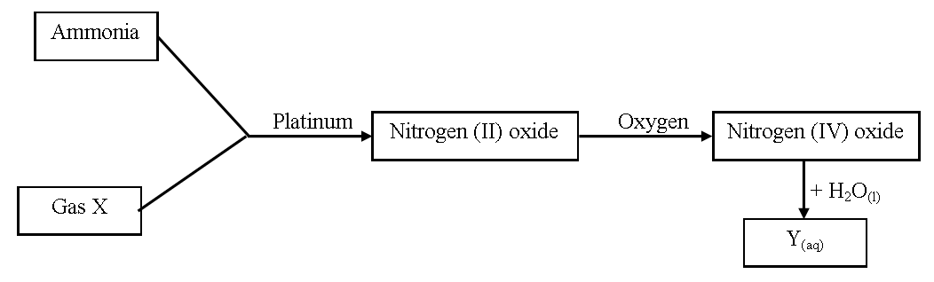
(a) Write an equation for the reaction between gas X and ammonia. (1 mark)
………………………………………………………………………………………… …………………………………………………………………………………………
(b) Write the formulae of the substances present in the mixture Y_{(aq)}. (1 mark)
…………………………………………………………………………….……………………………………………………………………………………………………………………….
19. When hydrogen sulphide gas was bubbled into an aqueous solution of iron (III) chloride, a yellow precipitate was deposited.
(a) State another observation that would be made. (1 mark)
………………………………………………………………………………………… ………………………………………………………………………………………… …………………………………………………………………………………………
(b) Write an equation of the reaction that took place. (1 mark)
………………………………………………………………………………………… …………………………………………………………………………………………
20. The table below shows the atomic numbers of elements P, Q and R.
Element | P | Q | R
Atomic | 13 | 7 | 12

(a) Explain why P and R would not be expected to form a compound. (1 mark)
………………………………………………………………………………………… ………………………………………………………………………………………… ….………………………………………………………………………………………
(b) Write an equation to show the effect of heat on the carbonate of R. (1 mark)
…………………………………………………………………………………………
21. Element T consists of two isotopes ⁶²T and ⁶⁴T in the ratio 7 : 3 respectively. Calculate the relative atomic mass of element T. (3 marks)
……………………………………………………………………………………………………….…………………………………………………………………………………………………………………………………………………………………………………………………………………………………………………………………………………………………

22. Name the process which takes place when:
(a) Solid carbon (IV) oxide changes directly into gas. (1 mark)
………………………………………………………………………………………… …………………………………………………………………………………………
(b) An alcohol reacts with alkanoic acid in the presence of sulphuric acid to form a sweet
smelling compound. (1 mark)
………………………………………………………………………………………….
23. Briefly explain how you would obtain pure sample of lead (II) chloride from a mixture of lead (II) chloride and silver chloride. (2 marks)
……………………………………………………………………………………………………….…………………………………………………………………………………………………………………………………………………………………………………………………….……………………………………………………………………………………………
24. Explain the following observations; very little carbon (IV) oxide is evolved when lead carbonate reacts with dilute hydrochloric acid. (2 marks)
……………………………………………………………………………………………………….…………………………………………………………………………………………………………………………………………………………………………………………………….……………………………………………………………………………………………
25. The table below gives some properties of compounds P, Q, R and S
Compound | B.P. (ºC) | M.P. (ºC) | Conductivity in water
P | 77 | -23 | Does not conduct
Q | 74 | -19 | Does not conduct
R | -161 | -185 | Conducts
S | 2407 | 714 | Conducts
(a) Which one of the compounds in the table is ionic? Explain. (1 mark)
………………………………………………………………………………………… …………………………………………………………………………………………
(b) Give the compound that is liquid at room temperature. (1 mark)
…………………………………………………………………………………………
26. When butan – 1 – ol is oxidized by acidified potassium dichromate, a weak organic acid is formed.
Draw and name the structural formula of the acid obtained from the above reaction.(2 marks)
…………………………………………………………………………………………………………………………………………………………………………………………………………………………………………………………………………………………………………………………………………………………………………………………………………………………………………………………………………………………………………………………………………………………………………………………………………………………………………………………………………………………………………………

27. Air was passed through several reagents as shown in the flow chart below.
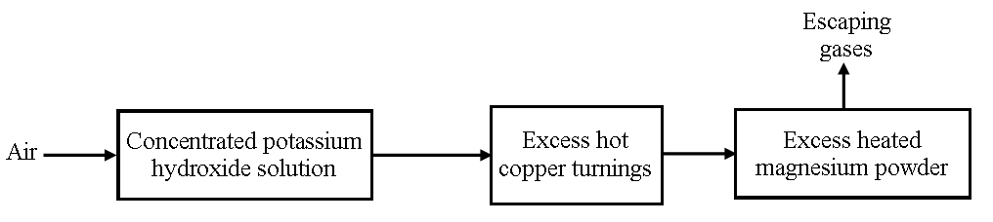
(a) Write an equation for the reaction that took place in the chamber with the magnesium
powder. (1 mark)
………………………………………………………………………………………… …………….……………………………………………………………………………
(b) Name one gas that escapes from the chamber containing magnesium powder. Give a
reason for your answer. (1 mark)
………………………………………………………………………………………… …………………………………………………………………………………………
28. A sisal farmer found that when pricked by a sisal thorn, application of a little solution of ash
helped to relieve the pain from the affected area. Explain. (2 marks)
……………………………………………………………………………………………………….……………………………………………………………………………………………

29. Explain why aluminium metal is not extracted from aluminium chloride. (2 marks)
……………………………………………………………………………………………………….……………………………………………………………………………………………………………………………………………………………………………………………….

30. Distinguish between a strong acid and concentrated acid. (2 marks)
………………………………………………………………………………………………… …………………………………………………………………………………………………
………………………………………………………………………………………………… …………………………………………………………………………………………………

31. In an experiment to determine the solubility of potassium nitrate at 30ºC, a saturated solution was heated in an evaporating dish until there was no further change in mass. The following data was obtained.
Mass of dish + solution = 128.9 g
Mass of dish + dry salt = 103.9 g
Mass of empty dish = 94.3 g
Determine the solubility of potassium nitrate at 30º C. (3 marks)
……………………………………………………………………………………………………….……………………………………………………………………………………………
……………………………………………………………………………………………………….………………………………………………………………………………………………………………………………………………………………………………………………..



ALLIANCE GIRLS 2025 PREDICTION
POSSIBLE KCSE EXAM
CHEMISTRY
233/2
(THEORY)
PAPER 2
TIME: 2 HOURS

NAME……………………………………………………………………………………….
SCHOOL……………………………………………… SIGN………………………..
INDEX NO……………………………………………. ADM NO……………………

Kenya Certificate of Secondary Education.
INSTRUCTIONS TO CANDIDATES:
- Write your name and index number in the spaces provided above.
- Sign and write the date of examination in the spaces provided.
- Answer all the questions in the spaces provided.
- All working must be clearly shown where necessary.
- Mathematical tables and electronic calculators may be used.
For Examiner’s Use Only:
Question | Maximum score | Candidate’s score
1 | 12
2 | 12
3 | 11
4 | 11
5 | 13
6 | 10
7 | 11
Total | 80
Answer all the questions in the spaces provided.
1. The grid below shows part of the periodic table. Use it to answer the questions that follow. The letters do not represent actual symbols.
 |  |  |  |  |  | S | U | V
P | R |  |  |  |  | T | X | W
Q
(a) Which of the elements has the highest atomic radius? Explain. (2 marks)
…………………………………………………………………………………………………………………………………………………………………………………………………………………………………………………………………………………………………………………………………………………………………………………………………………

(b) Identify the most reactive Oxidizing agent. Explain. (2 marks)
…………………………………………………………………………………………………………………………………………………………………………………………………………………………………………………………………………………………………………………………………………………………………………………………………………

(c) Compare the atomic radius of P and R. Explain (2 marks)
……………………………………………………………………………………………………………………………………………………………………………………………………
…………………………………………………………………………………………………..

(d)Give the formula of one stable ion with an electron arrangement of 2.8 which is:
- A Negatively charged divalent ion. (2 marks)
………………………………………………………………………………………

- A Positively charged monovalent.
………………………………………………………………………………………
(e) Given that the mass number of W is 40. Write down the composition of its nucleus.
(2 marks)
………………………………………………………………………………………………………………………………………………………………………………………………………………………………………………………………………………………………………

(f) Write the formula of the compounds formed between.
(i) Element R and X. (1 mark)
………………………………………………………………………………………
(ii) Give one property of the structure formed when R and X bond. (1 mark)
………………………………………………………………………………………… ………………………………………...........................................................................
2. a) Sodium hydroxide pellets were accidentally mixed with sodium chloride-18.2g of the mixture was dissolve in water to make one liter of solution. 100cm3 of the solution was neutralized by 50cm³ of 0.45M Sulphuric acid.
i) Write an equation for the reaction that took place. (1mark)
…………………………………………………………………………………………
…………………………………………………………………………………………
ii) Calculate the;
I. Number of moles of the substance that reacted with sulphuric acid. (1 mark)

II. Number of moles of the substance that would react with sulphuric acid in the one litre of solution. (1 mark)

III. Mass of the unreacted substance in the one litre of solution. (2 marks)
(H = 1.0, Na 23.0, Cl 35.5, 0 = 16.0)

b) The diagram below shows an incomplete set-up used to prepare and collect ammonia gas.
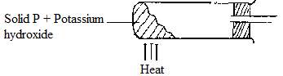
i) Name solid P. (1mark)
………………………………………………………………………………………

ii) Complete the diagram to show how a dry sample of ammonia gas can be collected.
(3 marks)
c) In an experiment, excess ammonia gas was passed over heated copper (II) oxide in a
combustion tube.
i) State the observation that was made in the combustion tube at the end of the experiment. (1 mark)
………………………………………………………………………………………………..
…………………………………………………………………………………………………

ii) What property of ammonia is shown in the above reaction? (1mark)
………………………………………………………………………………………………

iii) Give one use of ammonia. (1mark)
………………………………………………………………………………………………… …………………………………………………………………………………………………

3. (a) The scheme below was used to prepare a cleansing agent. Study it and answer the
questions that follow.
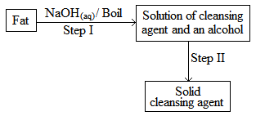
(i) What name is given to the type of cleansing agent prepared by the method above?
(½ mark)
……………………………………………………………………………………………

(ii) Name one chemical substance added in step II. (1 mark)
……………………………………………………………………………………………

(iii) What is the purpose of adding the chemical substance named in a (ii) above? (1 mark)
………………………………………………………………………………………………… ………………………………………………………………………………………………….

(iv) Name any other suitable substance that can be used in step I. (1 mark)
……………………………………………………………………………………………

(v)Explain how an aqueous solution of the cleansing agent removes oil during washing. (2 marks)
……………………………………………………………………………………………………………………………………………………………………………………………………………………
…………………………………………………………………………………………………………
…………………………………………………………………………………………………………
…………………………………………………………………………………………………………

(b) Study the scheme below and answer the questions that follow.

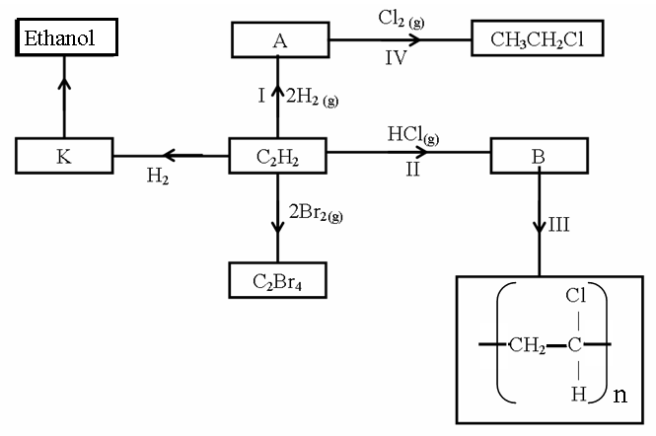
(i) Identify the catalyst used in step I (½ mark)
……………………………………………………………………………………………….
(ii) Name the compounds A and B (1 mark)
A…………………………………………….B……………..……………………………
(iii) Give one disadvantage of compound formed in step III (1 mark)
…………………………………………………………………………………………
…………………………………………………………………………………………
(iv) Name the reactions taking place at steps: (1 mark)
I…………………………………………IV...........................................................

(v) Describe how substance K is converted to ethanol (2 marks)
………………………………………………………………………………………………… ………………………………………………………………………………………………… …………………………………………………………………………………………………
…………………………………………………………………………………………………

4. The set-up below can be used to generate a gas.
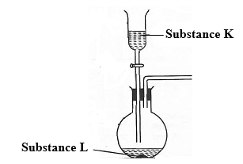
(a) (i) Complete the table below giving the names of substance K and L if the gases generated are carbon (IV) oxide and carbon (II) oxide. (2 marks)
Substance | Carbon (IV) oxide | Carbon (II) oxide
K
L
(ii) Complete the diagram to show how a sample of carbon (II) oxide can be collected.
(2 marks)
(iii) State two ways that can be used to distinguish carbon (IV) oxide from carbon (II)
oxide? (2 marks)

…………………………………………………………………………………………………………
…………………………………………………………………………………………………………
…………………………………………………………………………………………………………

(b) (i) In an experiment, carbon (IV) oxide gas was passed over heated charcoal held in a
combustion tube. Write a chemical equation for the reaction that took place in the
combustion tube. (1 mark)
…………………………………………………………………………………………………
(ii) State one use of carbon (II) oxide. (1 mark)
……………………………………………………………………………………………….
(c) The following set ups were used by Form Two students. Study and use them to answer the
questions that follow.
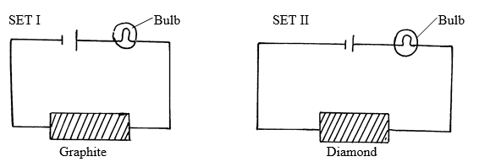
State and explain the difference in observation made in set up I and II above. (3 marks)
………………………………………………………………………………………………
………………………………………………………………………………………………
………………………………………………………………………………………………
5. (a) Define the term solubility. (1 mark)
………………………………………………………………………………………………… ………………………………………………………………………………………………… …………………………………………………………………………………………………
(b) In an experiment to determine the solubilities of two salts X and Y at different temperatures, a candidate recorded her observations as shown below.

Temperature (ºC) | 0 | 10 | 20 | 30 | 40 | 50 | 60 | 70 | 80 | 90
Solubility of X in g/100 g of H₂O | 14.3 | 17.4 | 20.7 | 25.0 | 28.5 | 33.3 | 40.0 | 47.0 | 55.0 | 64.0
Solubility of Y in g/100 g of H₂O | 25.0 | 27.5 | 30.0 | 32.5 | 35.0 | 37.6 | 40.1 | 42.4 | 45.0 | 48.0

(a) On the same axes plot the solubility curves of X and Y. (4 marks)

(b) From your graph to determine;
(i) The solubility of X and Y at 47 ºC
Solubility of X (1 mark)
……………………………………………………………………………..
Solubility of Y (1 mark)
………………………………………………………………………………

(ii) The temperature at which the two salts are soluble in water. (1 mark)
…………………………………………………………………………………
(c) If 60g of X is dissolved in 100 g of water and heated to 90ºC, calculate the amount of salt that crystallized out if cooled to 20 ºC. (1 mark)
…………………………………………………………………………………………………………
…………………………………………………………………………………………………………
…………………………………………………………………………………………………………

(d) State what would happen if a mixture salt X in 100 g of water and 30 g of Y in 100 g of water were cooled from 90 ºC to 70 ºC. (3 marks)
…………………………………………………………………………………………………………
…………………………………………………………………………………………………………
…………………………………………………………………………………………………………

(e) State one application of solubility. (1 mark)
……………………………………………………………………………………
6. (a) An ore is suspected to contain Lead metal. Describe the process that can be used to confirm the presence of Lead in the ore. (3 marks)
…………………………………………………………………………………………………………
…………………………………………………………………………………………………………
…………………………………………………………………………………………………………
…………………………………………………………………………………………………………
(b) The diagram below shows students set-up for the preparation and collection oxygen Gas
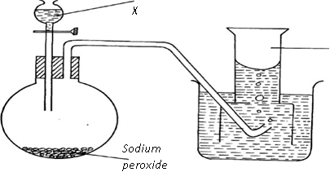
Oxygen
(i) Name substance X used (1mark)
……………………………………………………………………………………….
(ii) Write an equation to show the reaction of sodium peroxide with the substance named
(1mark)
……………………………………………………………………………………….
……………………………………………………………………………………….
(iii) Name a two other reagents that can be used to prepare oxygen gas in the laboratory using the apparatus shown above. (1 mark)
…………………………………………………………………………………………
………………………………………………………………………………………..
(iv) How would you confirm that the gas produced was oxygen. (1 mark)
………………………………………………………………………………………..
…………………………………………………………………………………………
(c) Apiece of cleaned magnesium ribbon was burnt in air to form a residue P which was then dissolved in water to form solution Q and a colourless gas R. A blue and red litmus paper was
(i) State the components of residue P. (1 mark)
………………………………………………………………………………………
………………………………………………………………………………………
- Identify colourless gas R …………………………………………................... (1 mark)

- Write an equation for the formation of solution Q and gas R. (1mark)
……………………………………………………………………………………….
………………………………………………………………………………………
7. The diagram below shows a set-up of apparatus that can be used to prepare nitrogen (IV) oxide. Study it and use it to answer the questions that follow
Lead(II)nitrate
boiling tube
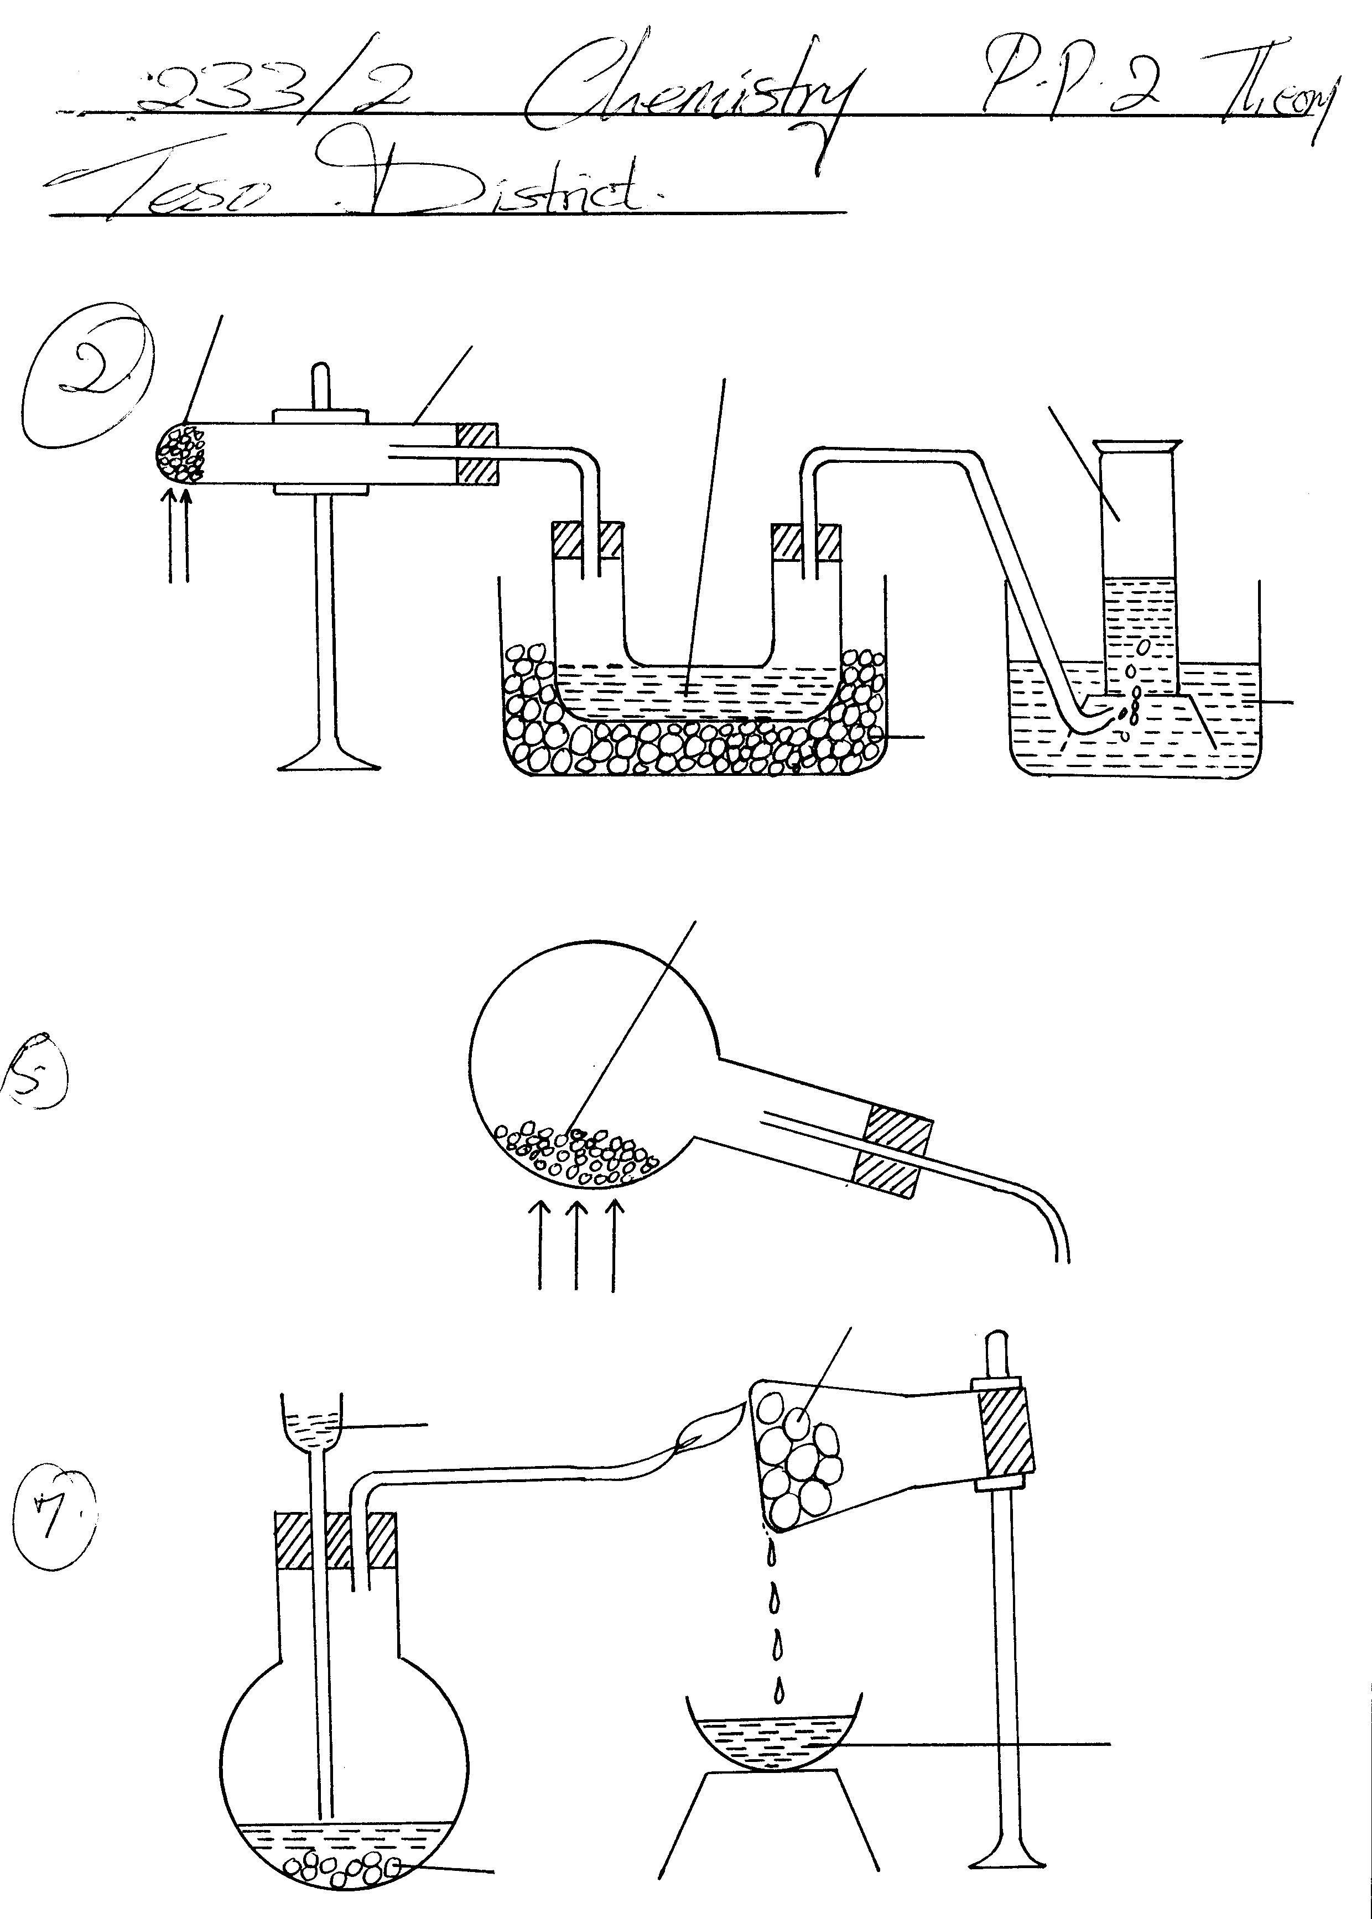
Liquid B
Gas A
water
ice
Heat

(a) (i) Write the equation for the reaction that takes place in the boiling tube. (1 mark)
………………………………………………………………………………………

(ii) State the observations made in the boiling tube. (2 marks)
…………………………………………………………………………………………………………
…………………………………………………………………………………………………………
…………………………………………………………………………………………………………

(iii) Explain why lead (II) nitrate is preferred over other metal nitrates in this experiment. (1 mark)
………………………………………………………………………………………..……………………………………………………………………………………….………………………………………………………………………………………..…………………………………………………

(iv) Describe how gas A can be identified. (1 mark)
……………………………………………………………………………………………………………………………………………………………………………………………………………………………………………………………………………..………………………………………………
(b) (i) Name liquid B (1 mark)
………………………………………………………………………………………..

(ii) Write a chemical equation to show how liquid B is formed in this experiment. (1mark)
………………………………………………………………………………………..……………………………………………………………………………………….………………………………………………………………………………………..…………………………………………………

(c) (i) In another experiment, excess aqueous lead (II) nitrate solution was reacted with a solution which contained 2.34g of sodium chloride. Calculate the mass of precipitate formed in this reaction. (Pb = 207, Cl = 35.5, Na = 23) (3 marks)
………………………………………………………………………………………………………………………………………………………………………………………………………………………………………………………………………………………………………………………………………………………………………………………………………………………………………………………………………………………………………………………………………………………………………………………………………………
(ii) Write an ionic equation for the reaction that takes place when nitrogen (IV) oxide
reacts with aqueous sodium hydroxide. (1 mark)

……………………………………………………………………………………………………………………………………………………………………………………………………..



ALLIANCE GIRLS 2025 PREDICTION
POSSIBLE KCSE EXAM
CHEMISTRY
233/3
(PRACTICAL)
PAPER 3
TIME: 2¼ HOURS

SCHOOL……………………………………………… SIGN………………………..

Kenya Certificate of Secondary Education.
CONFIDENTIAL
In addition to the fittings and apparatus found in chemistry laboratory, each student will require the following.

- 200cm³ of hydrochloric acid, solution P.
- 150cm³ of sodium hydroxide, solution Q.
- 0.50g of solid B weighed accurately.
- About 0.2g of solid Y.
- About 0.5g of solid M.
- About 0.5g of solid W.
- Burette 0-50 cm³.
- Pipette 25 cm³.
- One pipette filler
- Means of labeling (one label).
- 100 cm³ measuring cylinder.
- 10ml measuring cylinder
- 250 cm³ beaker.
- Two conical flasks.
- Six dry test-tubes.
- About 1cm by 3cm aluminium foil
- 1 red and 1 blue litmus papers.
- Universal indicator paper
- About 2cm³ ethanol placed in a test tube
- 2 boiling tubes.
- Metallic spatula
- Funnel.
- A test-tube holder.
- Stop clock (wall clock)

BENCH REAGENTS/ ACCESS REAGENTS
- Methyl orange indicator – supplied with dropper
- Distilled water in a 500ml wash bottle
- 2M sodium hydroxide – supplied with dropper
- 2M aqueous ammonia – supplied with dropper
- 0.5M lead (II) nitrate solution – supplied with dropper
- Source of heat
- Universal indicator solution supplied with a dropper
- pH chart
- Acidified potassium manganate (VII) – supplied with a dropper
- Bromine water – supplied with a dropper
NOTES
- Solution P is prepared by adding 18.0cm³ (density=1.18g/cm³) of concentrated hydrochloric acid into 600cm³ of distilled water contained in a one litre volumetric flask and diluting to one litre of solution.
- Solution Q is prepared by dissolving 8.80g of sodium hydroxide in 600cm³ of distilled water contained in a one litre volumetric flask and diluting to one litre of solution. (0.22M)
- Acidified potassium manganate (VII) is prepared by dissolving 2.0g of potassium manganate (VII) provided in about 100cm³ of 2M sulphuric (VI) acid, adding 800cm³ of distilled water and diluting to one litre of solution. Label this as acidified potassium manganate (VII).
- Bromine water is prepared by adding 2ml of liquid bromine to 100cm³ of distilled water and the mixture stirred well in a fume cupboard.
- Solids :
B is Na₂CO₃
- M is Ba(NO₃)₂
- W is Maleic acid
- Y is NaHCO₃



ALLIANCE GIRLS 2025 PREDICTION
POSSIBLE KCSE EXAM
CHEMISTRY
233/3
(PRACTICAL)
PAPER 3
TIME: 2¼ HOURS

NAME……………………………………………………………………………………….
SCHOOL……………………………………………… SIGN………………………..
INDEX NO……………………………………………. ADM NO……………………

INSTRUCTIONS TO CANDIDATES
- Write your name and ADMISSION numbers in the spaces provided above.
- Sign and write the date of examination in the spaces provided above.
- Answer ALL the questions in the spaces provided in the question paper.
- Mathematical tables and silent electronic calculators may be used.
- All working MUST be clearly shown where necessary.
- Candidates should check the question paper to ascertain that all pages are printed as indicated and that no questions are missing.
For Examiner’s Use Only
Question | Maximum Score | Candidate’s Score
1 | 20
2 | 10
3 | 10
TOTAL SCORE | 40

- (20 marks) You are provided with:
- Solution P, hydrochloric acid
- Solution Q, containing 8.8g per litre of sodium hydroxide.
- 0.6g of an impure carbonate, solid B

You are required to determine the:
- Concentration of solution P in moles per litre.
- Percentage purity of the carbonate, solid B.
Procedure I
Fill the burette with sodium hydroxide, solution Q. Pipette 25.0cm³ of hydrochloric acid, solution P into a conical flask. Add 2 – 3 drops of methyl orange indicator and titrate. (The colour of the indicator changes from pink to yellow). Record your results in table 1 below. Repeat the titration two more times and complete the table.
Table I
 | I | II | III
Final burette reading
Initial burette reading
Volume of solution Q used (cm³)
(4 marks)
- What is the average volume of solution Q used? (1 mark)

- Determine the:
- Concentration of solution Q in moles per litre. (Na = 23.0; O = 16.0, H = 1.0) (1 mark)

- Concentration of solution P in mole per litre (2 marks)

Procedure II
Using a 100ml measuring cylinder, measure out 100cm³ of solution P into a 250cm³ beaker.
Add all of solid B into the beaker containing solution P. Swirl the mixture and allow the reaction to proceed for about 4 minutes.
Label the solution obtained here as solution K.
Fill the burette with sodium hydroxide, solution Q. Pipette 25.0cm³ of solution K into a conical flask. Add 2- 3 drops of methyl orange indicator and titrate. Record your results in table II below. Repeat the titration two more times and complete the table.
Table II
 | I | II | III
Final burette reading
Initial burette reading
Volume of solution Q (cm³)
(4 marks)
- What is the average volume of solution Q used? (1 mark)

- Calculate the :
- Moles of hydrochloric acid in 25.0cm³ of solution K. (1 mark)

- Moles of hydrochloric acid in 100cm³ of solution K. (1 mark)

- Moles of hydrochloric acid in 100cm³ of the original hydrochloric acid solution P. (1 mark)

- Moles of hydrochloric acid that were used up in the reaction with solid B. (1 mark)

- Moles of the carbonate that reacted with hydrochloric acid. (1 mark)

- Given that the relative formula mass of the carbonate is 72, calculate the:
- Mass of the carbonate that reacted. (1 mark)

- Percentage purity of the carbonate, solid B. (1 mark)

- (10marks) You are provided with solid M. Carry out the tests below and record your observations and inferences in the spaces provided.

- Place all of solid M in a boiling tube and add about 10cm³ distilled water and shake.
Observations Inferences

(½mark) (½ mark)
- Divide the solution into five portions of about 2cm³ each.
- To the first portion, add aqueous sodium hydroxide dropwise until in excess.

Observations Inferences

(1mark) (1mark)
- To the second portion, add aqueous ammonia dropwise until in excess.

Observations Inferences

(1mark) (1mark)

- Dip a glass rod in the third portion and heat it on a burnsen burner flame, identify the colour of the flame produced.

Observations Inferences

(½mark) (½mark)
- To the fouth portion,add about 1cm³ of lead (II) nitrate solution.

Observations Inferences

(1mark) (1mark)

- To the fifth portion, add about 1cm³ of dilute sodium hydroxide followed by a small piece of aluminium foil. Warm the mixture gently and carefully. Test any gas produced using blue and red litmus papers.
Observations Inferences

(1mark) (1mark)

- (10marks)You are provided with solid W. Carry out the tests below and record your observations and inferences in the spaces provided.

- Place about one third of solid W on a metallic spatula and burn it using a Bunsen burner.
Observations Inferences

(1mark) (1mark)
- Place the remaining solid W into a boiling tube. Add 10cm³ of distilled water and shake well. Use 2cm³ portions of the mixture for each of the following reactions.
- To the first portion, add 2 drops of acidified potassium manganate (VII) and shake well.

Observations Inferences

(1mark) (1mark)

- To the second portion, add three drops of bromine water
Observations Inferences

(1mark) (1mark)

- To the third portion put universal indicator paper.
Observations Inferences

(1mark) (1mark)
- To the fourth portion add a little solid Y, sodium hydrogen carbonate.
Observations Inferences

(½mark) (½mark)
- To the fifth portion add about 2cm³ of ethanol and warm the mixture.
Observations Inferences

(½mark) (½mark)



ALLIANCE GIRLS 2025 PREDICTION
POSSIBLE KCSE EXAM
PHYSICS
232/1
(THEORY)
PAPER 1
TIME: 2 HOURS

NAME……………………………………………………………………………………….
SCHOOL……………………………………………… SIGN………………………..
INDEX NO……………………………………………. ADM NO……………………

INSTRUCTIONS TO CANDIDATES
- Write your Name,Signature and Index Number in the spaces provided above.
- This paper consists of two sections: A and B
- Answer all the questions in the spaces provided
- All working must be clearly shown.
- Mathematical tables and electronic calculators may be used Take g=10ms⁻²
- Density of mercury = 13600 kg/m³
For Examiner’s Use
SECTION | QUESTION | MAXIMUM SCORE | CANDIDATE’S SCORE
A | 1-13 | 25
B | 14 | 11
 | 15 | 11
 | 16 | 09
 | 17 | 12
 | 18 | 12
TOTAL |  | 80
Section A (25 marks)
Water Paraffin
Answer all the questions in the spaces provided
- A partially inflated balloon at sea level becomes fully inflated at higher altitudes. Explain this observation (2 marks)
…………………………………………………………………………………………………………
…………………………………………………………………………………………………………
…………………………………………………………………………………………………………
…………………………………………………………………………………………………………

- The figure below shows a pith ball being lifted into the funnel by blowing air into the funnel Explain this observation (2 marks)
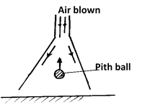
…………………………………………………………………………………………………………
…………………………………………………………………………………………………………
…………………………………………………………………………………………………………

- State two reasons why gases diffuses at a higher rate than liquids. (2 marks)
…………………………………………………………………………………………………………
…………………………………………………………………………………………………………
…………………………………………………………………………………………………………
…………………………………………………………………………………………………………
- A student set up an experiment as shown below using two gas jars, one with hot coloured water, the other with cold clear water separated by a smooth card. The upper jar is upside down. Explain the observation made when the card is removed. (2 marks)
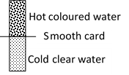
…………………………………………………………………………………………………………
…………………………………………………………………………………………………………
…………………………………………………………………………………………………………

- The figure below shows the scale of a Vernier calipers which is closed fully. State the Zero error of the instrument (1 mark) 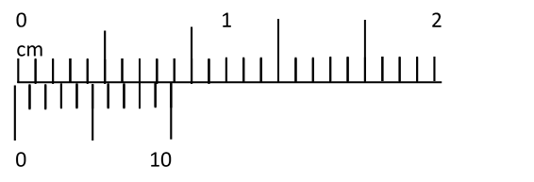
…………………………………………………………………………………………………………

- The figure below shows a uniform body suspended freely through a hole on an optical pin. State with reason the case where the body is more stable (2 marks)
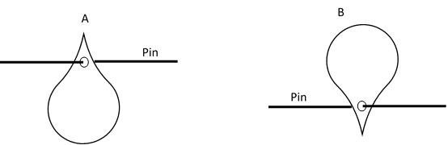

…………………………………………………………………………………………………………
…………………………………………………………………………………………………………
…………………………………………………………………………………………………………

- The figure below shows a metal being heater at the middle. Giving the reason state the wax that will fall off first (2 marks)

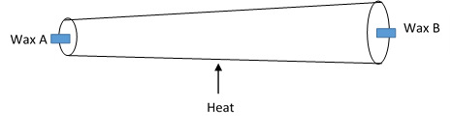
…………………………………………………………………………………………………………
…………………………………………………………………………………………………………
…………………………………………………………………………………………………………

- The figure below shows a system with a liquid enclosed by two pistons. Equal force F is applied on the system as shown. Giving reason show with an arrow the direction of movement of the liquid (2 marks)
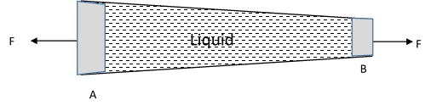

…………………………………………………………………………………………………………
…………………………………………………………………………………………………………
…………………………………………………………………………………………………………
…………………………………………………………………………………………………………

- The figure below shows a bimetallic wheel whose diameter is not affected by changes in
temperature. Briefly explain how the diameter of the wheel remain unchanged as the temperature increases. (2 marks)

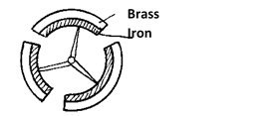
…………………………………………………………………………………………………………
…………………………………………………………………………………………………………
…………………………………………………………………………………………………………

- Two identical springs have a combined spring constant of 3.5N/cm when in series Determine combined spring constant when the springs are in parallel. (2 marks)

- Two coins A and B of the same mass and material are placed on a turntable as show below. The turntable is then rotated at a high speed. With reason name the coin that skids first(2 mk)
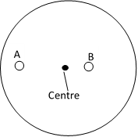
…………………………………………………………………………………………………………
…………………………………………………………………………………………………………
…………………………………………………………………………………………………………
- A substance of volume Xcm³ and density 800kgm⁻³ is mixed with 100cm³ of water of density 1000kgm⁻³. The density of the mixture is 960kgm⁻³. Determine the value of X. (2 marks
…………………………………………………………………………………………………………
…………………………………………………………………………………………………………
…………………………………………………………………………………………………………
…………………………………………………………………………………………………………

- A bullet of mass 10g travelling at a speed of 400ms⁻¹ hits a tree trunk. It penetrates the tree trunk and stops inside the trunk after 4 cm. Calculate the average resistance force offered by the trunk to the bullet. (2 marks)
…………………………………………………………………………………………………………
…………………………………………………………………………………………………………
…………………………………………………………………………………………………………
…………………………………………………………………………………………………………

Section B (55 marks)
Water Paraffin
Answer all the questions in the spaces provided
- (a) A body accelerates from rest. Its velocity after 5 seconds is 26m/s and after 9 seconds its velocity is 42m/s. calculate
i) Distance moved during the motion (3 marks)

ii) Average speed of the journey (2 marks)

(b) A car can be brought to rest from a speed of 20m/s in a time of 2s when brakes are
applies.
i. Find the average deceleration (1 mark)

ii. The car is stopped by a policeman when moving at a speed of 20m/s. If the driver’s reaction time is 0.2s determine the shortest stopping distance. (2 marks)

(c) The figure below shows the graph of a tennis ball bouncing severally on a table
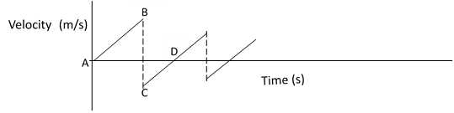

Describe the motion between
- AB (1 mark)
…………………………………………………………………………………………………………
…………………………………………………………………………………………………………
…………………………………………………………………………………………………………
- BC (1 mark)
…………………………………………………………………………………………………………
…………………………………………………………………………………………………………
…………………………………………………………………………………………………………
- CD (1 mark)
…………………………………………………………………………………………………………
…………………………………………………………………………………………………………
- (a) State the Pascal principle (1 mark)
…………………………………………………………………………………………………………
…………………………………………………………………………………………………………
(b) State the principal of moments (1 mark)
…………………………………………………………………………………………………………
…………………………………………………………………………………………………………
(c) The figure below shows a 100cm uniform bar of weight 50N balanced horizontally on
two pistons.
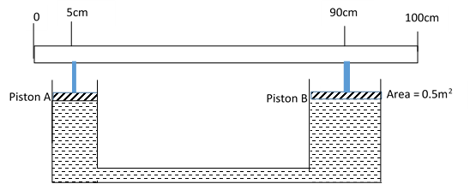
Correct to 2 decimal places determine
- Force exerted on piston A (3 marks)

- Force exerted on Piston B (3 marks)

- Cross section area of piston A (3 marks)

- a. The figure below shows 30cm³ of gas trapped in a tube containing mercury to a height of 14.5cm. The prevailing atmospheric pressure is 760mmHg. Determine the pressure acting on the gas in Pascals (3 marks)
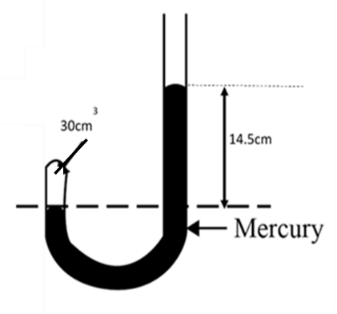

b. Determine the volume of the gas when the tube is held as shown below
i. (3 marks)
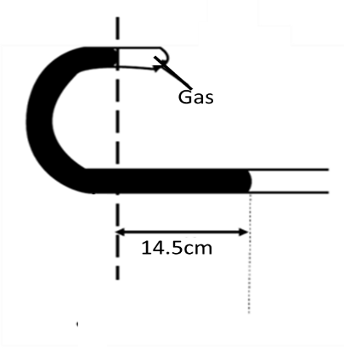

ii. (3 marks)
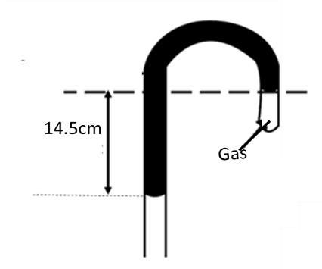

- a) State the law of floatation. (1 mark)
…………………………………………………………………………………………………………
…………………………………………………………………………………………………………
b) The figure below shows a block cuboid of dimensions 4cm by 4cm by 16cm floating in a liquid in an overflow can with $\frac{3}{4}$ of its height submerged.
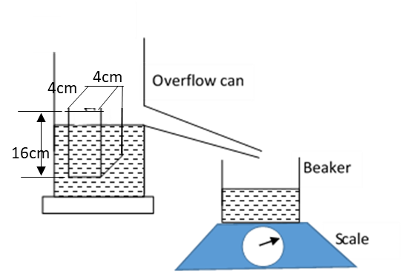
Given that the mass of the beaker when empty is 85g and the reading on the scale in the set up above is 245g, calculate:
(i) The density of the block. (3 marks)

(ii) The density of the liquid. (2 marks)

(c) A metal block is suspended from a spring balance and held inside a beaker without
touching the beaker. Water is added gradually into the beaker. The graph below shows the
variation of up thrust on the block with depth of water.
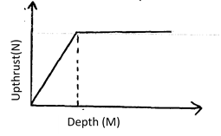
Explain the shape of the graph. (2 marks)
…………………………………………………………………………………………………………
…………………………………………………………………………………………………………
…………………………………………………………………………………………………………

(d) The figure below shows a pulley system being used to raise a load.

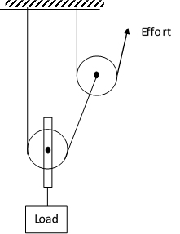
(i) Indicate the direction of the strings (1 mark)

(ii) If an effort of 35N raises a load of 105N, determine the efficiency of the system.
(3 marks)

18. (a) The figure below shows a car of mass (m) moving along a curved part of the road with a
constant speed.
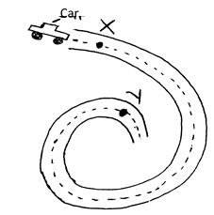
(i) Explain why the car is more likely to skid at Y than at X. (2 marks)
…………………………………………………………………………………………………………
…………………………………………………………………………………………………………
…………………………………………………………………………………………………………

(ii) If the radius of the road at V is 250m and the car has a mass of 600kg, determine the
maximum speed at which the car can be driven while at V without skidding. Force of
friction between the road and the tyres is 18000N. (3 marks)
…………………………………………………………………………………………………………
…………………………………………………………………………………………………………
…………………………………………………………………………………………………………
…………………………………………………………………………………………………………
…………………………………………………………………………………………………………
(b) A string of length 70cm is used to whirl a stone in a circle in a vertical plane at 5 rev/s.
Determine:
(i) The period (1 mark)

(ii) The angular velocity. (2 marks)

(iii) The speed of the stone (2 marks)

- A body moving in a circle with constant speed is said to have an acceleration. Explain.

(1 mark)
…………………………………………………………………………………………………………
…………………………………………………………………………………………………………
…………………………………………………………………………………………………………



ALLIANCE GIRLS 2025 PREDICTION
POSSIBLE KCSE EXAM
PHYSICS
232/2
(THEORY)
PAPER 2
TIME: 2 HOURS

NAME……………………………………………………………………………………….
SCHOOL……………………………………………… SIGN………………………..
INDEX NO……………………………………………. ADM NO……………………

Kenya Certificate of Secondary Education.
INSTRUCTION TO CANDIDATES
- Write your name, index number in the spaces provided.
- This paper consists of TWO sections: A and B.
- Answer ALL questions in section A and B in the spaces provided.
- ALL workings MUST be clearly shown.
- Mathematical tables and electronic calculators may be used.
For Examiner’s Use Only
Section | Question | Maximum score | Candidate’s score
A | 1 – 12 | 25
B | 13  14  15  16 | 16  14  14  11
 | Total | 80

Answer ALL questions in section A and B in the spaces provided.
1. The figure below shows an object O in front of a curved mirror M.
- On the figure, locate the image formed. (3 marks)
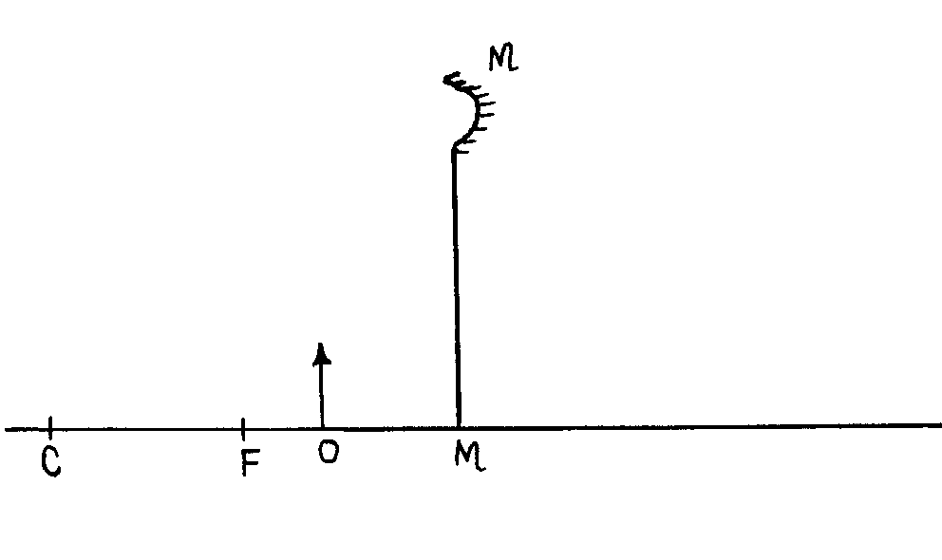
2. State two ways of decreasing the strength of an electromagnet. (2 marks)
…………………………………………………………………………………………………………
…………………………………………………………………………………………………………
…………………………………………………………………………………………………………

3. State one disadvantage of using a convex mirror as a driving mirror. (1 mark) …………………………………………………………………………………………………………………………………………………………………………………………………………………..

4. State two factors that affect the resistivity of an electrical conductor. (2 marks) ………………………………………………………………………………………………………………………………………………………………………………………………………………………………………………………………………………………………………………………………

5. A coin is placed at the bottom of a beaker containing a transparent liquid. When viewed from the top, the coin appears nearer the surface than it actually is. Explain the observation. (2 marks)
…………………………………………………………………………………………………………………………………………………………………………………………………………………….…………………………………………………………………………………………………………
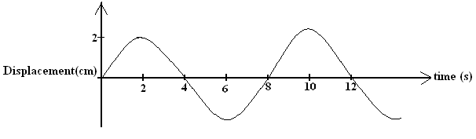
6. The figure below shows a wave in progress.
Determine the
a) Amplitude (1 mark) ………………………………………………………………………………………………… …………………………………………………………………………………………………
b) Frequency (2 marks) ………………………………………………………………………………………………… ………………………………………………………………………………………………….

c) On the figure above, draw how the wave would appear if the period and amplitude is
halved. (1 mark)
8. A ferromagnetic material is being magnetized by single stroking method. On the axes provided,
sketch a graph to show how the strength of the magnet being created varies with the number of
strokes (1 mark)
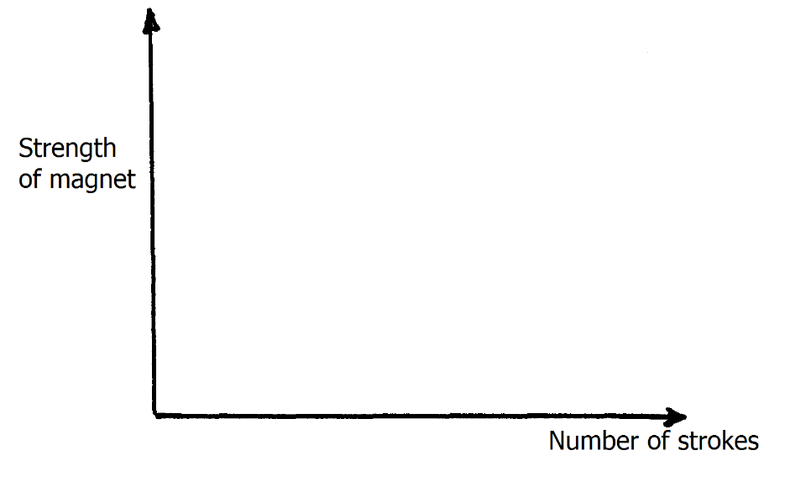
9. Figure 4 shows a conductor carrying current placed in the magnetic field and moves in the
direction shown
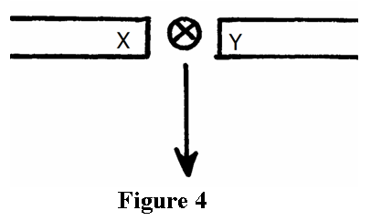
Identify the polarities of X and Y. (2 marks)
X…………………………………………………………………………………………………
Y…………………………………………………………………………………………………
10. A boy standing in front of a cliff blows a while and hears echo after 0.5s. He then makes
17metres further away from the cliff and blows the whistle again. He now hears the echo after
6.0 s. determined the speed of the sound. (3 marks)
………………………………………………………………………………………………… ………………………………………………………………………………………………… ………………………………………………………………………………………………… ………………………………………………………………………………………………..

11. (a) What is meant by the term electric current? (1 mark)
………………………………………………………………………………………………… …………………………………………………………………………………………………

(b) 0.25A of current passes through a point in a conductor in 3.5 minutes. Calculate the
amount of charge passing through the point in this time. (2 marks)
………………………………………………………………………………………………… ………………………………………………………………………………………………….. …………………………………………………………………………………………………..
12. An unmagnetized steel rod is clamped facing North-South direction and then hammered
repeatedly for some time. When tested, it is found to be magnetized. Explain this observation (2 marks) ………………………………………………………………………………………………… ………………………………………………………………………………………………… …………………………………………………………………………………………………

SECTION II (55 MARKS)
13. (a) State Ohm’s law. (1 mark)
………………………………………………………………………………………………… …………………………………………………………………………………………………
b). The graph below shows results obtained in an experiment to determine the e.m.f.(E) and the
internal resistance, r, of a cell.
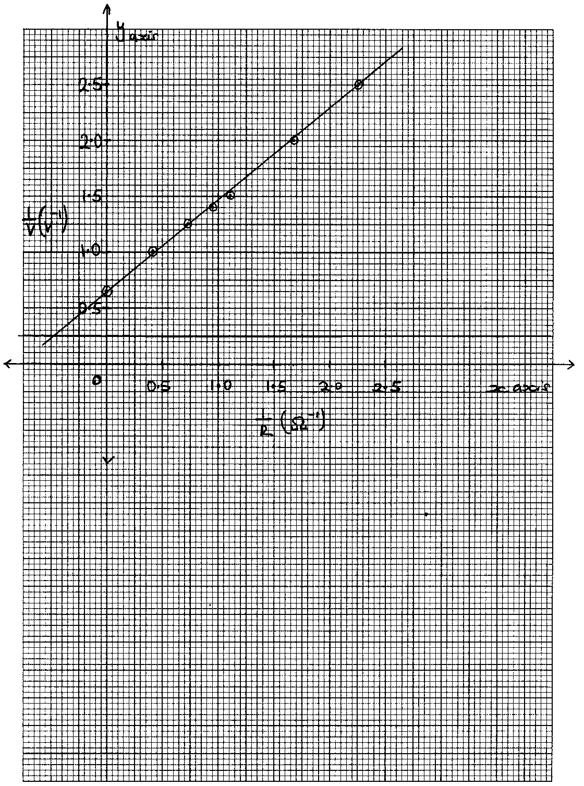
Given that the equation of the graph is = + 1
Use the graph to determine the values of:-
(i) E (2 marks)
………………………………………………………………………………………………… ………………………………………………………………………………………………… ………………………………………………………………………………………………..
(ii) r (3 marks) ………………………………………………………………………………………………… ………………………………………………………………………………………………… ………………………………………………………………………………………………… …………………………………………………………………………………………………
c) The figure below shows five resistors and a source of voltage of 6V.
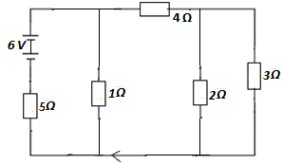
i) Find the effective resistance of the circuit. (2 marks)
………………………………………………………………………………………………… ………………………………………………………………………………………………… …………………………………………………………………………………………………

ii) Calculate the current through 5Ω. (3 marks)
………………………………………………………………………………………………… ………………………………………………………………………………………………… ………………………………………………………………………………………………… …………………………………………………………………………………………………
(iii) What is the p.d across 2Ω. (3 marks)
………………………………………………………………………………………………… ………………………………………………………………………………………………… ………………………………………………………………………………………………… ………………………………………………………………………………………………..

iv) Calculate the current through 1Ω. (2 marks)
………………………………………………………………………………………………… ………………………………………………………………………………………………… ………………………………………………………………………………………………… ………………………………………………………………………………………………..

14. (a) An object is placed 30cm in front of a thin converging lens of focal length 20cm. The set up
is represented in the figure.

lens

40 30 20 10 10 20 30 40

- On the same figure construct a ray diagram to locate the position of the image. (3 marks)

- Determine the magnification produced. (2 marks)
………………………………………………………………………………………………… ………………………………………………………………………………………………… …………………………………………………………………………………………………

(b) An object 6cm tall is placed 40cm from a convex lens of focal length 50cm. Find the position of the image. (3 marks)
………………………………………………………………………………………………… ………………………………………………………………………………………………… ………………………………………………………………………………………………… ………………………………………………………………………………………………… ………………………………………………………………………………………………..
(c) State two differences between the human eye and the camera. (2 marks)
………………………………………………………………………………………………… ………………………………………………………………………………………………… ………………………………………………………………………………………………… ………………………………………………………………………………………………..

(d) The figure below shows an eye defect.
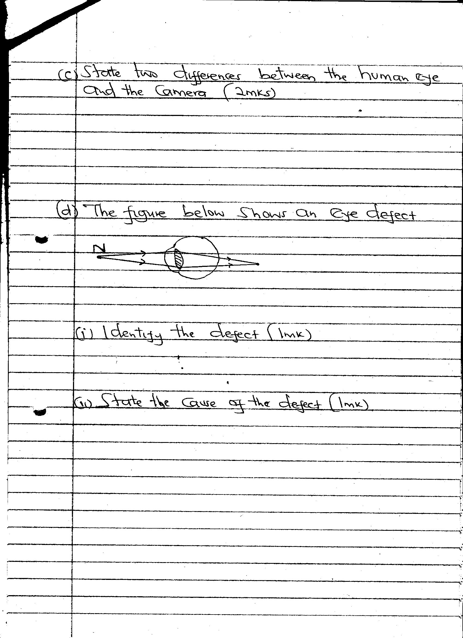
- Identify the defect. (1 mark)
………………………………………………………………………………………
- State the cause of the defect. (1 mark)
………………………………………………………………………………………..

(iii) Using a well labeled diagram, illustrate how the defect is corrected. (2 marks)

15. (a) The figure below shows a pair of parallel plates of a capacitor connected to a Battery the upper plates is displaced slightly to the left.
+
-

State with reason the effect of this movement of the capacitance (2 marks)
…………………………………………………………………………………………………………
…………………………………………………………………………………………………………
…………………………………………………………………………………………………………

(b) The figure below shows an electrical circuit with three capacitors A, B and C of Capacitance
4.0 μF, 5.0 μF and 3.0 μF respectively connected to a 12V battery
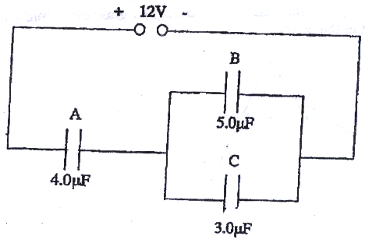
Determine:
(i) The combined capacitance of the three capacitors (3 marks)
…………………………………………………………………………………………………………
…………………………………………………………………………………………………………
…………………………………………………………………………………………………………
(ii) The charge of the capacitor A (2 marks)
…………………………………………………………………………………………………………
…………………………………………………………………………………………………………
…………………………………………………………………………………………………………
(iii) The potential difference across the capacitor B (2 marks)
…………………………………………………………………………………………………………
…………………………………………………………………………………………………………
…………………………………………………………………………………………………………

c) A positively charged sphere is suspended by an insulating thread. A negatively charged conductor is suspended near it. The conductor is first attracted, after touching the sphere it is repelled. Explain this observation. (2 marks)
…………………………………………………………………………………………………………
…………………………………………………………………………………………………………
…………………………………………………………………………………………………………
…………………………………………………………………………………………………………

d) A 2μF capacitor is charged to a potential of 200V, the supply is disconnected. The capacitor is then connected to another uncharged capacitor. The p.d across the parallel arrangement is 80V. Find the capacitance of the second capacitor. (3 marks)
…………………………………………………………………………………………………………
…………………………………………………………………………………………………………
…………………………………………………………………………………………………………
…………………………………………………………………………………………………………
…………………………………………………………………………………………………………
16. (a) A single ray of light in incident on an equilateral glass position as shown in the figure below. Complete the diagram to show the path of light through and out of the position.(critical angle of glass = 42⁰) (3 marks)

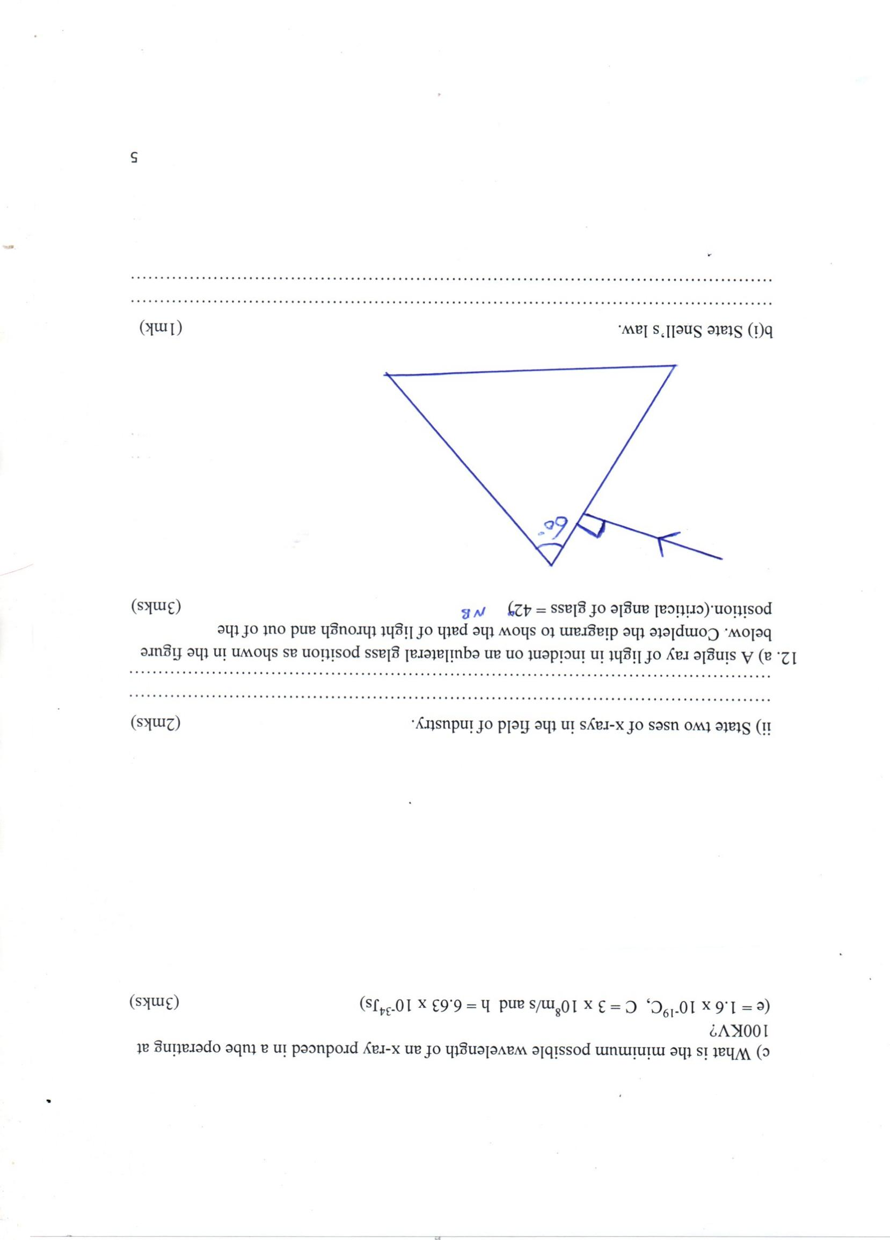

(b) State two (2) conditions necessary for total internal reflection (2 marks)
………………………………………………………………………………………………… ………………………………………………………………………………………………… …………………………………………………………………………………………………

(c) (i) Figure below shows an object O at the bottom of a beaker full of a liquid. An observer above the beaker sees its image at point X inside a liquid.
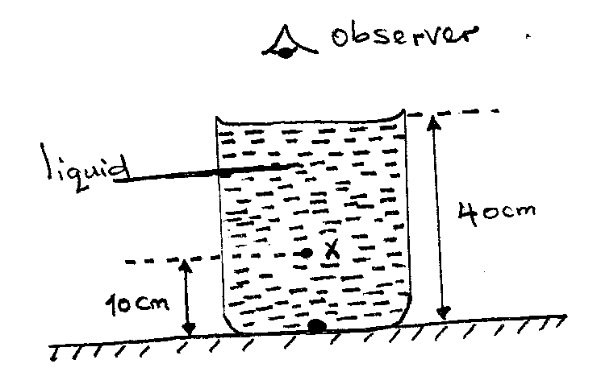

Determine the refractive index of the liquid. (3 marks)
…………………………………………………………………………………………………………
…………………………………………………………………………………………………………
…………………………………………………………………………………………………………
…………………………………………………………………………………………………………
…………………………………………………………………………………………………………

(ii) Define the term critical angle(c) of a medium. (1 mark)
…………………………………………………………………………………………………………
…………………………………………………………………………………………………………

(d) State two uses of optical fibre. (2 marks)
…………………………………………………………………………………………………………
…………………………………………………………………………………………………………
…………………………………………………………………………………………………………



ALLIANCE GIRLS 2025 PREDICTION
POSSIBLE KCSE EXAM
PHYSICS
232/3
(PRACTICAL)
PAPER 3
TIME: 2½ HOURS

SCHOOL……………………………………………… SIGN………………………..

CONFIDENTIAL
QUESTION ONE
Every student should be provided with the following:
- Two new dry cell size D
- Cell holder for 2 cell
- A piece of resistance wire( Nichrome wire SWG 30) 20cm long labeled W
- Voltmeter (0 - 3V or 0 - 5V)
- Ammeter (0 - 1A)
- A nichrome wire(SWG 30) mounted on a millimeter scale labelled PQ
- Seven connecting wires in which four are with crocodile clips on both ends and three are with crocodile clips on one end
- Jockey attached to a connecting wire
- Micrometer screw gauge (can be shared)
QUESTION TWO
- A meter rule
- A concave lens focal length 10cm
- A lens holder
- A candle stick
- A white screen
- A stop watch
- A marble
- A watch glass of diameter 10cm
- Some Plasticine



ALLIANCE GIRLS 2025 PREDICTION
POSSIBLE KCSE EXAM
232/3
PHYSICS
(PRACTICAL)
PAPER 3
TIME: 2½ HOURS

NAME……………………………………………………………………………………….
SCHOOL……………………………………………… SIGN………………………..
INDEX NO……………………………………………. ADM NO……………………

INSTRUCTIONS TO CANDIDATES
1. Write your name, index number, class, date and signature in the spaces provided above.
2. This paper consists of two questions 1 and 2.
3. Answer all questions in the spaces provided.
4. Non-programmable calculators and mathematical tables may be used.
5. Show all your workings.
QUESTION 1 | a(ii) | a(iii) | a(iv) | a(v) | a(vi) | b(vii) | TOTAL
Maximum score | 6 | 5 | 3 | 1 | 2 | 3
Candidates score
QUESTION 2 | a(i) | a(ii) | a(iii) | b(vii) | b(viii) | b(ix) | b(xi) | b(xii) | b(xii)I | b(xii)II | b(xiii)
Maximum score | 1 | 1 | 1 | 6 | 2 | 1 | 1 | 1 | 1 | 2 | 3
Candidates score

Question 1
You are provided with the following:
-Two dry cell
- Cell holder
-A piece of resistance wire labeled W
-Voltmeter (0 - 3V or 0 - 5V)
-Ammeter (0 - 1A)
-A nichrome wire mounted on a millimeter scale labelled PQ
-Seven connecting wires in which four are with crocodile clips on both ends and three are with crocodile clips on one end
- Jockey attached to a connecting wire
- Micrometer screw gauge (can be shared)
Proceed as follows:
a) i). Set up the circuit as shown in the figure below.

W
Q
P
A
V
Jockey
Nichrome wire
L

ii) With the Jockey at Q i.e. L= 0.0 cm, take the voltmeter reading and ammeter reading. Record V and I. Repeat to get the readings for L=20.0cm, 40.0cm, 60.0cm, 60.0cm, 80.0cm and 100.0cm respectively and complete the table below.

Length L (cm) | 0.0 | 20.0 | 40.0 | 60.0 | 80.0 | 100.0
Voltage V (v)
Current I (A)
(6marks)
iii).Plot a graph of voltmeter readings (y-axis) against ammeter readings. (5marks)

iv) Determine the slope of the graph (3marks)

v) What physical quantity is represented by the slope of the graph at any given point (1mark)

vi) Using a micrometer screw gauge, measure the diameter, d of the wire W.

d = mm (1mark)

= m (1mark)

vii) Calculate the quantity and give its units. (3marks)

Question 2
PART A
You are provided with the following apparatus
- A meter rule
- A concave lens with holder
- A candle stick
- A white screen
- A stop watch
- Marble
- Watch glass
- Plasticine
- Micrometer screw gauge
Proceed as follows:
(a) Find the approximate focal length by focusing a sharp image of a distant object onto a screen. The object (preferably window frame) must be at least 4m away. Turn lens such that side A faces the screen

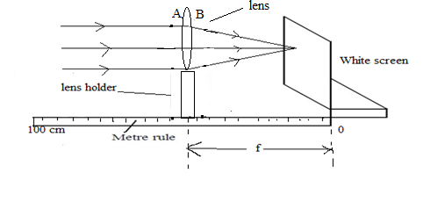
i) f₁=…………………………… (1mark)
(ii) f₂=…………………….. (1mark)
iii) Find the Average of f₁ and f₂ (1mark)

b)(i)Now Set up the apparatus as shown in figure below such that S=55cm.Adjust the position of the lens to obtain a sharp enlarged image of the candle flame. (Ensure that the candle flame, the lens and white screen same horizontal level)

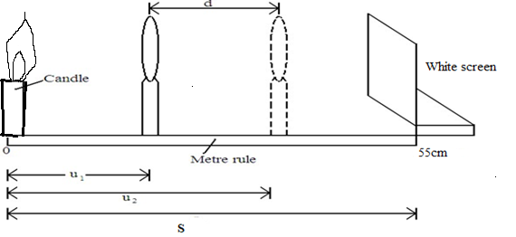

ii) Measure the distance u₁ between the candle and the lens

iii)Without changing the position of the candle and the screen, move the lens to obtain a sharp diminished image of the candle flame
iv) Measure the distance u₂ between the candle and the lens
v) Record the values of u₁ and u₂ in the table below.
vi) Repeat the procedure in (i) above for S=45cm.
(vii)Complete the table (6marks)
S(cm) | U₁(cm) | U₂(cm ) | d=U₁-U₂
55
45
viii) Determine the average value of K (2marks)

ix) What does physical quantity K represent (1mark)

PART B
Procedure:
x. Arrange the apparatus as shown in the figure below:
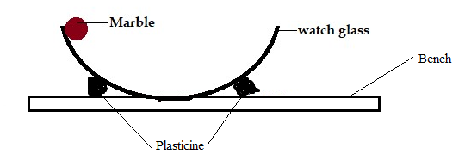

xi.Release the marble from the edge of the watch glass to freely oscillate. Measure the time taken, t, for 5 oscillations.

t = …………………… (1 mark)

xii. Calculate the periodic time, T

T = ……………………… (1 mark)

(I) Measure the diameter, D of the marble using the micrometer screw-gauge.

D = ……………………m (1 mark)

(II) Determine the volume, V of the marble. (2 marks)

xiii) The period, T, of oscillation of the marble and radius, r of the marble are related by the equation:
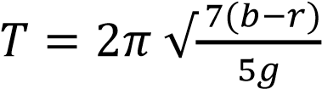
Where g = 10 m/s² and b is a constant of the watch glass. Determine the value of b
(3 marks)



ALLIANCE GIRLS 2025 PREDICTION
POSSIBLE KCSE EXAM
443/1
AGRICULTURE
PAPER 1
TIME: 2 HOURS

NAME……………………………………………………………………………………….
SCHOOL……………………………………………… SIGN………………………..
INDEX NO……………………………………………. ADM NO……………………

Kenya Certificate of Secondary Education.
INSTRUCTION TO CANDIDATES
- Write your name and index number and school, Sign and write the date in the spaces provided above.
- This paper consists of THREE sections; A, B and C.
- Answer All the questions in section A and B in the spaces provided and any TWO questions from section C in the answer sheet provided

FOR EXAMINERS USE ONLY
SECTION | QUESTION | MAXIMUM SCORE | CANDIDATE’S SCORE
A | 1 - 17 | 30
B | 18 - 22 | 20
C |  | 20
 |  | 20
TOTAL SCORE |  | 90

SECTION A (30 MARKS)
Answer all the question in this section in the spaces provided.
1. Name the routine field practice done by:
(a) Removal of extra suckers in banana stool. (½mrk)
…………………………………………………………………………………………………

(b) Removal of old stems down to level of top foliage in pyrethrum. (½mrk) …………………………………………………………………………………………………

(c) Removal of suckers from coffee bushes. (½mrk)
…………………………………………………………………………………………………

2. State three characteristics of phosphate fertilizers. (1½mks)
………………………………………………………………………………………………………………………………………………………………………………………………………………………………………………………………………………………………………

3. State two physical properties of soil that influence crop production. (1mk)
……………………………………………………………………………………………………………………………………………………………………………………………………

4. Outline four ways by which crop pests are classified. (2mks)
…………………………………………………………………………………………………………………………………………………………………………………………………………………………………………………………………………………………………………………………………………………………………………………………………………

5. State three uses of labour records in Agriculture. (1½mks)
………………………………………………………………………………………………………………………………………………………………………………………………………………………………………………………………………………………………………
6. Give four advantages of overhead irrigation in crop production. (2mrks)
…………………………………………………………………………………………………………………………………………………………………………………………………………………………………………………………………………………………………………………………………………………………………………………………………………

7. List three basic concepts in agricultural economics. (1½mrks)
………………………………………………………………………………………………………………………………………………………………………………………………………………………………………………………………………………………………………

8. Give four varieties of tomatoes grown for processing. (2mks)
…………………………………………………………………………………………………………………………………………………………………………………………………………………………………………………………………………………………………………………………………………………………………………………………………………

9. State four pasture management practices done to enhance yields per unit area. (2mrks)
…………………………………………………………………………………………………………………………………………………………………………………………………………………………………………………………………………………………………………………………………………………………………………………………………………

10. Name two macro-nutrients which classified as:
(a) Fertilizer elements. (1mrk)
……………………………………………………………………………………………………………………………………………………………………………………

(b) Liming elements. (1mrk)
……………………………………………………………………………………………………………………………………………………………………………………

11. Give three ways by which pruning helps to control disease in crops. (1½mrks)
…………………………………………………………………………………………………………………………………………………………………………………………………………………………………………………………………………………………………………………………………………………………………………………………………………

12. State four ways in which weeds are excellently adapted to the environment. (2mrks)
…………………………………………………………………………………………………………………………………………………………………………………………………………………………………………………………………………………………………………………………………………………………………………………………………………

13. State four factors that determine the time at which a crop is planted. (2mks)
…………………………………………………………………………………………………………………………………………………………………………………………………………………………………………………………………………………………………………………………………………………………………………………………………………

14. Give four factors that affected the effectiveness of a pesticide. (2mrks)
…………………………………………………………………………………………………………………………………………………………………………………………………………………………………………………………………………………………………………………………………………………………………………………………………………

15. State four reasons for staking tomatoes in crop production. (2mrks)
……………………………………………………………………………………………………………………………………………………………………………………………………………………………………………………………………………………………………………………………………………………………………………………………………………………………………………………………………………………………………………
16 State three cultural methods of soil and water conservation. (1½mrks)
………………………………………………………………………………………………………………………………………………………………………………………………………………………………………………………………………………………………………

17. State four benefits of having a land title deed to a farmer. `(2mrks)
…………………………………………………………………………………………………………………………………………………………………………………………………………………………………………………………………………………………………………………………………………………………………………………………………………

SECTION B. (20 MARKS)
Answer ALL questions in this section in the spaces provided
18. Study the diagram below and answer the questions that follow. The illustrations represent
a method of crop propagation.
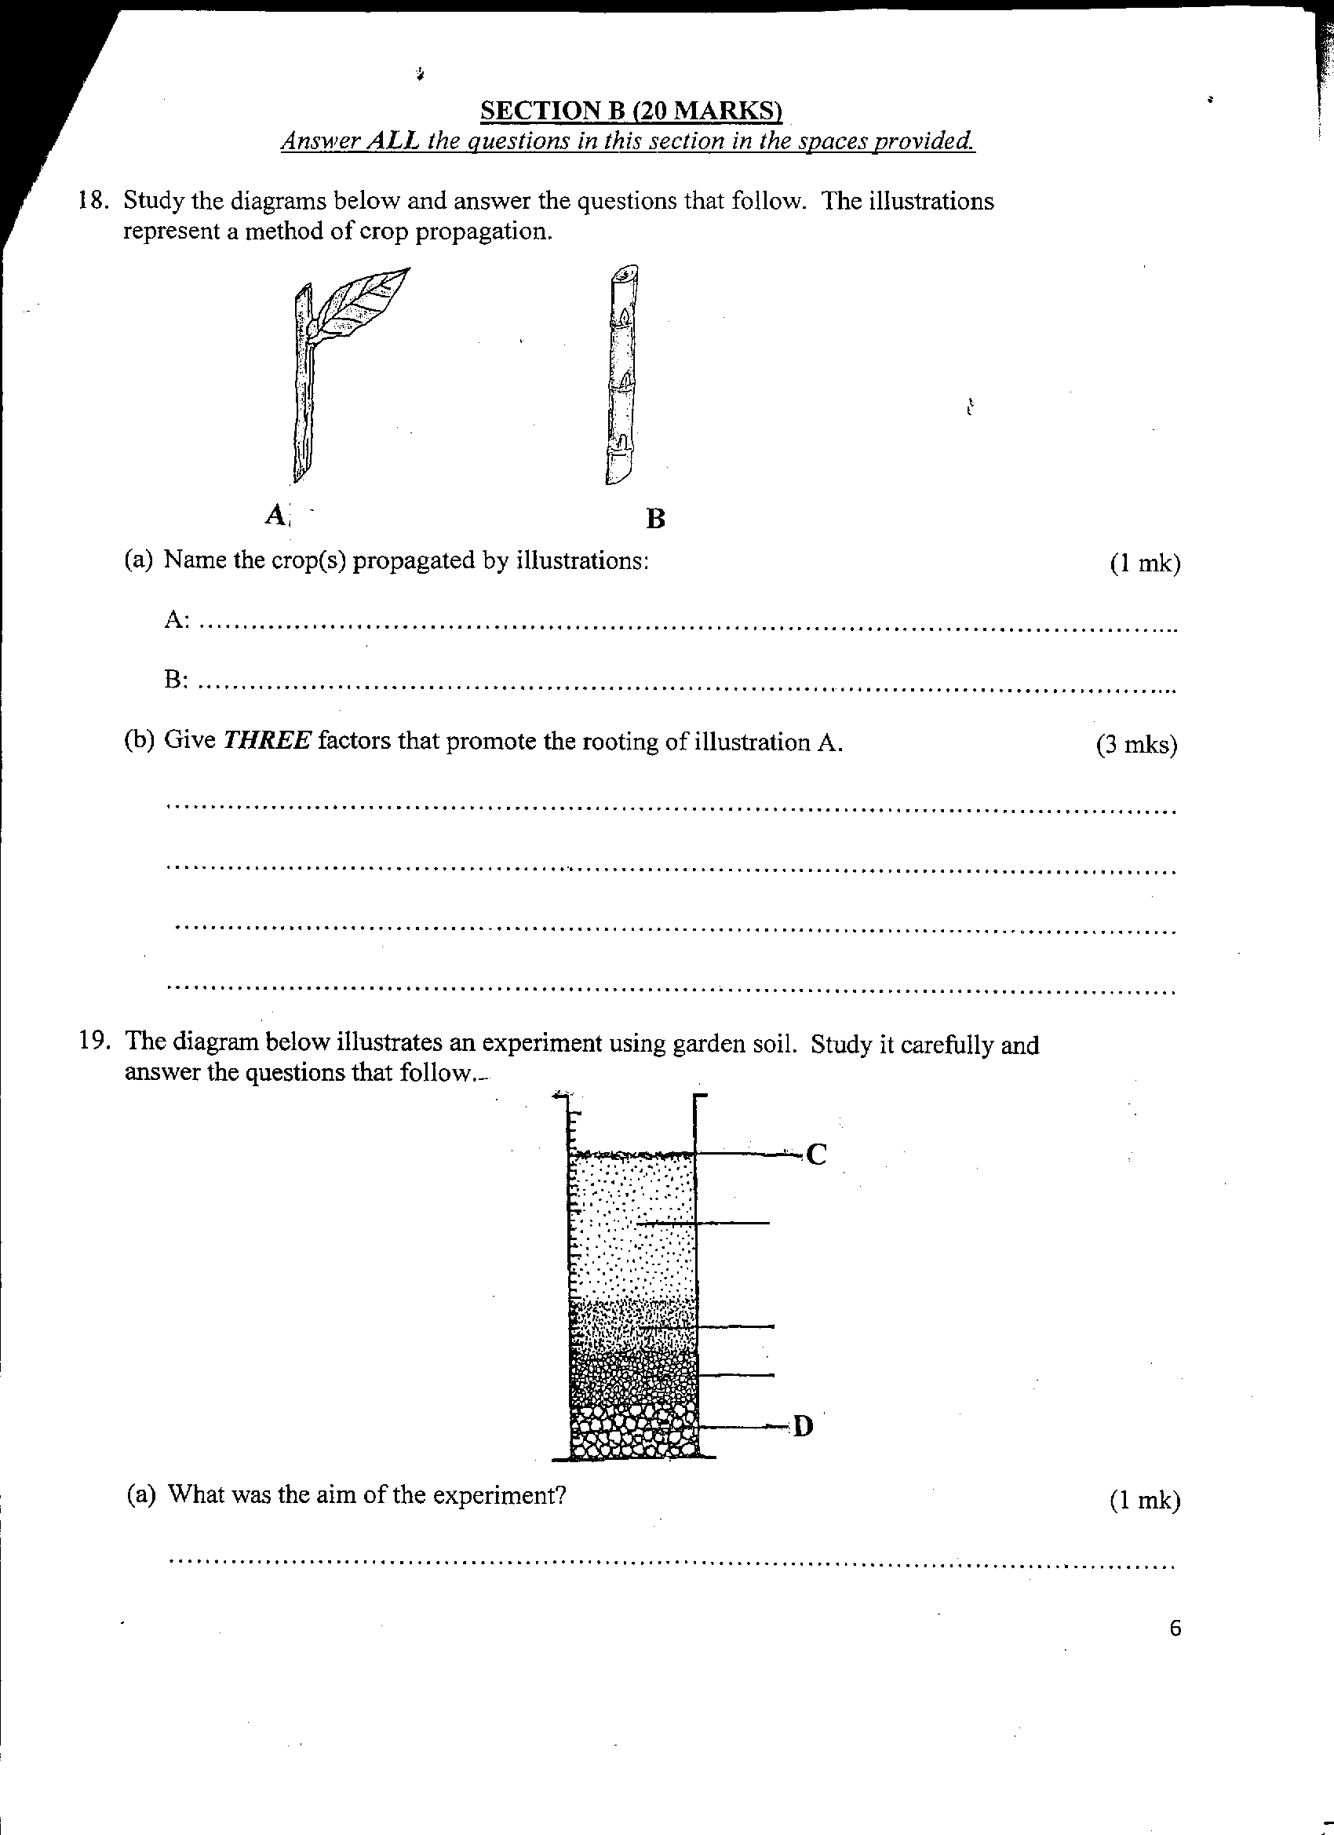

(a) Name the crops propagated by illustrations: (2mrks)
A.............................................................................................................
B...............................................................................................................
(b) Give three factors that promote the rooting of illustration A. (3mrks)
………………………………………………………………………………………………………………………………………………………………………………………………………………………………………………………………………………………………………………………
19 The diagram below illustrates an experiment using garden soil. Study it carefully and answer the questions that follow.
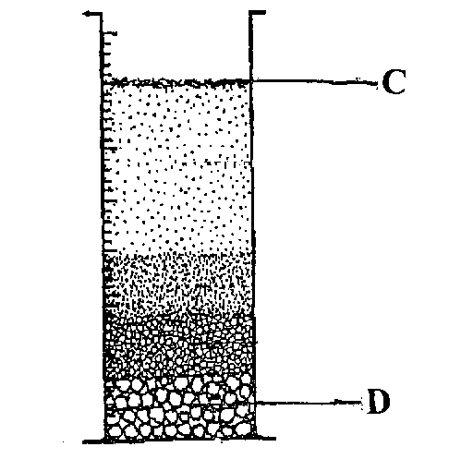

(a) What was the aim of the experiment? (1mrk)
…………………………………………………………………………………………………

(b) Name the parts labeled C and D. (2mrks)
C.............................................................................................................................
D.............................................................................................................................
(c) Name the property of soil being investigated. (1mrk)
…………………………………………………………………………………………

20. The illustration below shows a type of soil erosion. Study it carefully and answer the questions that follow.
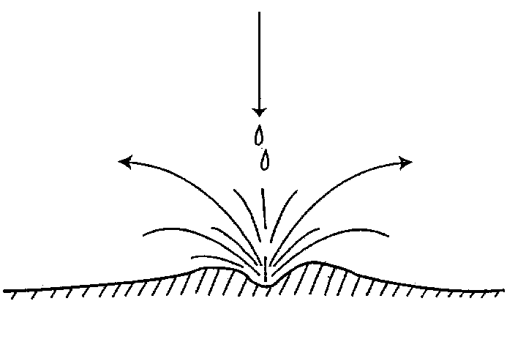

(a) Identify the type of erosion illustrated above. (1mrk)
…………………………………………………………………………………………………

(b) Give two soil factors that influence the rate of soil erosion. (2mrks)
………………………………………………………………………………………………………………………………………………………..……………………………………………
(c) Name one agent of soil erosion. (1mrk)
……………………………………………………………………………………………………

21. The diagram below represents a method of manure preparation. Study it carefully and answer the questions that follow.
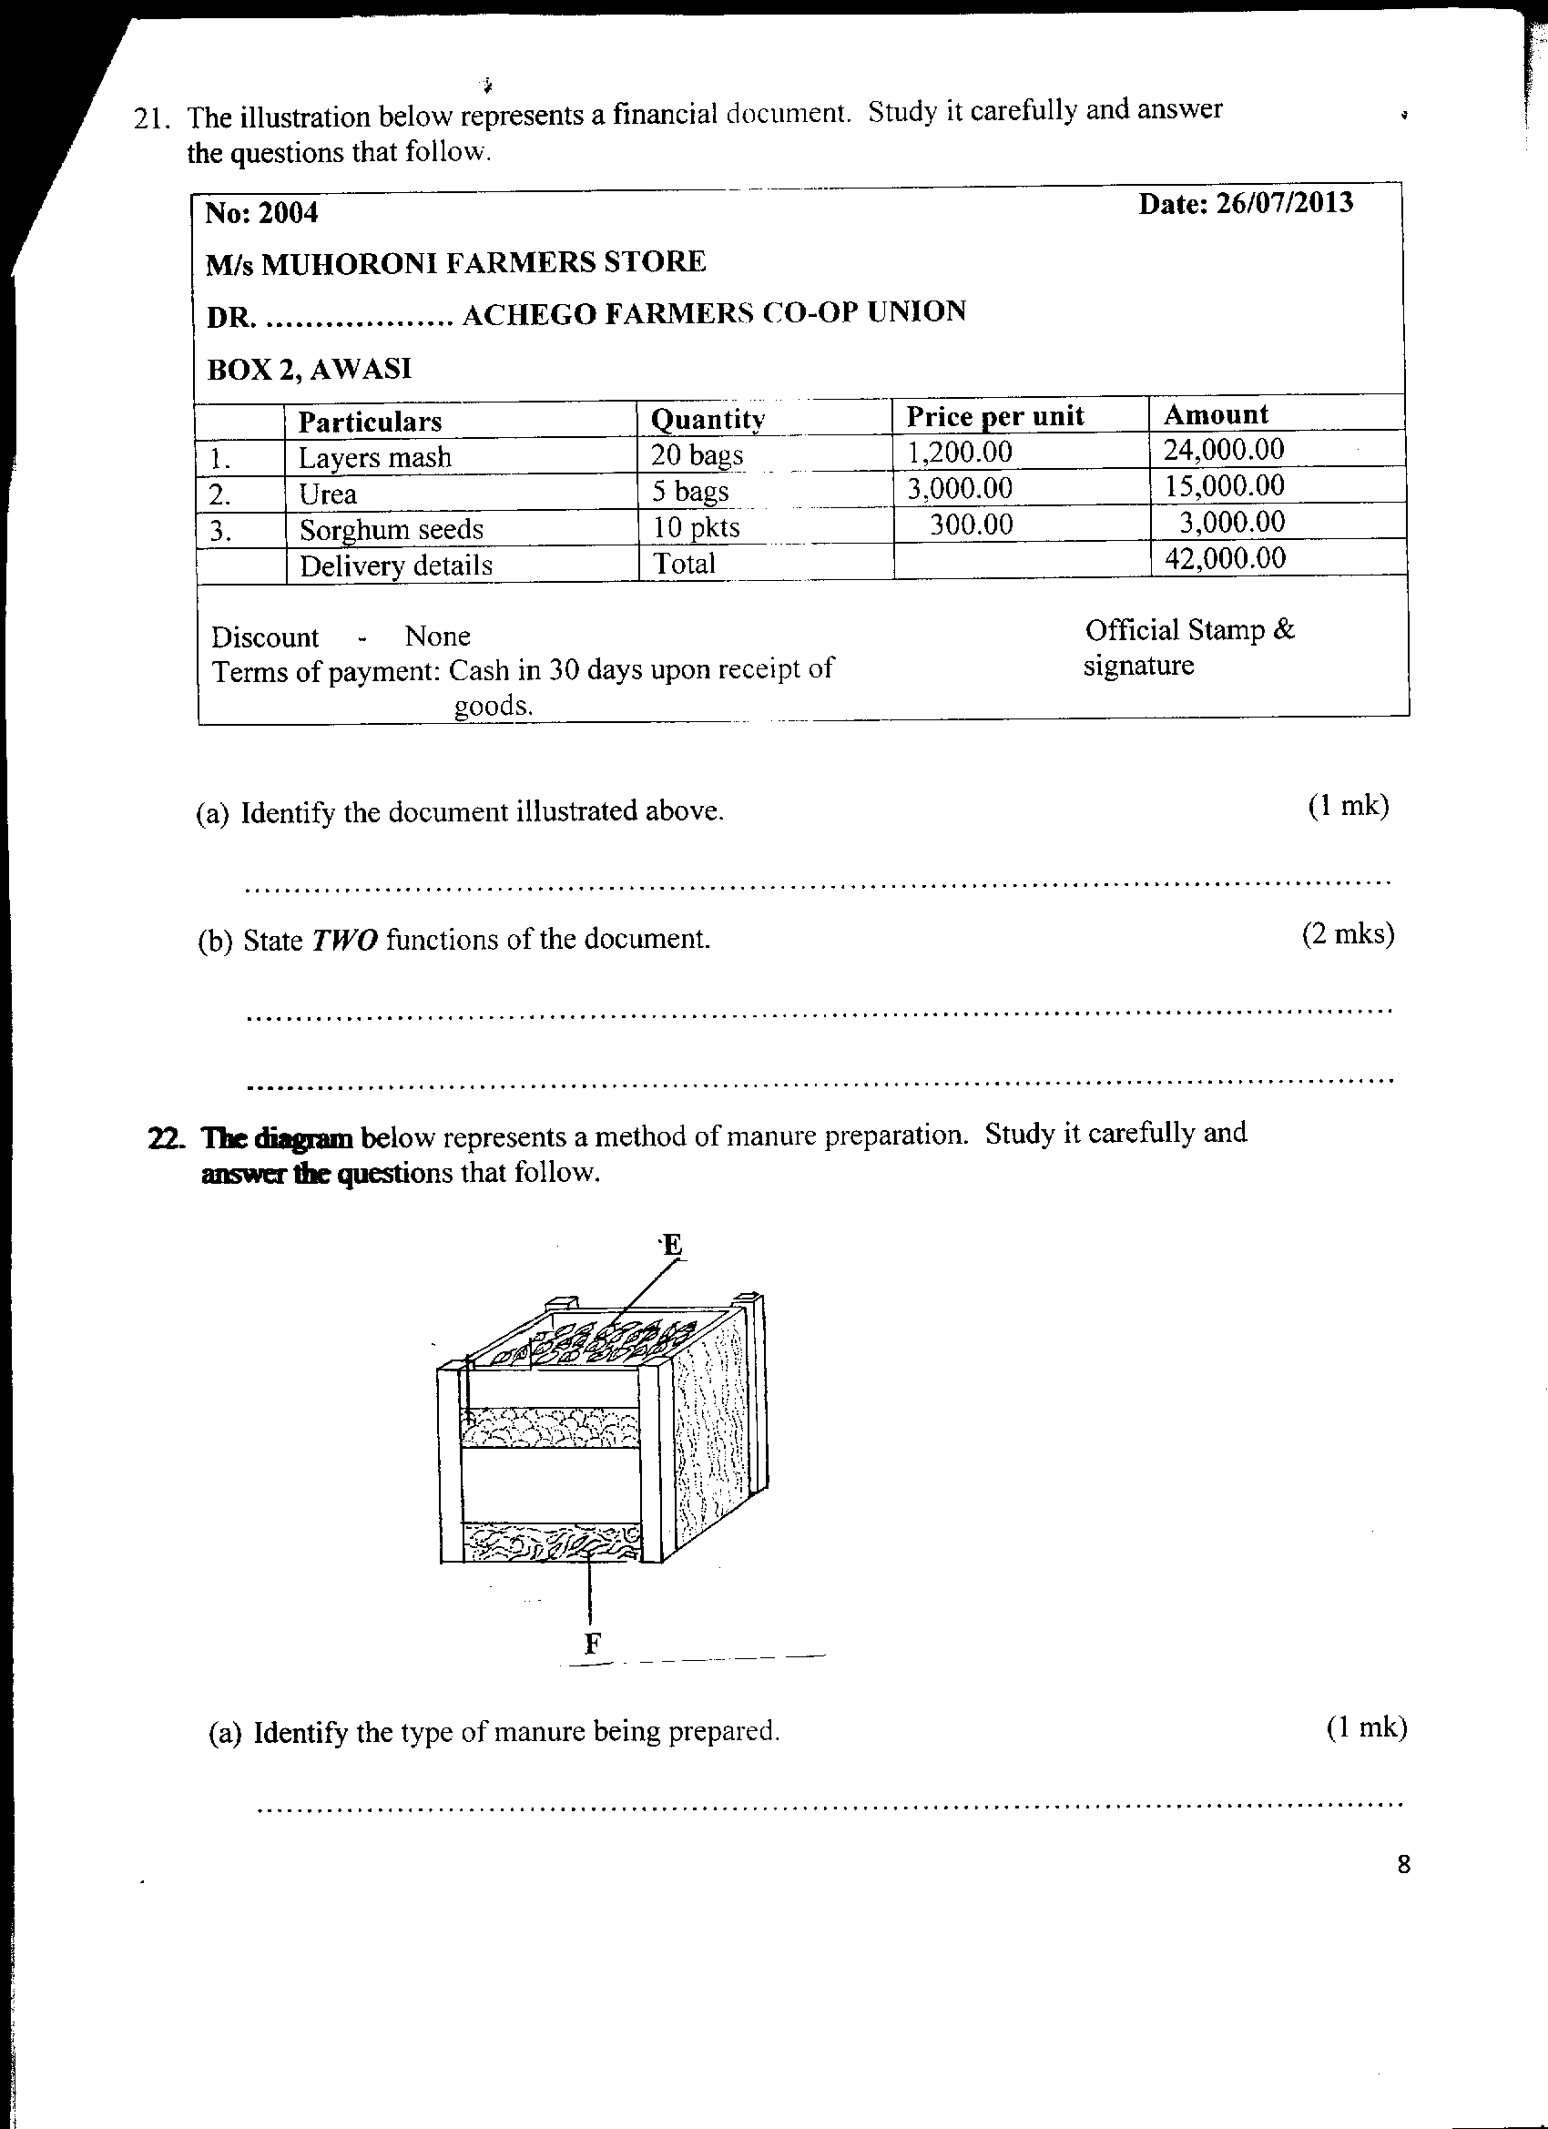
(a) Identify the type of manure being prepared. (1mrk)
…………………………………………………………………………………………………………

(b) Name the parts labeled E and F. (2mrks)
E..............................................................................................................
F...............................................................................................................

(c) Give four disadvantages of manures. (4mrks)
……………………………………………………………………………...…………………………………………………………………………………………………………..............................................................................................................................................................................................................................................................................................................................

SECTION C (40MARKS)
Answer any two questions from this section in the answer sheet provided
22. (a) Describe land preparation for planting of grass seeds. (4mrks)
(b) Explain the precautions that should be observed during the harvesting of pyrethrum (4mks)
(c) Explain six benefits of land consolidation in Agricultural production. (12mrks)

23. (a) Describe the field management practices that should be carried out on dry bean production. (10mrks)
(b) Explain five factors that should be considered when deciding on the depth of planting a seed. (5mrks)
(c) Describe the characteristics of a crop suitable for green manure. (5mrks)

24. (a) Describe the procedure followed when collecting a soil sample from the field for testing in the laboratory (5mks)
(b) Describe the benefits of using certified seeds in crop production. (5mrks)
(c) Describe the safety precautions a farmer should take when using herbicides. (10mks)



ALLIANCE GIRLS 2025 PREDICTION
POSSIBLE KCSE EXAM
443/2
AGRICULTURE
PAPER 2
TIME: 2 HOURS

NAME……………………………………………………………………………………….
SCHOOL……………………………………………… SIGN………………………..
INDEX NO……………………………………………. ADM NO……………………

Kenya Certificate of Secondary Education.

INSTRUCTION TO CANDIDATES
- Write your name and index number and school, Sign and write the date in the spaces provided above.
- This paper consists of THREE sections; A, B and C.
- Answer All the questions in section A and B in the spaces provided and any TWO questions from section C in the answer sheet provided

FOR EXAMINERS USE ONLY
SECTION | QUESTION | MAXIMUM SCORE | CANDIDATE’S SCORE
A | 1 - 20 | 30
B | 21 - 24 | 20
C | 25-27 | 40
TOTAL SCORE |  | 90

SECTION A (30 MARKS)
Answer all the question in this section in the spaces provided.
1. Explain the meaning of the following terms.
  - Raddling. (½mk)
………………………………………………………………………………………………………………………………………………………………………………………………
  - Farrowing. (½mk)
………………………………………………………………………………………………………………………………………………………………………………………………
  - Caponisation (½mk)
………………………………………………………………………………………………………………………………………………………………………………………………
  - Gutting. (½mk)
………………………………………………………………………………………………………………………………………………………………………………………………

2. What do the figures 3.3.3 in pig production stand for? (1mk) ………………………………………………………………………………………………………………………………………………………………………………………………………………………………………………………………………………………………………

3. Name any two tools in the farm that can be used to sharpen a blunt panga (1mk)
……………………………………………………………………………………………………………………………………………………………………………………

4. Name two livestock diseases prevented by use of the vaccine blanthrax. (1mk)
………………………………………………………………………………………………………………………………………………………………………………………………………………………………………………………………………………………………………

5. State any four mechanical methods of controlling ticks. (2mks)
………………………………………………………………………………………………………………………………………………………………………………………………
………………………………………………………………………………………………………………………………………………………………………………………………

6. List any four farm structures a dairy cattle farmer may have in the farm. (2mks)
………………………………………………………………………………………………………………………………………………………………………………………………
………………………………………………………………………………………………
………………………………………………………………………………………………

7. State two disadvantages of using a barbed wire fence in sheep rearing. (1mk)
………………………………………………………………………………………………………………………………………………………………………………………………

8. State four characteristics of an effective acaricide. (2mks)
………………………………………………………………………………………………………………………………………………………………………………………………
………………………………………………………………………………………….……
………………………………………………………………………………………………

9. State any four factors that affect the digestibility of feeds in an animal. (2mks)
………………………………………………………………………………………………………………………………………………………………………………………………
……………………………………………………………………………………….………
…………………………………………………………………………………….…………

10. Distinguish between mothering ability and prolificacy. (1mk)
………………………………………………………………………………………………………………………………………………………………………………………………
………………………………………………………………………………………….……
11. State four characteristics of succulent roughage feedstuffs. (2mks)
………………………………………………………………………………………………
…………………………………………………………………………………………………………………………………………………………………………………………….…
……………………………………………………………………………………………….

12. State four advantages of inbreeding. (2mks)
………………………………………………………………………………………………………………………………………………………………………………………………………………………………………………………………………………………………
………………………………………………………………………………………………

13. Identify the breed of pig that has the following features.
-Broad and slightly dished snout.
- Has a white skin.
- Has upright ears.

Identity (1mk)
………………………………………………………………………………………………

14. Name two methods used in castration of farm animals. (1mk)
………………………………………………………………………………………………………………………………………………………………………………………………………………………………………………………………………………………………

15. State four causes of stress in poultry. (2mks)
………………………………………………………………………………………………………………………………………………………………………………………………………………………………………………………………………………………………
………………………………………………………………………………………………

16. List any two construction materials required in the construction of a green house. (1mk)
……………………………………………………………………………………………………………………………………………………………………………………

17. Name any two sheep breeds kept for production of meat. (1mk)
……………………………………………………………………………………………………………………………………………………………………………………

- State how the following conditions are achieved in a calf pen.

a) Draught free. (½mk)
…………………………………………………………………………………………
b) Proper lighting (½mk)
…………………………………………………………………………………………

- State the functions of the following parts of a plunge dip

a) Drying yard. (1mk)
……………………………………………………………………………………………………………………………………………………………………………………
b) Foot bath. (1mk)
…………………………………………………………………………………………………………………………………………………………………………………...

20. State four uses of a crush. (2mks)
……………………………………………………………………………………………………………………………………………………………………………………
…………………………………………………………………………………………
…………………………………………………………………………………………

SECTION B 20 MARKS
Answer all questions in this section in the spaces provided.
- The diagram below represents an external parasite. Study carefully and use it to answer the questions that follow.
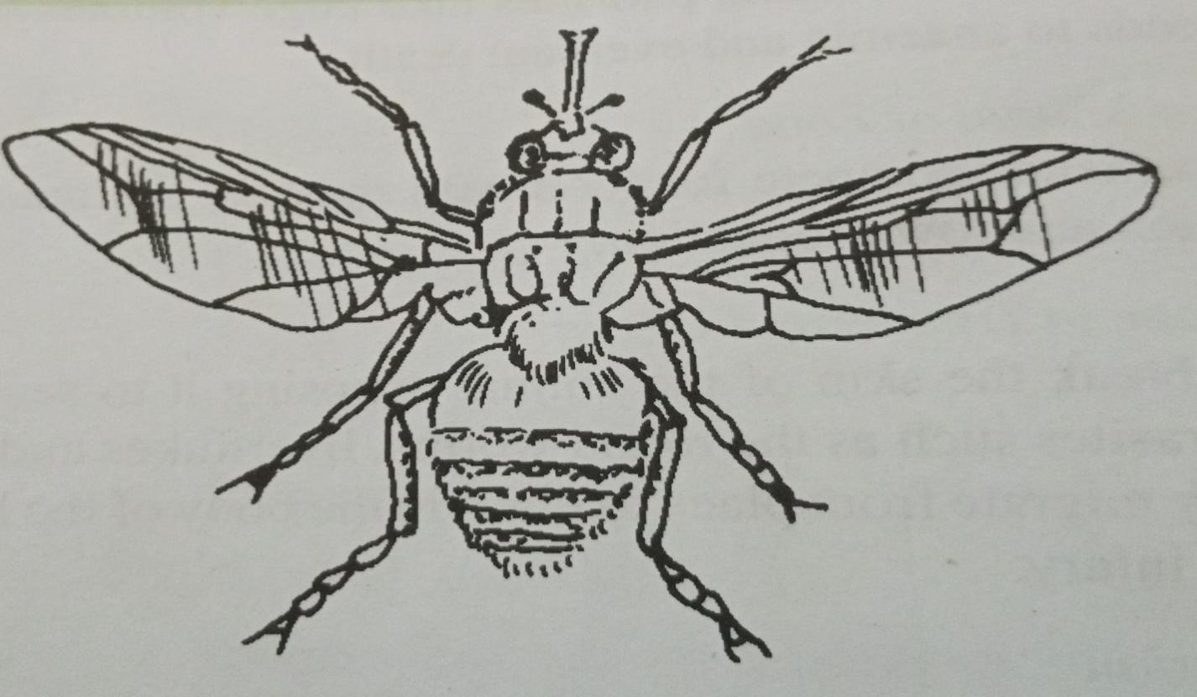

a) Identify the parasite above. (1mk)
………………………………………………………………………………………………

b) State any two harmful effects of the parasite above. (2mks)
………………………………………………………………………………………………………………………………………………………………………………………………

c) State any two control measures for the parasite above. (2mks)
………………………………………………………………………………………………………………………………………………………………………………………………

22. The diagram below shows a routine practice being carried out on an animal. Study it and answer the question that follows.
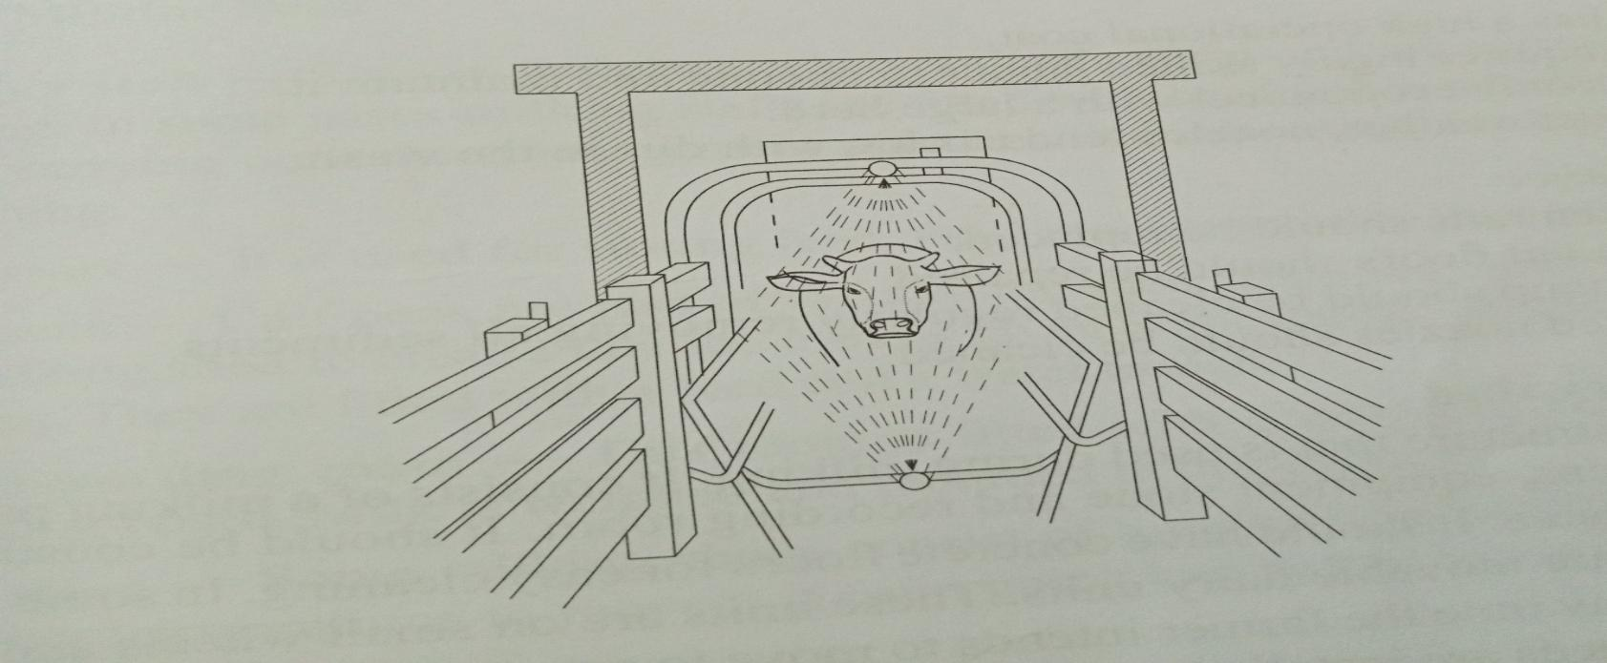
a) Identify the practice. (1mk)
…………………………………………………………………………………………………
b) Name the structure in which the practice is being carried out. (1mk)
…………………………………………………………………………………………………
c) State three advantages of using the above structure instead of a plunge dip. (3mks)
………………………………………………………………………………………………………………………………………………………………………………………………………………………………………………………………………………………………………
…………………………………………………………………………………………………

23. Below is a diagram of a cow suffering from a deficiency disease. Study it and answer the questions that follow.
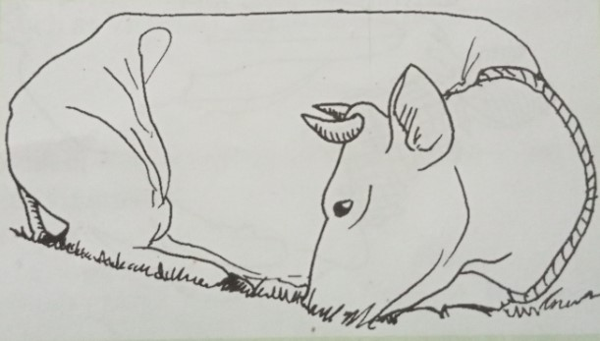
a) Identify the disease the animal is suffering from. (1mk)
……………………………………………………………………………………………

- State the cause of the disease. (1mk)
…………………………………………………………………………………………………………………………………………………………………………………………

- List any three symptoms of the above disease. (3mks)
………………………………………………………………………………………………………………………………………………………………………………………… ……………………………………………………………………………………………
4. The diagram below represents farm tools and equipment. Study and answer the questions that follow.
B
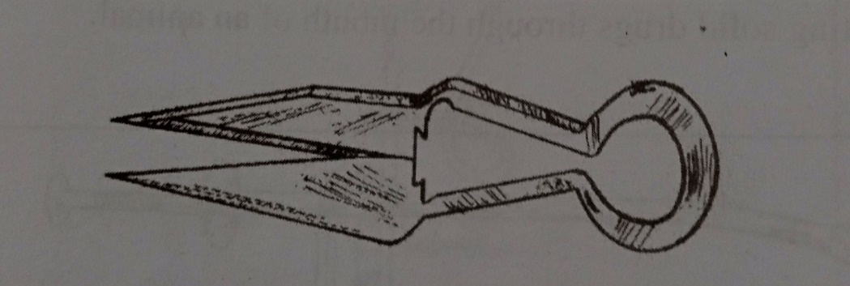
A
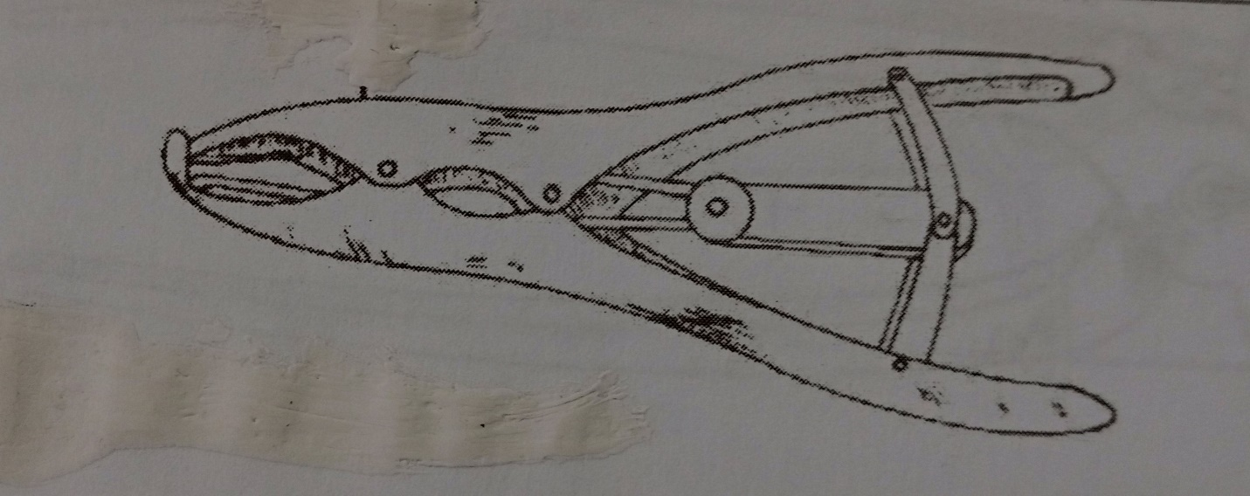
- Identify the tools labeled A, and B. (2mks) A:………………………………………………………………………………………
B………………………………………………………………………………………

- State one use of each of the tools labeled A and B. (2mks)
A:……………………………………………………………………………………………

B:……………………………………………………………………………………………
- State one maintenance practice for the tool labeled A. (1mk)
……………………………………………………………………………………………………………………………………………………………………………………

SECTION C (40 MARKS)
Answer any two questions in this section in the spaces provided

25.a) Discuss New castle disease under the following sub headings.
(i) Causal organism. (1mk)
(ii) Animals attacked. (1mk)
(iii) Symptoms of attack. (5mks)
(iv) Control measures. (3mks)

b) Outline the characteristics of indigenous cattle breeds. (5mks)
c) Describe five microbial activities that take place in the rumen of ruminant
animals. (5mks)

26.a) State and explain any five predisposing factors of livestock diseases. (10mks)
b) Describe the procedure of constructing a barbed wire fence. (5mks)
c) Outline any five general functions of vitamins in livestock. (5mks)

27.a) Discuss any five essentials of clean milk production. (10mks)
b) Describe the process of egg formation in the reproductive system of a hen. (10mks)



ALLIANCE GIRLS 2025 PREDICTION
POSSIBLE KCSE EXAM
565/1
BUSINESS STUDIES
PAPER 1
TIME: 2 HOURS

NAME……………………………………………………………………………………….
SCHOOL……………………………………………… SIGN………………………..
INDEX NO……………………………………………. ADM NO……………………

Kenya Certificate of Secondary Education.
INSTRUCTIONS
- Write your NAME, SCHOOL and INDEX NUMBER in the spaces provided.
- Answer ALL questions provided in the spaces provided.
- This paper consists of 10 printed pages and 25 questions.

FOR EXAMINERS USE ONLY
Question | 1 | 2 | 3 | 4 | 5 | 6 | 7 | 8 | 9 | 10 | 11 | 12 | 14 | 15 | 16
MARKS
17 | 18 | 19 | 20 | 21 | 22 | 23 | 24 | 25 | TOTAL

Answer ALL questions provided in the spaces provided
1. Outline three reasons why cash payment would be preferred to cheque payment. (3 marks)
…………………………………………………………………………………………………………
…………………………………………………………………………………………………………
…………………………………………………………………………………………………………
…………………………………………………………………………………………………………

2. State four reasons why a farmer would prefer to transport a herd of cattle by rail rather than by road. (4 marks)
…………………………………………………………………………………………………………
…………………………………………………………………………………………………………
…………………………………………………………………………………………………………
…………………………………………………………………………………………………………
…………………………………………………………………………………………………………

3. State four advantages of using internet as a means of communication. (4 marks)
…………………………………………………………………………………………………………
…………………………………………………………………………………………………………
…………………………………………………………………………………………………………
…………………………………………………………………………………………………………

4. State four measures which the Kenyan government can take to solve the unemployment problem. (4 marks)
…………………………………………………………………………………………………………
…………………………………………………………………………………………………………
…………………………………………………………………………………………………………
…………………………………………………………………………………………………………

5. Highlight four roles played by an entrepreneur in the production process. (4 marks)
…………………………………………………………………………………………………………
…………………………………………………………………………………………………………
…………………………………………………………………………………………………………
…………………………………………………………………………………………………………

6. The diagram below shows a demand curve for a firm operating in a given type of market structure. (4 marks)

a
Price

Quantity
a) State the name which is given to such a demand curve. (1 marks)
...........................................................................................................................................
b) Indicate on the diagram the possible price and quantity. (2 marks)
...........................................................................................................................................
c) State the significant of the point labelled a. (1 mark)
........................................................................................................
7. State four advantages of using intermediaries in the distribution of goods. (4 marks)
…………………………………………………………………………………………………………
…………………………………………………………………………………………………………
…………………………………………………………………………………………………………
…………………………………………………………………………………………………………

8. Give four reasons facing cooperative societies. (4 marks)
…………………………………………………………………………………………………………
…………………………………………………………………………………………………………
…………………………………………………………………………………………………………
…………………………………………………………………………………………………………

9. State four advantages of franking machine. (4 marks)
…………………………………………………………………………………………………………
…………………………………………………………………………………………………………
…………………………………………………………………………………………………………
…………………………………………………………………………………………………………

10. The following information was extracted from the books of Venus traders.
Rate of turnover. 3 times
Mark-up. 20%
Opening stock. Sh 160,000
Closing stock. Sh 200,000
Required
i) Gross profit. (2 marks)
…………………………………………………………………………………………………………
…………………………………………………………………………………………………………
…………………………………………………………………………………………………………

ii) Sales. (2 marks)
…………………………………………………………………………………………………………
…………………………………………………………………………………………………………
…………………………………………………………………………………………………………
11. Outline four factors that may hinder occupational mobility of labour. (4 marks)
…………………………………………………………………………………………………………
…………………………………………………………………………………………………………
…………………………………………………………………………………………………………
…………………………………………………………………………………………………………

12. The following relate to Furaha Traders for the year 2020
i) Closing capital (31.12.2020) sh 300,000
ii) The owner converted his personal computer valued at sh 35,000 into business use.
iii) The owner had withdrawn goods worth sh 40,000 for personal use.
iv) Incurred losses amounting to sh 65,000
Determine Furaha Traders intial capital on(1.01.2006). (4 marks)

13. For each of the following books of original entry, indicate the source document: (4 mks)
Journal | Source document
Purchase journal
Sales day book
Petty cash book
General journal
14. Highlight four measures that a government may take to reduce the mortality rate in a
country. (4 marks)
…………………………………………………………………………………………………………
…………………………………………………………………………………………………………
…………………………………………………………………………………………………………
…………………………………………………………………………………………………………

15. The following balances were extracted from the books of Mavuno Traders for the year ended 31st march 2021.
Gross profit. 186,200
Discount allowed. 7,400
Carriage outwards. 13,500
Rent received. 34,300
Office expenses. 19,600
Salaries. 57,000
Prepare a profit and loss for the ended 31st march 2021. (5 marks)

16. State four factors that determine the amount of money held for transaction motive. (4 marks)
…………………………………………………………………………………………………………
…………………………………………………………………………………………………………
…………………………………………………………………………………………………………
…………………………………………………………………………………………………………

17. State four objectives of product promotion. (4 marks)
…………………………………………………………………………………………………………
…………………………………………………………………………………………………………
…………………………………………………………………………………………………………
…………………………………………………………………………………………………………

18. Highlight four difficulties faced in satisfaction of human wants. (4 marks)
…………………………………………………………………………………………………………
…………………………………………………………………………………………………………
…………………………………………………………………………………………………………
…………………………………………………………………………………………………………

19.Highlight four factors under economic environment that positively affects the business.(4marks)
…………………………………………………………………………………………………………
…………………………………………………………………………………………………………
…………………………………………………………………………………………………………
…………………………………………………………………………………………………………

20. Outline any four measures that a firm should take to improve the performance of its labour force. (4 marks)
…………………………………………………………………………………………………………
…………………………………………………………………………………………………………
…………………………………………………………………………………………………………
…………………………………………………………………………………………………………
…………………………………………………………………………………………………………
21. List four reasons why distributors of goods would prefer to locate warehouse near it customers. (4 marks)
…………………………………………………………………………………………………………
…………………………………………………………………………………………………………
…………………………………………………………………………………………………………
…………………………………………………………………………………………………………

22. Highlight four benefits of globalisation to business enterprise. (4 marks)
…………………………………………………………………………………………………………
…………………………………………………………………………………………………………
…………………………………………………………………………………………………………
…………………………………………………………………………………………………………

23. Kazi moto insured a motor vehicle against fire with MotoMoto company by paying Kshs.300.000. later the car was destroyed at a garage and a compensation of Kshs. 4,000 were paid. Using insurance terms, state what each of the following stand for; (4 marks)
a) Kazi Moto
........................................................................................................................................
b) Fire
.......................................................................................................................................

c) Kshs 300,000
........................................................................................................................................

d) Moto Moto Company
........................................................................................................................................

24. State four responsibilities of a business to its customers. (4 marks)
…………………………………………………………………………………………………………
…………………………………………………………………………………………………………
…………………………………………………………………………………………………………
…………………………………………………………………………………………………………
25. Show the effect of each of the following transaction to capital, assets and liabilities
indicating if its increasing(+), decreasing(-) or nil (0). (4 marks)
Transaction | Capital | Asset | Liability
a) Converted private house into business premises
b) Paid creditors in cash
c) Sold a business car valued at sh 400,000 for sh 300,000 on credit
d) Sold goods on credit



ALLIANCE GIRLS 2025 PREDICTION
POSSIBLE KCSE EXAM
565/2
BUSINESS STUDIES
PAPER 2
TIME: 2½ HOURS

NAME……………………………………………………………………………………….
SCHOOL……………………………………………… SIGN………………………..
INDEX NO……………………………………………. ADM NO……………………

Kenya Certificate of Secondary Education.

INSTRUCTIONS
- Write your NAME, SCHOOL and INDEX NUMBER in the spaces provided.
- Answer ANY FIVE questions provided in the spaces provided.
- This paper consists of 6 questions

FOR EXAMINERS USE ONLY
Questions | 1 | 2 | 3 | 4 | 5 | 6
Mark
TOTAL

1. (a) Explain five factors that may lead to the success of a business enterprise.(10 marks)
(b) Spain and France are developed countries in Europe. Discuss five problems of using
national income statistics to compare the living standards of their citizens.(10 marks)
2. (a) Explain five principles that would lead to effective operation of Jubilee insurance
company. (10 marks)
(b) Explain five attributes of a good money material. (10 marks)
3. (a) Explain five differences of a public Limited company and a partnership.(10 marks)
(b) Explain five characteristics of economic resources. (10 marks)
4. (a) Describe five documents required to register a public limited company.(10 marks)
(b) On 1st June 2018, the following balances were in the books of Semenya Traders.
Cash sh 15,000 Bank CR 40,000
The following transactions occurred during the month.
Date 4 Omenga a debtor settled his account of sh 10,000 by a cheque of sh 8,000.
7 Deposited sh 4,000 into the business Bank account from the cash till
8 Paid rent by cash sh 4,000
14 Cash sales sh 14,000
17 Purchased furniture worth sh 3,000 paying by cheque
18 Settled Maina’s account of sh 10,000 after being allowed a discount of 5% by
cash
20 Received sh 6,000 cash from Nyori a debtor.
22 Kemboi a debtor settled his account of sh 4,000 by cheque having been allowed
a discount of 2%.
25 Deposited sh 17,000 into the bank from private sources.
30 Banked all the cash.

Required
Prepare a three column cash book duly balanced.
5. (a) Kenya Power is a monopoly in Power distribution in Kenya. Explain five sources from
which it could have received its power. (10 marks)
(b) Explain five features of a good filing system. (10 marks)

6. (a) Advertising in the Newspapers is one way of promoting sales of goods. Highlight five limitations of advertising goods in Newspapers. (10 marks)

(b) The following trial balance relates to Kangogo traders as at 30th June 2018
Particular Dr Cr
Stock 1st July 2017 450,000
Purchases 800,000
Sales 1,200,000
Carriage Outwards 10,000
Carriage Inwards 5,000
Returns 30,000 20,000
Sundry Expenses 100,000
Transport 20,000
Stock 30th June 2018 550,000
Capital 745,000
_________ ________
1,965,000 1,965,00
Required:
Calculate;
(i) Rate of stock turnover (3 marks)
(ii) Rate of return on capital (2 marks)
(iii) Markup (2 marks)
(iv) Turnover (1 mark)
(v) Margin (2 marks)



ALLIANCE GIRLS 2025 PREDICTION
POSSIBLE KCSE EXAM
101/1
ENGLISH
Functional Skills
PAPER 1
TIME: 2 HOURS

NAME……………………………………………………………………………………….
SCHOOL……………………………………………… SIGN………………………..
INDEX NO……………………………………………. ADM NO……………………

Kenya Certificate of Secondary Education.
Instructions to candidates
- Write your name and index number in the spaces provided.
- Sign and write the date of the examination.
- Answer all the questions in this question paper
- All your answers must be written in the spaces provided.
- Candidates should answer all the questions in English.

QUESTIONS | MAXIMUM SCORE | CANDIDATE’S SCORE
1 | 20
2 | 10
3 | 30
TOTAL

- FUNCTIONAL SKILLS (20MKS)
This year your country experienced a severe famine caused by drought. A commission was set up to investigate ways of preventing a similar calamity in future. As secretary to the commission write the report.
……………………………………………………………………………………………………………………………………………………………………………………………………………………………………………………………………………………………………………………………………………………………………………………………………………………………………………………………………………………………………………………………………………………………………………………………………………………………………………………………………………………………………………………………………………………………………………………………………………………………………………………………………………………………………………………………………………………………………………………………………………………………………………………………………………………………………………………………………………………………………………………………………………………………………………………………………………………………………………………………………………………………………………………………………………………………………………………………………………………………………………………………………………………………………………………………………………………………………………………………………………………………………………………………………………………………………………………………………………………………………………………………………………………………………………………………………………………………………………………………………………………………………………………………………………………………………………………………………………………………………………………………………………………………………………………………………………………………………………………………………………………………………………………………………………………………………………………………………………………………………………………………………………………………………………………………………………………………………………………………………………………………………………………………………………………………………………………………………………………………………………………………………………………
………………………………………………………………………………………………………………………………………………………………………………………………………………………………………………………………………………………………………………………………………………………………………………………………………………………………………………………………………………………………………………………………………………………………………………………………………………………………………………………………………………………………………………………………………………………………………………………………………………………………………………………………………………………………………………………………………………………………………………………………………………………………………………………………………………………………………………………………………………………………………………………………………………………………………………………………………………………………………………………………………………………………………………………………………………………………………………………………………………………………………………………………………………………………………………………………………………………………………………………………………………………………………………………………………………………………………………………………………………………………………………………………………………………………………………………………………………………………………………………………………………………………………………………………………………………………………………………………………………………………………………………………………………………………………………………………………………………………………………………………………………………………………………………………………………………………………………………………………………………………………………………………………………………………………………………………………………………………………………………………………………………………………………………………………………………………………………………………………………………………………………………………………………………………………………………………………………………………………………………………

- CLOZE TEST (10MKS)
Imagine that while walking along a road, you saw a large shiny bag sitting ………………….. (1) , unattended. You look around and there is no one else…………………..(2) would you do? Would you walk…………………….(3) from the bag as most cautious people would? Maybe your curiosity would get the …………………(4) of your caution and the urge to know what the ……………………….of the bag are might overwhelm you. If you looked into the bag and found it full of crisp new ……………………………..(6) , would you make attempts to find……………………….(7) owner of the bag? Might you be tempted to keep the money ……………………….(8)yourself? After all, there is always so much in our lives that we can buy or pay for. ………………………………..(9) you choose to keep the bag, would you do so with a ………………………………..(10) conscience, or would you forever be plagued by the idea that you kept money, which was not yours?
- ORAL SKILLS: (30 MARKS)
- Read the oral poem below and then answer the questions that follow: (5 marks)
He couldn’t wait, eh!
For the child of my mother
To finish school
He begged, eh!
That man begged
He begged and begged

He couldn’t wait, eh!
For the child of my mother
To dress up
Questions.
- What makes this oral poem rhythmic? (2mks)
………………………………………………………………………………………………………
………………………………………………………………………………………………………

- Which word are you likely to stress in the second line of the first and last stanzas and why? (2mks)
………………………………………………………………………………………………………
………………………………………………………………………………………………………
- How would you say the last line of the poem? (1mk)
…………………………………………………………………………………………………………………………………………………………………………………….
- Identify the word with the odd underlined sound from the following sets of
words. (5 marks)

(i) Pooh poop pool poor ……………………….
(ii) Tortoise boy join ploy ……………………….
(iii) Scuttle scythe scullery sculpture ……………………….
(iv) Gingivitis gigolo gist gender ……………………….
(v) Cannibal caesura calcium cachet

- Provide another word that is pronounced the same as the following words (3 marks)

(i) Not ………………………………………………….
(ii) Pain ………………………………………………….
(iii) key ………………………………………………….
- Study the genre below and answer the questions that follow. (6 marks)
The short child shot a shot of his short white wash.
(i) Classify the genre. (2 marks)
………………………………………………………………………………………
………………………………………………………………………………………
(ii) Identify any sound pattern used in the genre above. (2 marks)
………………………………………………………………………………………
………………………………………………………………………………………
(iii) State two functions of the genre above. (2 marks)
………………………………………………………………………………………………………
………………………………………………………………………………………………………
………………………………………………………………………………………………………

- (i) You are invited as a motivational speaker to give a talk to a group of people. State
three factors about the audience that you must consider before giving the
speech. (3 marks)
………………………………………………………………………………………………………………………………………………………………………………………………………………………………………………………………………………………………
(ii) State three factors the listener ought to observe in order to gain from the
speech (3 marks)
………………………………………………………………………………………………………………………………………………………………………………………………………………………………………………………………………………

iii) Two friends, Wepukhulu and Khaseve have a debate. Wepukhulu strongly feels that
a man should marry more than one wife. Khaseve on the other hand argues that a man should only marry one wife. Advise them on five things they should do in order to disagree in an agreeable manner so that their conversation does not degenerate into a quarrel. (5 marks)



ALLIANCE GIRLS 2025 PREDICTION
POSSIBLE KCSE EXAM
101/2
ENGLISH
PAPER 2
TIME: 2½ HOURS

NAME……………………………………………………………………………………….
SCHOOL……………………………………………… SIGN………………………..
INDEX NO……………………………………………. ADM NO……………………

Kenya Certificate of Secondary Education.

INSTRUCTIONS TO CANDIDATES
- Write your details in the spaces provided above.
- Answer all the questions in this paper.
- Answer the questions in English
EXAMINER’S USE ONLY
QUESTION | MARKS | CANDIDATE’S SCORE
1 | 20
2 | 25
3 | 20
4 | 20
5 | 15
TOTAL | 100

- COMPREHENSION
Read the passage below and answer the questions that follow
The process of developing social skills among children at an early age is important. Researchers have cited rejection by peers as the greatest challenge children face in their quest to build meaningful social skills. It has been reported that children who get bullied and snubbed by peers are more likely to have problems in relating with others. In recent times, researchers have found at least three factors in a child’s behaviour that can lead to social rejection. The factors involve a child’s inability to pick up on and respond to nonverbal cues from their pals. In the United states 10 to 13 percent of school-going children experience some form of rejection by their peers. In addition to causing mental health problems, bullying and social isolation can increase the likelihood of a child getting poor grades, dropping out of school,, or developing substance abuse problems.

It is reported that the social skills that children gain on the playground or elsewhere could show up later in life, according to Richard Lavoie, an expert in child social behaviour. He says that children experiment with the relationship styles they will have as adults during unstructured playtime-when children interact without the guidance of an authority figure. Researchers say that the number-one need of any human is to be liked by other humans. However, researchers have expressed concern that our children are like strangers in their own land. They don’t understand the basic rules of social behaviour and their mistakes are usually unintentional.

Children who face rejection may have problems in at least one of three different areas of nonverbal communication, which is the reason they are rejected. These are reading nonverbal cues; understanding their social meaning; and coming up with options for resolving a social conflict. A child, for example, simply my not notice a person’s scowl of impatience or understand what a tapped foot means. In another situation, a child may have trouble reconciling the desires of a friend with her own. Anyone trying to help children on their social skills should try to pinpoint the weaknesses a child has and then build those up.

When children have prolonged struggles with socializing, “a vicious cycle begins,” children who are shunned by others have few opportunities to practice social skills whereas popular children have more than enough opportunities to perfect theirs. However, having just one or two friends can be enough to give a child the social practice he or she need.
Parents, teachers and other adults in a child’s life can help, too. Instead of reacting with anger or embarrassment to a child who, say, asks Aunt Vera if her new hairdo was a mistake, parents should teach social skills with the same tone they use for teaching numeracy skills or proper hygiene.If presented as a learning opportunity, rather than a punishment, children usually appreciate the lesson. It is important to note that most children are so desperate to have friends that they just jump on board.

To teach social skills, Lavoie advises a five-step approach in his book. The process works for children with or without learning disabilities and is best conducted immediately after a wrongdoing has been made. First, ask the child what happened and listen without judgment. Second, ask the child to identify their mistake. Often children only know that someone got upset, but don’t understand their own role in the outcome. Third, help the child identify the cue they missed or mistake they made, by asking something like: “How would you feel if Emma was hogging the tyre swing?” Instead of lecturing with the word “should,” offer options the child “could” have taken in the moment, such as “You could have asked Emma to join you or told her you would give her the swing after your turn. “Fourth, you can create an imaginary but similar scenario where the child can make the right choice. For example, you could say, “If you were playing with a shovel in the sand box and Aiden wanted to use it, what would you do?” Lastly, give the child” social homework” by asking him to practice this new skill, saying: “Now that you know the importance of sharing, I want to hear about something you share tomorrow.”
(Adapted from livescience.com-Tue Feb 2, 2010)
Questions
- In one sentence, explain what this passage is talking about? (2mks)
………………………………………………………………………………………………………………………………………………………………………………………………………………………………………………………………………………………………………………………………………………………………………………………………………………………………
- What is the number one need of any human being? (1mk)
……………………………………………………………………………………………………………………………………………………………………………………………………………………………………………………………………………………
- What are cited as the causes for social rejection according to the passage (2mks)
………………………………………………………………………………………………………………………………………………………………………………………………………………………………………………………………………………………………………………………………………………………………………………………………………………………………
- What is social rejection likely to lead to (2mks)
………………………………………………………………………………………………………………………………………………………………………………………………………………………………………………………………………………………………………………………………………………………………………………………………………………………………

- What vicious cycle is referred to in this passage (2mks)
………………………………………………………………………………………………………………………………………………………………………………………………………………………………………………………………………………………………………………………………………………………………………………………………………………………………
- How can a parent make children appreciate the lesson on social skills? (2mks)
………………………………………………………………………………………………………………………………………………………………………………………………………………………………………………………………………………………………………………………………………………………………………………………………………………………………
- “How would you feel if Emma was hogging the tyre swing?” Re-write in reported speech.
(1mk)
……………………………………………………………………………………………………………………………………………………………………………………………………………………………………………………………………………………
- Make notes on the five-step approach to teach children social skills (5mks)
………………………………………………………………………………………………………………………………………………………………………………………………………………………………………………………………………………………………………………………………………………………………………………………………………………………………………………………………………………………………………………………………………………………………………………………………………………………………………………………………………………………………………………………………………………………………………………………………………………………………………………………………………………………………………………………………………………………………………………………………………………………………………………………………………………

- Explain the meanings of the following words and phrases as used in the passage (3mks)
- Authority figure
……………………………………………………………………………………………………………………………………
- Shunned
……………………………………………………………………………………………………………………………………
- Jump on board
…………………………………………………………………………………………………………………………………
- Read the excerpt below and answer the questions that follow (25mks)
John Lara; The Samaritan
Read the excerpt below and then answer the questions that follow. (25 marks)
Mossi: Municipal fund? How?
Seymour: We just need to do some reallocation of budget line items.
Ted: I agree. We must set aside some money to take care of investigators, lawyers, prosecutors and judges if things go wrong.
Seymour: You see, the waste disposal system in our town is in a terrible state. There is garbage all over the place and the drains are broken. As we speak, it is a serious health hazard. We can justify reallocation of funds on the need to address this problem. In reality, we will use some of the funds to fight off cases that are without a doubt coming.
Mossi: (Surprised and in disbelief) What?
Seymour: Yes, we have to get money to fight the cases. And enough of it, I dare say!
Mossi: But that will only get us deeper into problems!
Seymour: Yes, it will; but we will be the better armed to deal with the trouble and even more of it.
Mossi: Over my dead body! What you are suggesting is illegal? The law is very clear. A Municipal Council cannot spend any money at any time of a financial year except as provided in the national estimates, and as contained in an Appropriation Act approved by Parliament.
Ted: (Looking at Mayor Mossi in disbelief) What do you mean? You would rather we are prosecuted and imprisoned?
Seymour: In that case, we can submit a supplementary estimate of expenditure. That is allowed under the law.
Mossi: So long as that money will be committed to other uses, I will be blamed for the misallocation. It will get me into more trouble!
Seymour: You will be in a position to deal with the trouble. Can’t you understand? You will have the money!
Mossi: (Pointing at Seymour and Ted) Look here, my good friends, you have in the past forced my hand into misallocating funds by making unreasonable demands.
Seymour: Which demands?
Mossi: You cannot deny that you have forced me to concede to endless demands ranging from regular travel with enhanced allowances for members of the Municipal Council, sitting allowances of unnecessary committee meetings, to loans and mortgages. It is as though all the money allocated to the Municipality is exclusively meant for Council Members!
Seymour: Don’t start pontificating! You will never get away with the crimes committed under your watch if things get out hand! And you also know how much you have stolen! So you better be wise! Let’s do a supplementary estimate.
Mossi: (Hand raised and wagging his finger pointing at Seymour in anger) I know you very well. I know those things you deal with! If you are not careful, I will have you arrested and prosecuted! I can make you see real smoke! And I can strike harder than thunder!

- Where does this conversation take place and what happens before it? (3 marks)
…………………………………………………………………………………………………………
…………………………………………………………………………………………………………
…………………………………………………………………………………………………………
…………………………………………………………………………………………………………

- Basing on the events that happen earlier in the play, explain the cause of the conflict in this excerpt (3 marks)
…………………………………………………………………………………………………………
…………………………………………………………………………………………………………
…………………………………………………………………………………………………………
…………………………………………………………………………………………………………

- Identify and illustrate one theme brought out in the excerpt. (2 marks)
…………………………………………………………………………………………………………
…………………………………………………………………………………………………………
…………………………………………………………………………………………………………

- How is Seymour portrayed in the excerpt? Illustrate your answer. (4 marks)
…………………………………………………………………………………………………………
…………………………………………………………………………………………………………
…………………………………………………………………………………………………………
…………………………………………………………………………………………………………
…………………………………………………………………………………………………………

- “If you are not careful, I will have you arrested and prosecuted!” From your knowledge of the play, state any three accusations for which Seymour can be arrested and prosecuted. (3 mks)
…………………………………………………………………………………………………………
…………………………………………………………………………………………………………
…………………………………………………………………………………………………………
…………………………………………………………………………………………………………

- Explain the effect of any two stylistic features used in this excerpt. (4 marks)
…………………………………………………………………………………………………………
…………………………………………………………………………………………………………
…………………………………………………………………………………………………………
…………………………………………………………………………………………………………
…………………………………………………………………………………………………………

- What is the mood of this excerpt? (2 marks)
…………………………………………………………………………………………………………
…………………………………………………………………………………………………………
…………………………………………………………………………………………………………

- “We just need to do some reallocation of budget line items.” Begin: What…. (1 mark)
…………………………………………………………………………………………………………
…………………………………………………………………………………………………………

- Explain the meaning of the following expressions as used in the excerpt. (3 marks)
(i) fight off …………………………………………………………………………
(ii) concede …………………………………………………………………………
(iii) pontificating ……………………………………………………………………

- Read the following narrative then answer the questions that follow (20mks)
Once upon a time Hare and Hyena were very good friends. They visited each other every day and herded their cows together.
There came a time when the cows started dying one after the other. The two friends wanted to find out why the cows were dying. Hare said, ‘Let us go and kill our mothers and take out their livers. We shall then cook and taste these livers. The bitter liver will show whose mother was making the cows die. At once Hyena went and killed his mother. He took out the liver and cooked it. Hare went and hid his mother in the garden in bushy banana plants. He then went and killed an antelope, took out its liver and cooked it.

The two friends met to eat their livers. “My liver is very bitter”, said the Hyena. “Mine is very sweet,” said Hare, “So it was your mother who was making the cows die.” Hyena kept quiet and went home feeling sad. He moved from the old house to a smaller one because now he had no mother. Hare did the same

After a short time, there was great famine in the land. The two friends decided that each of them was to look for food on alternate days sharing, on an equal basis what was available. When it was Hyena’s turn, he went and found only honeycombs without any honey. When Hyenabrought these, Hare refused this because he had secretly gone to his mother who had given him some bananas. This went on for many days, and Hyena grew thinner and thinner. Then he started wondering. “How does my friend remain fat and he doesn’t eat anything. I will find out.”

One day he followed Hare. Hare went to his mother as usual. ‘Mother, mother, I have come’ and the mother dropped some bananas which Hare ate quickly. He then looked for some honeycombs and took them to the friend. “This is all I could find my friend.” The Hyena kept quiet. The next day he went to the banana plant and called. His voice however was very deep and no bananas were dropped for him.
There was an old hyenawho was staying at the end of the forest and used to give advice to people. So Hare’s friend went to her and told her his problem. “Go and put your tongue on the path of black ants,” He was told, “Let them bite your tongue until it hurts. That’s how your voice will be soft.”

Hyena went and did as he was told. When he went to Hare’s mother his voice was as soft as Hare’s. “Mother, mother I have come.” And Hare’s mother dropped bananas for his him. Then he told her to come and greet him. When she came down and saw it was Hyena she screamed but there was nobody near to help. Hyena killed her immediately.

Hyena went and met Hare as usual saying nothing about Hare’s mother. The following day it was Hare’s. “Mother, mother I have come.’ And Hare’s mother dropped bananas for his him. Then he told her to come and greet him. When she came down and saw it was Hyena she screamed but there was nobody near to help. Hyena killed her immediately.

Hyena went and met Hare as usual saying nothing about Hare’s mother. The following day it was Hare’s turn. He went to his usual place. “Mother” he called again. He climbed up. There was nobody. Having seen some blood on the ground, Hare knew what had happened to his mother.

When Hare got back to Hyena’s house, he said nothing. At night, Hare took all cows including Hyena’s and went away to live in another part of the country. That ended the Hare and Hyena’s friendship. And that is the end of my story to you.

Questions
- With illustrations, classify the above narrative (2mks)
………………………………………………………………………………………………………………………………………………………………………………………………………………………………………………………………………………………………………………………

- Identify three features of narratives (3mks)
………………………………………………………………………………………………………………………………………………………………………………………………………………………………………………………………………………………………………………………………………………………………………………………………………………………………

- Identify three features in this story that are characteristics of oral narratives (3mks)
………………………………………………………………………………………………………………………………………………………………………………………………………………………………………………………………………………………………………………………

- Briefly explain the character traits of the following (4mks)
- Hare
……………………………………………………………………………………………………………………………………
- Hyena
……………………………………………………………………………………………………………………………………
- What moral lesson do you learn from this story? (2mks)
………………………………………………………………………………………………………………………………………………………………………………………………………………………………………………………………………………………………………………………

- Identify two socio-economic activities from the community in which the narrative is taken from. (2mks)
………………………………………………………………………………………………………………………………………………………………………………………………………………………………………………………………………………………………………………………………………………………………………………………………………………………………

- You have been selected for a fieldwork research to collect the above item.
- Briefly explain two ways in which you would collect information on the item. (2mks)
…………………………………………………………………………………………………………………………………………………………………………………………………………………………………………………………………………………………………………………………………………………………………………………………………………

- Identify two challenges you might encounter during the field work and state how you would solve them. (2mks)
………………………………………………………………………………………………………………………………………………………………………………………………………………………………………………………………………………………………………

- Then he started wondering “How does my friend remain fat and he doesn’t eat anything. I will find out”. (Re-write into indirect speech) (1mk)
……………………………………………………………………………………………………………………………………………………………………………………………………………………………………………………………………………………

- Describe the irony in the fifth paragraph (2mks)
………………………………………………………………………………………………………………………………………………………………………………………………………………………………………………………………………………………………………………………………………………………………………………………………………………………………

- GRAMMAR (15MKS)
- Rewrite the following sentences according to the instructions given (3mks)
- He will not be given a driving license. He passes the road test (Rewrite as one using ‘unless’)
……………………………………………………………………………………………………………………………………………………………………………………………………

- The woman left the child with a neighbor and went to the market. (Begin: leaving….)
……………………………………………………………………………………………………………………………………………………………………………………………………

- The boys went to play in the field (underline the adverbial)

- Supply the correct preposition to complete the sentences given. (3mks)
- Property worth millions of shillings went up …………………….flames.
- The three boys shared the bread ……………………………..themselves.
- We should strive to live …………………………………our means.

- Use the correct form of the word in brackets to fill in the blank spaces in the sentences (3mks)
- The audience was offended by the ……………………….………..(sense) of the speaker.
- The ………………………………………..(acquire) of a university degree is a great milestone to a student.
- Everyone should obey the law ………………………………of their position in the society.

- Use the correct alternative to complete the sentences below (4mks)
- Teaching ……………………………………(practice/practice) is not an easy job for teacher-trainees.
- The prophet’s ……………………………….(prophesy/prophecy) was misleading to his audience.
- He …………………………………….((insured/ensured) his car with Madison.
- Mwita ………………………………..(hanged/hung) the chart on the wall.

- Write the following sentences in indirect speech (1mk)
“These are juicy mangoes,” Ken said.
……………………………………………………………………………………………………………………………………………………………………………………………………………………………………………………………………………………
- You do not require to cheat to pass (1mk)
(Supply a suitable question tag).
……………………………………………………………………………………………………………………………………………………………………………………………………………………………………………………………………………………



ALLIANCE GIRLS 2025 PREDICTION
POSSIBLE KCSE EXAM
101/3
ENGLISH
(Creative compositions and essays based on set texts)
PAPER 3
TIME: 2½ HOURS

NAME……………………………………………………………………………………….
SCHOOL……………………………………………… SIGN………………………..
INDEX NO……………………………………………. ADM NO……………………

Kenya Certificate of Secondary Education.

INSTRUCTIONS TO THE CANDIDATES:
- Answer three questions only.
- Question one and two are compulsory.
- In question three choose only one of the optional set text you have prepared on.
- Where a candidate presents work on more than one optional text. Only the first one to appear will be marked.
For Examiner’s Use Only:
QUESTION | MAXIMUM SCORE | CANDIDATE’S SCORE
1 | 20
2 | 20
3 | 20
TOTAL SCORE | 60

QUESTIONS
- IMAGINATIVE COMPOSITION (COMPULSORY) 20 marks
Either
a) Write a composition ending with the following words:
…………. since that day, I have always promised myself to remain focused in my studies.
Or
b) Write a composition explaining what Kenyan youths can do to help in the fight against alcohol and substance abuse.

2: Compulsory Text 20marks

Fathers of Nations by Paul B Vitta
Women are faced by endless difficulties in the society. Basing your arguments in the happenings in the text Fathers of Nations by Paul B Vitta write an essay to support this assertion.

3: Essay based on Optional Text (20 marks)
Answer any one question
Either
a) A Silent Song and Other Stories by Godwin Siundu
People who live in urban places are faced by many challenges. Prove how true this statement is basing your illustrations on Meja Mwangi’s Incident in the Park.
Or
b) Parliament of Owls by Adipo Sidang
“Many African governments are dysfunctional and end up mistreating their citizens.” Using appropriate examples from Adipo Sidang’s play Parliament of Owls, write an essay to illustrate this statement.
Or
c) Artist of the Floating World by Kazoo Ishiguro.
Ono’s past is greatly revealed through the marriage negotiations in the text. Justify the statement using illustrations from the novel Artist of the Floating World.



ALLIANCE GIRLS 2025 PREDICTION
POSSIBLE KCSE EXAM
102/1
KISWAHILI
INSHA
PAPER 1
TIME: 1¾ HOURS

NAME……………………………………………………………………………………….
SCHOOL……………………………………………… SIGN………………………..
INDEX NO……………………………………………. ADM NO……………………

Kenya Certificate of Secondary Education.
Maagizo
- Andika insha mbili.
- Insha ya kwanza ni ya lazima kisha chagua insha nyingine moja kati ya hizo tatu zilizobakia
- Kila insha isipungue maneno 400
- Kila insha ni alama 20
- Kila insha lazima iandikwe kwa lugha ya Kiswahili

KWA MATUMIZI YA MTAHINI PEKEE
Swali | Upeo | Alama
1 | 20
 | 20
Jumla | 40

1.lazima
1. Siku za hivi karibuni umesoma riwaya mpya iliyoandikwa na Msanifu Kombo inayoitwa : Afrika imelaaniwa. Andika tahakiki ya riwaya hii.

2.Hatua ya serikali kuu kumpa kila mwanafunzi wa darasa la kwanza tarakilishi ni manufaa sana. Jadili

3.Andika kisa kitakachodihirisha ukweli wa methali ifuatayo:
Ukiona cha mwenzako kikinyolewa na chako tia maji

4.Andika insha itakayomalizikia kwa kauli hii: Ama kweli sikufikiria wala kutegemea kuwa aushi yangu ingebadilika jinsi hiyo.



ALLIANCE GIRLS 2025 PREDICTION
POSSIBLE KCSE EXAM
102/2
KISWAHILI
LUGHA
PAPER 2
TIME: 2½ HOURS

NAME……………………………………………………………………………………….
SCHOOL……………………………………………… SIGN………………………..
INDEX NO……………………………………………. ADM NO……………………

Kenya Certificate of Secondary Education.
MAAGIZO KWA MTAHINIWA
Jibu maswali yote.
Majibu yote yaandikwe katika nafasi zilizoachwa katika kijitabu hiki cha maswali.
Karatasi hii ina kurasa nane. Watahiniwa ni lazima waangalie kama kurasa zote za karatasi hii zimepigwa chapa sawasawa na kuwa maswali yote yamo

KWA MATUMIZI YA MTAHINI PEKEE
SWALI | UPEO | ALAMA
1 | 15
2 | 15
3 | 40
4 | 10
JUMLA | 80
1.UFAHAMU (Alama 15)
Soma taarifa ifuatayo kisha ujibu maswali.
Mwanamke wa kisasa anazaliwa na kukulia katika mazingira yaliyobadilika mno. Matazamio yake maishani ni tofauti na yale ya wanawake walioishi mapote mawili yaliyopita; wanawake makamu ya nyanyake na mamake mkuu.

Yeye hutarajia kuzaliwa, kukua, kuolewa, kuwa mke wa bwana, kumzalia watoto na daima dawamu kuwa ‘mwendani wa jikoni’ akawapikia watoto na bwanake chakula; na akitoka jikoni aelekee shambani kulima, kichakani kuchanja kuni, mtoni kufua nguo na kuteka maji ya kutumia nyumbani. Mwanamke wa kisasa huandamana na mwanamume. Akanyagapo mume naye papo huutia wayo wake.

Mwanamke wa kisasa huenda shule na kujifunza yote yafunzwayo huko. Hushindana na wanawake kwa wanaume na kuibuka mshindi si mara haba. Huibuka mshindi katika masomo ya lugha, Historia, Jiografia, Hesabu, Sayansi na mengineyo, sawa na mwanamume.

Mwanamke wa kisasa hutaka kufanya kazi za kibega, akazifanya. Akataka kuwa mwalimu, akawa.Akataka kuwa daktari, akafanikiwa.Almuradi, siku hizi mwanamke hufanya kazi yoyote ile afanyayo mwanamume. Kuna wanawake marubani wa ndege, masonara, waashi, wahandisi, madereva wa magari, mawakili mahakimu, mawaziri wakuu na hata marais wa nchi Hakuna kazi isiyofanywa na mwanamke siku hizi.

Mwanamke wa kisasa hateswi akafyata ulimi. Anapohiniwa yeye hupigania haki yake kwa dhati na hamasa. Katu hakubali ‘mahali pake’ katika jamii alipotengewa na wanaume wenye mawazo ya kihafidhina yaliyopitwa na wakati.

Siku hizi mwanamke huolewa tu wakati amepata kazi ya kumwezesha kujikimu maishani au pale anapokuwa na hakika kwamba biashara yake iwapo ni mfanyi biashara, imepiga hatua ya kutomrudisha ukatani.

Mwanamke wa kisasa haamuliwi katika jambo, lolote, bali hufanya maamuzi yake mwenyewe. Kwa upande mwingine, mwanamume wa ‘kisasa’, ambaye bado amefungwa pingu na taasubi za kiume, hapendezwi na mwanamke huyu. Huuma kidole akatamani ya kale, lakini wapi! Analazimika kumkubali mwanamke huyu kama mshiriki sawa maishani, na kuishi naye, apende asipende. Shingo upande analazimika kukubali kwamba mabadiliko haya sio mithili ya kiwingu kipitacho, bali ni ya aushi.

Maswali
- i) Msemo ‘mwendani wa jikoni’ unadhihirisha hali gani ya mwanamke katika jamii?(al1)
………………………………………………………………………………………………………………………………………………………………………………………………………………
ii) Thibitisha hali uliyotaja hapo juu kwa kutoa hoja nne. (alama 2)
………………………………………………………………………………………………………………………………………………………………………………………………………………………………………………………………………………………………………………………………………………………………………………………………………………………………
- Mwandishi ana maana gani anaposema ‘akanyagapo mume naye papo huutia wayo wake’ (alama 1)
……………………………………………………………………………………………………………………………………………………………………………………………………
- Tofautisha mwanamke wa kiasili na wa kisasa ukizingatia maswala ya ndoa na elimu. (alama 4)
………………………………………………………………………………………………………………………………………………………………………………………………………………………………………………………………………………………………………………………………………………………………………………………………………………………………
- Eleza hoja sita zinazoonyesha kuwa wanaume wana ‘mawazo ya kihafidhina’ dhidi ya mwanamke. (alama3)
………………………………………………………………………………………………………………………………………………………………………………………………………………………………………………………………………………………………………………………………………………………………………………………………………………………………………………………………………………………………………………………………………………………………………………………………………………………………………………
- Fafanua athari zinazotokana na mabadiliko ya mwanamke wa kisasa katika jamii kulingana na mwandishi. (alama2)
…………………………………………………………………………………………………………………………………………………………………………………………………………………………………………………………………………………………………………………………………………………………………………………………………………………………………………
- Eleza maana ya maneno yafuatayo kama yalivyotumika katika taarifa. (alama 2)
- Ukatani
…………………………………………………………………………………………………..
- Aushi
…………………………………………………………………………………………………..

2. UFUPISHO (ALAMA 15)
Soma kifungu kifauatacho kisha ujibu maswali.
Mifuko ni muhimu sana katika maisha ya binadamu ya kila siku. Baadhi ya mifuko huundwa kwa namna ambayo inadumu na inaweza kutumiwa mara kadha wa kadha. Hii huweza kuhifadhiwa na kutumiwa kwa kipindi kirefu. Asilimia kubwa ya mifuko ya aina hii hutengenezwa kutokana na nguo au ngozi. Hata hivyo, ipo mifuko mingine ambayo si ya uashi, haidumu. Hii ni mifuko myepesi, rahisi kubebeka na inayopatikana kwa wingi sana. Hii ni mifuko ya plastiki.

Mifuko ya plastiki hupatikana katika maeneo mengi sana. Mifuko hii sio ghali inapolinganishwa na ile ya nguo au ya ngozi. Hii ni ya gharama ya chni na hupendwa kutokana na wepesi wake. Hata hivyo, mifuko hii inaweza kuwa chanzo cha matatizo mengi. Matatizo haya hutokana na linalopasa kufanywa kuhusu mifuko hii baada ya kutumiwa kwake. Mifuko ya nguo ambayo inatupwa kwenye jalala huishia kuoza na kuwa sehemu ya uchafu wa jalala hilo. Kwa upande wake, mifuko huo. Hata inapofukiwa arthini haiwezi kuoza hata kama kufukiwa huko ni kwa miaka mingi. Aidha hata pale inapochomwa, haiwezi kuteketea hadi kuwa jivu kama ilivyomifuko ya karatasi.

Upo umuhimu mkubwa wa kuwepo kwa sera madhaubuti za kupambana na tatizo la mifuko hii. lazima zitungwe sheria ambazo zinakabiliana na uchafuzi wa mazingira kwa njia hii. kwa njia hii hatari zianzowakabili watu na wanyama zitapunguzwa kwa kiasi kikubwa. Kwa hakika njia mojawapo ambayo ingeweza kutumiwa ni kuharamisha matumizi ya mifuko hii katika upakiaji. Sheria zinaweza kupitishwa ambazo zinahimiza matumizi ya mifuko mbadala kama ile ya karatasi kubebea vitu vidogo Fauka ya hayo, pana haja ya kuwazia kuwepo kwa njia nzuri kuteketezea mifuko hiyo. Inawezekana kuhimiza watumiaji kuirejesha mifuko hiyo mahali Fulani kwa ajili ya uteketezaji huo. Hata hivyo, hali hii huenda ikawa ngumu kwa kuwa inahitaji nidhamu ya hali ya juu sana kwa upand ewa watumiaji.

- Fupisha ujumbe wa aya tatu za mwanzo kwa maneno 105 – 110. (alama 10, 1 utiririko)
Matayarisho
………………………………………………………………………………………………………………………………………………………………………………………………………………………………………………………………………………………………………………………………………………………………………………………………………………………………………………………………………………………………………………………………………………………………………………………………………………………………………………………………………………………………………………………………………………………………………………………………………………………………………………………………………………………………………………………………………………………………………………………………………………………………………………………………………………………………………………………………………………………………………………………
………………………………………………………………………………………………………………………………………………………………………………………………………………

Nakala safi
………………………………………………………………………………………………………………………………………………………………………………………………………………………………………………………………………………………………………………………………………………………………………………………………………………………………
………………………………………………………………………………………………………………………………………………………………………………………………………………………………………………………………………………………………………………………………………………………………………………………………………………………………………………………………………………………………………………………………………
………………………………………………………………………………………………………………………………………………………………………………………………………………………………………………………………………………………………………………………

- Eleza mawazo makuu yanayojitokeza katika aya ya mwisho (maneno 50 – 55) (alama 5, 1 utiririko)
Matayarisho
………………………………………………………………………………………………………………………………………………………………………………………………………………………………………………………………………………………………………………………………………………………………………………………………………………………………………………………………………………………………………………………………………
………………………………………………………………………………………………………

Nakala safi
………………………………………………………………………………………………………………………………………………………………………………………………………………………………………………………………………………………………………………………………………………………………………………………………………………………………………………………………………………………………………………………………………
………………………………………………………………………………………………………………………………………………………………………………………………………………………………………………………………………………………………………

3. SARUFI NA MATUMIZI YA LUGHA (Alama 40)
- Taja sauti mbili zinazotamkiwa kwenye kaakaa laini (alama 1)
…………………………………………………………………………………………………
- Eleza tofauti za sentensi zifuatazo (alama 2)
- Amerudi shuleni!
…………………………………………………………………………………………………
- Amerudi shuleni.
…………………………………………………………………………………………………

- Tambua aina za maneno yaliyopigiwa mstari.
- Afisa mkuu anafuata sharia sembuse wewe. (alama 1)
……………………………………………………………………………………………………………………………………………………………………………………………………
- Ameenda huko mbali sokoni (alama 1)
……………………………………………………………………………………………………………………………………………………………………………………………………

- Tambua aina ya vihusishi katika sentensi zifuatazo
- Jumba alifuatalo li mbele ya msikiti wa Musa (alama 1)
………………………………………………………………………………………………………………………………………………………………………………………………………………………………
- Kisiwa cha Ginigi kimekauka (alama 1)
………………………………………………………………………………………………………………………………………………………………………………………………………………………………

- Tambua hali katika sentensi ifuatayo.
Vyungu vya aina hii vyafinyangwa na huyu. (alama 1)
………………………………………………………………………………………………………………………………………………………………………………………………………………

- Toa maana mbili za neno lifuatalo (alama 2)
Somo
……………………………………………………………………………………………………………………………………………………………………………………………………

- Kanusha
Mama alimwambia sipo alime haraka (alama 1)
…………………………………………………………………………………………………

Nyambua vitenzi vifuatavyo katika kauli zilizowekwa katika mabano

- Lia (Kutendeshwa) (alama 1)
…………………………………………………………………………………………………
- -Ja (Kutendea) (alama 1)
…………………………………………………………………………………………………

- Andika katika hali ya wastani umoja
Kigombe kile kiliumia kikwato (alama 2)
……………………………………………………………………………………………………………………………………………………………………………………………………

- Akifisha sentensi ifuatayo.
Je kuna manusura wowote yeye alitaka kujua. (alama 2)
……………………………………………………………………………………………………………………………………………………………………………………………………

- Eleza maana ya kirai (alama 1)
……………………………………………………………………………………………………………………………………………………………………………………………………

- Onyesha aina ya virai katika sentensi ifuatayo.
Nilimpata akilalama ndani ya darasa (alama 2)
……………………………………………………………………………………………………………………………………………………………………………………………………

- Andika sentensi ifuatayo katika usemi halisi.
Mwelekezi wake alimwambia kuwa angeweza kuwa mwindaji mashuhuri ikiwa angeyafuata mashauri yake. (alama 2)
……………………………………………………………………………………………………………………………………………………………………………………………………

- Changanua sentensi ifuatayo kwa kutumia mishale.
Mtoto mmoja aliyekuwa mgonjwa sana alitibiwa jana. (alama 4)
………………………………………………………………………………………………………………………………………………………………………………………………………………………………………………………………………………………………………………………………………………………………………………………………………………………………………………………………………………………………………………………………………
………………………………………………………………………………………………………………………………………………………………………………………………………………

- Andika sentensi hii upya bila kubadilisha maana ukitumia “o” rejeshi
Mwanafunzi alitumwa nyumbani juzi na hajapata karo hadi leo (alama 1)
………………………………………………………………………………………………………………………………………………………………………………………………………………

- Ainisha shamirisho na chagizo katika sentensi ifuatayo
Wachimba migodi wanafanya kazi haraka ipasavyo. (alama 2)
……………………………………………………………………………………………………………………………………………………………………………………………………

- Tumia kivumishi kimilikishi nafsi ya pili wingi katika sentensi (alama 2)
………………………………………………………………………………………………………………………………………………………………………………………………………………
………………………………………………………………………………………………………………………………………………………………………………………………………………
- Onyesha viambishi katika fungutenzi hili ( alama 2)
Sajilika
………………………………………………………………………………………………………………………………………………………………………………………………………………

- Eleza matumizi ya “na” katika sentensi ifuatayo. (alama 2)
Ndovu aliuawa na wawindaji haramu nami nikawaripoti
………………………………………………………………………………………………………………………………………………………………………………………………………………………………

- Unda nomino kutokana na vitenzi vifuatavyo ( alama 2)
- Takrimu
………………………………………………………………………………………………………
- Sakini
………………………………………………………………………………………………………

- Weka vitenzi hivi katika hali ya kuamrisha kulingana na maelezo katika mabano(alama 2)
- -nywa (umoja)
………………………………………………………………………………………………………

Tubu (wingi)
………………………………………………………………………………………………………

- Weka neno lifuatalo katika ngeli mwafaka (alama 1)
Nyasi
……………………………………………………………………………………………………………………………………………………………………………………………………………………

4. ISIMU JAMII (ALAMAMA 10)
Eleza sababu za vijana kutumia lugha ya sheng’ (alama 10)
………………………………………………………………………………………………………
………………………………………………………………………………………………………………………………………………………………………………………………………………
………………………………………………………………………………………………………
………………………………………………………………………………………………………………………………………………………………………………………………………………
………………………………………………………………………………………………………
………………………………………………………………………………………………………………………………………………………………………………………………………………
………………………………………………………………………………………………………
………………………………………………………………………………………………………………………………………………………………………………………………………………
………………………………………………………………………………………………………
………………………………………………………………………………………………………………………………………………………………………………………………………………
………………………………………………………………………………………………………
………………………………………………………………………………………………………………………………………………………………………………………………………………
………………………………………………………………………………………………………
………………………………………………………………………………………………………………………………………………………………………………………………………………
………………………………………………………………………………………………………
………………………………………………………………………………………………………………………………………………………………………………………………………………
………………………………………………………………………………………………………
………………………………………………………………………………………………………



ALLIANCE GIRLS 2025 PREDICTION
POSSIBLE KCSE EXAM
102/3
KISWAHILI
FASIHI
PAPER 3
TIME: 2½ HOURS

NAME……………………………………………………………………………………….
SCHOOL……………………………………………… SIGN………………………..
INDEX NO……………………………………………. ADM NO……………………

Kenya Certificate of Secondary Education.
MAAGIZO
- Jibu maswali manne pekee.
- Swali la kwanza ni la lazima.
- Maswali hayo mengine matatu yachaguliwe kutoka sehemunne zilizobaki – yaani Riwaya, Tamthilia, Ushairi na FasihiSimulizi..
- Usijibu maswali mawili kutoka sehemu moja.
- Kila Swali lina alama20

Kwa Matumizi ya Mtahini Pekee
1 | 2 | 3 | 4 | 5 | 6 | 7 | 8 | JUMLA

SEHEMU A
SEHEMU A:
FASIHI SIMULIZI
1. LAZIMA
Soma kifungu hiki kisha ujibu maswali
Lala mtoto lala*2
Mama atakuja lala
Alienda sokoni lala
Aje na ndizi lala
Na maziwa ya mtoto lala
Kukupa kwangu wewe kinofu
Kipenzi mwana lala*2

Lala mtoto lala*2
Basi kipenzi lala
Baba atakuja lala
Aje na mkate lala
Mkate wa mtoto lala
Tanona ja ndovu lala

Maswali
- Huku ukithibitisha jibu lako eleza huu ni wimbo wa aina gani? (alama 2)
- Eleza sifa za wimbo wa aina hii. (alama 5)
- Onyesha umuhimu wa wimbo huu. (alama 4)
- Eleza ni shughuli gani za kiuchumi ambazo jamii hii inajihusisha nayo katika wimbo huu. (alama2)
- Tambua mbinu zozote mbili za lugha zilizotumika katika wimbo huu. (alama 2)
- Fafanua changamoto tano ambazo mtafiti anaweza kumbana nazo akiwa nyanjani. (alama 5)

SEHEMU YA B:
RIWAYA- NGUU ZA JADI
Jibu swali la 2 au 3
2. Hivyo, alitaka kubadili hali hata kama ilimaanisha kukitia kichwa chake kinywani mwa simba. Alitaka kuliokoa jahazi lililokuwa likielekea mwambani kwa kasi. Lakini angeliweza vipi kupambana na utandu wa mahasidi hao?.
(a) Eleza mbinu nne za kimtindo zinazojitokeza katika dondoo hili (alama 4)
(b) Eleza sababu za msemaji kutaka kufaulisha kauli iloyopigiwa mstari (alama 10)
(c) Eleza umuhimu wa mrejelewa katika kuijenga riwaya hii (alama 6)
au
3. Dunia yote inajua aliyemsaliti Yesu Kristo. Unajua mtu huyo aliishia wapi?
  - Fafanua muktadha wa dondoo hili (alama 4)
  - Tambua mbinu mbili za kimtindo zinazojitokeza katika dondoo hili. (alama 4)
  - Fafanua namna wahusika walivyowaendea kinyume wenzao katika riwaya ya
Nguu za Jadi. (alama 12)
SEHEMU C: TAMTHILIA;
BEMBEA YA MAISHA – TIMOTHY M. AREGE
Jibu Swali la 4 au 5.
4. “Huku ndiko kuvumilia hasa. Tazama faraja ilivyoalika sasa”
a) Weka dondoo hili katika muktadha. (alama 4)
b) Eleza sifa za msemaji katika dondoo. (alama 6)
c) Onyesha jinsi faraja ilivyoalika katika maisha ya msemewa kwa kurejelea tamthilia ya: Bembea ya Maisha. (alama 10)
AU
5.(a) Changanua mtindo katika kifungu kifuatacho. (alama 10)
Maskini mke wangu! Kumbe ugonjwa haukumsaza mwaka baada ya mwaka. Umemla bila huruma. Awali niliona kama mchezo. Kumbe ilikuwa kweli! Kauli yake ninaona imesimama. Ni mwele hakika. Laiti ningejua, jana ningeishi tofauti. Silesi zetu za maisha tungezila zilivyokuja kwa furaha. (Kimya). Siku hazigandi wala jana hairudi. Sasa jana imebaki kuwa kumbukizi baada ya kusombwa na wakati mfano wa mafuriko msimu wa masika. (Kimya). Kwa bahati nzuri bado tupo. Ninaweza kuiachia dunia tabasamu iwe silesi kwa vizazi vijavyo na kila mwenye nia njema. (Kimya). Siwezi kuendelea kuishi hivi. Sasa nimekata shauri. Lazima niache njia ya zamani na kuifuata mpya. Maisha mapya. Pombe! (kama anayeisemea pombe). Umenichezesha kama mwanasesere kwa muda mrefu. Umeninyima fursa ya kuielewa familia yangu. Hapana! Siku zangu za uzeeni lazima nizitumie kumwangalia mke wangu mgonjwa. Lazima nimshukuru kwa vitendo kwa jinsi alivyojitolea kuijenga familia yetu. (anapunga mkono.) Kwaheri pombe. Buriani.
b) Bainisha toni ya dondoo hili. (alama 2)
c) Fafanua umuhimu wa msemaji wa maneno haya katika kuijenga tamthilia nzima. (alama 8)

SEHEMU YA D
USHAIRI
Jibu swali la 6 au la 7.
6. Soma shairi lifuatalo kisha ujibu maswali:
Binadamu hatosheki, ni kiumbe chenye zani, kweli mja hapendeki,
Kwa kweli haaminiki, hila ameficha ndani, la wazi ni unafiki
Ukweliwe haafiki, njama zake zi moyoni, usimwone ni rafiki
Mtu kuwa na tamaa, akitaka kiso chake, ni hatari kama nyoka.

Wengine watakuua, wakiona una pesa, hata zikiwa kidogo,
Hizo kwao ni maua, hupupiwa zikatesa, wakazifuata nyago,
Hadi kwenye wao ua, pasipo hata kupesa, wala kukupa kisogo,
Mtu kuwa na tamaa, akitaka kiso chake, ni hatari kama nyoka

Pindi kinunua kitu, hafurai Shaitani, bali tajawa chukizo,
Mtu kiwa mtukutu, tanunua mtimani, kwalo lako tekelezo,
Tamko lake ‘Subutu’, kuondoa tumaini, na kukuulia wazo,
Mtu kuwa na tamaa, akitaka kiso chake, ni hatari kama nyoka,

Aliye na taraghani, taabu kuishi naye, kazi yake kujidai,
Takusema faraghani, asosema kiwa naye, kupendeza maadui,
Hana faida nyumbani, ni mtu akuchimbaye, mradi usitumai,
Mtu kuwa na tamaa, akitaka kiso chake, ni hatari kama nyoka,

Kwa hakika ni balaa, kumkirimu mchawi, aliejaa uchoyo,
Bahati ina hadaa, kukupa alo sadawi, aibatili rohoyo
Mipangoyo kwake jaa, na nia ya ustawi, huwiza vunja kaniyo,
Mtu kuwa na tamaa, akitaka kiso chake, ni hatari kama nyoka

Ninacho change killo, ninalia sanasana, kinyesi nimetupiwa,
Ningetoa azimio, lakini uwezo sina, kwa matatizo kuambiwa,
Ama nitumie mbio, fuadi ninanena, akilini nazuiwa,
Mtu kuwa na tamaa, akitaka kiso chake, ni hatari kama nyoka.

MASWALI:
a) Lipe shairi hili anwani mwafaka. (alama 1)
b) Fafanua mambo matatu ambayo nafsineni analalamikia. (alama 3)
c) Ainisha shairi hili kwa kuzingatia vigezo vifuatavyo. (alama 3)
(i) Idadi ya vipande katika kila mshororo
(ii) Mpangilio wa vina katika kila ubeti
(iii) Idadi ya mishororo katika kila ubeti
d) Andika ubeti wa nne katika lugha nathari. (alama 4)
e) Bainisha tamathali mbili za usemi zilizotumiwa katika shairi hili. (alama 2)
f) Huku ukitoa mifano, onyesha mbinu mbili alizotumia mshairi kutosheleza mahitaji ya kiarudhi. (alama 2)
g) Andika aina mbili za urudiaji zilizotumiwa katika shairi hili. (alama 2)
h) Fafanua muundo wa ubeti wa tano. (alama 3)
AU
7. Soma shairi lifuatalo kisha ujibu maswali.
Na ujenge nyumba yako, jingi jasho likuoshe,
Ufyeke, upime na uweke nguzo,
Kisha paa uweke na ukandike,
Siku nyingi bila kuingiliwa na mgeni hutakaa.

Wataanza kutalii mpaka mende usiku,
Nje na ndani ya nyumba watazunguka,
Bila woga, bila ruhusa ulichonacho watakula,
Masalia yatakuwa yako, ijara ya kaziyo.

Na nyingi dawa uweke, nyumba nzima uihame,
Ukae nje nzima siku usubiri,
Wazima wamelala ukirudi usiku,
Vichwa vigumu hawafi mende rahisi.

Kifo cha mende sharti miguu juu
Kichwa ukikanyage kipasuke usikie,
Na kisha wengine usiku mchana uwasake.
Mpaka watakapokwisha. Usiseme nao.

Maswali
(i) Hili ni shairi la aina gani? (alama 1)
(ii) Eleza muundo wa shairi hili (alama 3)
iii) Eleza jinsi mshairi alivyoutumia uhuru wake katika utunzi wa shairi hili. (alama 4)
iv)Taja mbinu mbili za lugha alizotumia mshairi na uzitolee mifano. (alama 4)
v)Andika ubeti wa tatu kwa lugha nathari. (alama 4)
vi)Eleza ujumbe wa mshairi. (alama 2)
vii)Toa mfano mmoja wa mshororo mshata. (alama 1)
viii)Kichwa gani kinaliafiki shairi hili? (alama 1)

SEHEMU E:
HADITHI FUPI
Mapambazuko ya Machweo na Hadithi Nyingine.
8. Harubu ya maisha Paul Nganga Mutua
“Naja. Nakamilisha shughuli ndogo hapa kisha nianze safari…”
(a) Weka dondoo hili katika muktadha wake (alama 4)
(b) Eleza sifa sita za msemaji wa kauli hii (alama 6)
(c) Jadili changamoto wanazokumbana nazo waajiriwa kwa kurejelea hadithi hii. (alama10)



ALLIANCE GIRLS 2025 PREDICTION
POSSIBLE KCSE EXAM
121/1
MATHEMATICS
PAPER 1
TIME: 2½ HOURS

NAME……………………………………………………………………………………….
SCHOOL……………………………………………… SIGN………………………..
INDEX NO……………………………………………. ADM NO……………………

Kenya Certificate of Secondary Education.

INSTRUCTIONS TO CANDIDATES.
1) Write your name and index number in the spaces provided above.
2) Sign and write the date of examination in the spaces provided above.
3) Answer ALL questions in section A and B.
4) All your workings must be clearly shown as must be awarded for correct working even if the answer is wrong.
5) Non programmable silent scientific calculators and KNEC mathematical tables may be used.
FOR EXAMINERS’S USE ONLY
Section 1
Question | 1 | 2 | 3 | 4 | 5 | 6 | 7 | 8 | 9 | 10 | 11 | 12 | 13 | 14 | 15 | 16 | Total
Marks
Section 1I GRAND TOTAL
Question | 17 | 18 | 19 | 20 | 21 | 22 | 13 | 24 | Total
Marks

SECTION A ( 50 MARKS)
- Evaluate (3mks)

- A fruit juice dealer sell the juice in packet of 300ml, 500ml and 750ml. find the size of the smallest container that can fill each of the packets and leave a remainder of 200ml. (3mks)

- Without using table or calculators, evaluate (3mks)

- Simplify the following quadratic expression. (3mks)

- In a fundraising committee of 45 people, the ratio of men to women is 7:2. Find the number of women required to join the existing committee so that the ratio of men to women is changed to 5: 4. (3mks)

- A student expanded ( x + y)² incorrectly as x ²+ y ² calculate the percentage error in the answer if x = 4 and y = 6 (3mks)

- The figure below shows a trough which is 40 cm wide at the top and 25 cm wide at the bottom. The
trough is 20cm deep and 4.5 m long. Calculate the capacity of the trough in litres. (3mks)

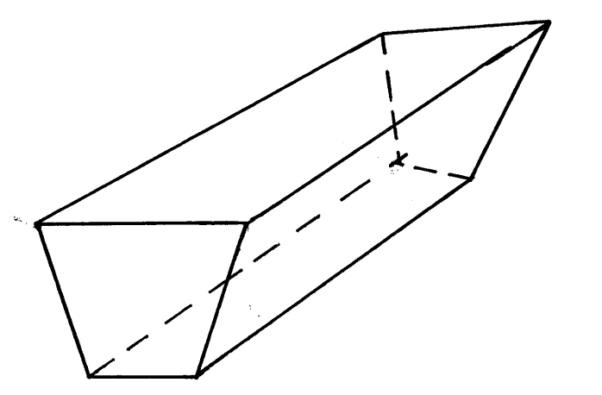

40 cm
4.5 m
25 cm

- Jemima’s team entered a contest where teams of students compete by answering questions that earn either 3 points of 5 points. Jemima’s team scored 44 points after answering 12 questions correctly. How many five-points questions did the team answer correctly. (3mks)

- Using compass and ruler only construct a triangle ABC such that AB= 6cm ,BC = 5cm and angle ABC = 67.5º measure the length of AC. (3mks)

10. Use table of reciprocals only to work out :$\frac{13}{0.156}− \frac{3}{0.6735}$ ( 3mks)

E
9cm
6cm
8cm
B
A
D
C

11. In the figure below, angle ABE is equal to angle ADC AE = 6cm, ED = 9cm and AB = 8cm,
calculate the length of BC. (3mks)
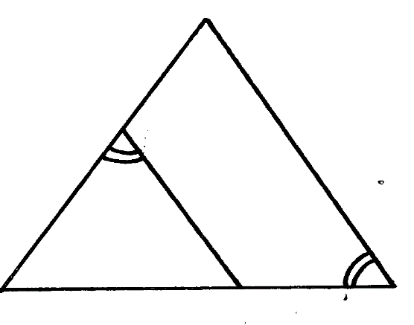

12. Simplify the expression below leaving your answer in rationalized surd form of a + b$\sqrt{c}$
$\frac{1+\tan{120^{o}}}{1+Cos 330^{o}}$ (4mks)

\

13. The two sides of a triangle are given 6 cm and 5 cm. the angle between them is 130º. calculate the area of the triangle ( giving your answer to 2 decimal places) (3mks)

14. Given that Km + hn = r and that m = $\left(\begin{aligned}−3 \\ −2\end{aligned}\right)$ n = $\left(\begin{aligned}0 \\ 4\end{aligned}\right)$ and r = $\left(\begin{aligned}−6 \\ 0\end{aligned}\right)$ . Find the scalars k and h (3mks)
~
~
~
~
~
~

15. A Kenyan bank buys and sells foreign currencies as shown.

Buying (Kshs.) Selling (Kshs.)
1 Euro 84.15 84.26
100 Japanese Yen 65.37 65.45

A Japanese travelling from France to Kenya had 5000 Euros. He converted all the 5000 Euros to Kenya shillings at the bank. While in Kenya, he spent a total of Kshs. 289,850 and then converted the remaining Kenya shilling to Japanese Yen. Calculate the amount in Japanese Yen that he received. (3mks)

16. The length of a rectangular mat is 1.5 m longer that its width, Find the length of the mat if its area is 6.5 m²( give your answer to 4 significant figures) (3mks)

SECTION II
Answer only five questions from this section
17. Five towns V,W,X,Y and Z are situated such that W is 200km east of V. X is 300km from W on a bearing of 150º. Y is 350km on a bearing of 240º from X. Z is 150º from V but 200º from X.
Draw the diagram representing the position of the towns. (use a scale of 1cm to represent 50km)
(5mks)

(b) From the diagram determine
(i) the distance in km of V from Z (1mk)
(ii) The bearing of Y from W ( 1mk)
(c) A plane heading to town X takes off from town Y and flies upwards at a constant angle which
is less than 90º. After flying a distance of 350km in the air it sees town X at an angle of depression of 50º. Calculate the distance of the plane from X at this point to the nearest km. (3mks)

18. Two circles of radii 3.5 and 4.2 cm with centres O₁ and O₂ respectively intersect at points A and B as shown in the figure below. The distance between the two centres is 6 cm.
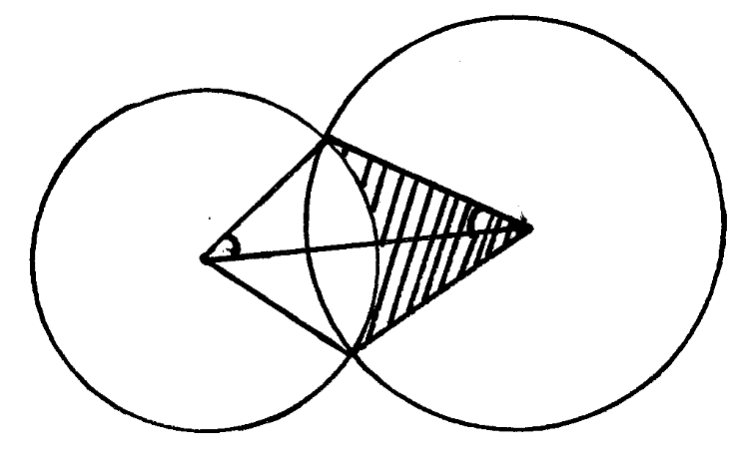
A
α
3.5 cm
4.2 cm
O₂
O₁

B
Calculate
- The size of AO₁B ( to the nearest degree) ( 3mks)

- The size of A O₂ B ( to the nearest degree) ( 3mks)

- The area of quadrilateral O₁AO₂B, correct to 2 decimal places. (2mks)

- The shaded area correct to 2 significant figures. ( take $π{22}/7$) ( 2mks)

19 (a) Complete the table below for the function y = 2 x ² + 4 X -3
X | -4 | -3 | -2 | -1 | 0 | 1 | 2
2x² | 32 |  | 8 | 2 | 0 | 2
4x-3 |  |  | -11 |  | -3
Y |  |  | -3 |  |  | 3 | 13
(b) Draw the graph of the function y = 2x² + 4x – 3 on the grid provided. (3mks)

(c) Use your graph to estimate the roots of the equation 2x² + 4x – 3 = 0 (1mk)

- Use your graph to obtain the roots of the equation 2x² + x – 5 = 0 to 1 decimal place. (3mks)

- Draw the line of symmetry to pass through the turning point of this curve. (1mk)

Age x years | 0≤ x < 5 | 5≤ x < 15 | 15≤ x < 25 | 25≤ x < 45 | 45≤ x < 75
Number of patients | 14 | 41 | 59 | 70 | 15

20. The table below shows patients who attend a clinic in one week and were grouped by age as shown in the table below.
- Estimate the mean age (4mks)

- On the grid provided draw a histogram to represent the distribution. (3mks)
Use the scales: 1cm to represent 5 units on the horizontal axis 2 cm to represent 5 units on the
vertical axis.

- (i) State the group in which the median mark lies ( 1mk)

(ii) A vertical line drawn through the median mark divides the total area of the histogram into
two equal. Using this information estimate the median mark. (2mks)

21. (a) Show by shading the unwanted region, the region which satisfies the following inequalities (8mks)
y> -3
4y ≤5x + 20
2y < - 5 x + 10
4y≤ - 3x – 12

(b) Calculate the area of this region in a square units (2mks)

22. The figure below (not drawn to scale) shows a quadrilateral ABCD inscribed in a circle. AB = 5cm, BC = 8cm,CD = 7cm and AD = 8cm. AC is one of the diagonals of length 10cm.
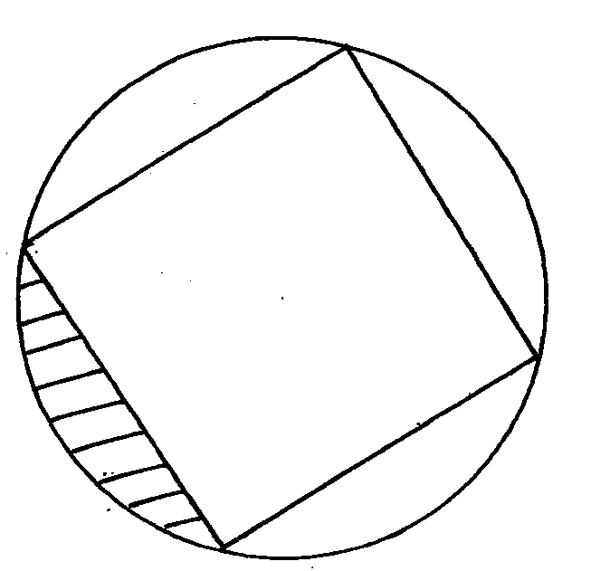
8cm
D
C

B
A
5cm
7cm
8cm

- Find the size of angle ABC. (3mks)

- Find the radius of the circle. (2mks)

- Hence, calculate the area of the shaded region. (5mks)

23. The diagram shows a frustum ABCDEF GH formed from a smaller pyramid ABCDO. The base the top of the frustums are squares of sides 12cm and 5 cm respectively. If Ob = 6cm and each of the slant edges of the frustum is 15 cm long. Calculate to 1 decimal place:
(a) the height OY of the small pyramid (3mks)
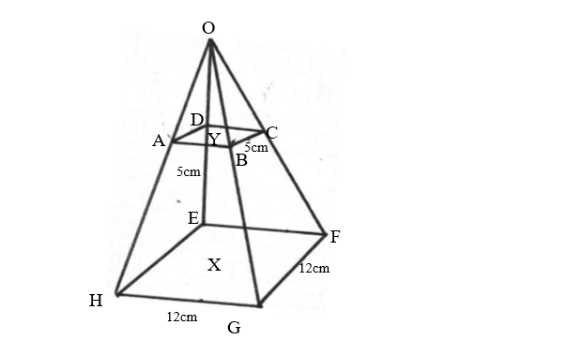

(b) the vertical height X Y of the frustum ( 4mks)

(c) the volume of the frustum (3mks)

24. The table below shows the income tax rates
Total income per month Rate in shillings per pound
In Kenya Pounds
1 - 325 2
326 - 650 3
651 - 975 4
976 - 1300 5
1301 and above 7

Mr. Musango earned a basic salary of shs. x and a house allowance of shs. 3000 per month. He claimed a tax relief for a married person of shs. 455 month. He paid shs. 1794 income tax per month.
- Calculate Mr. Musango’s basic salary in shs. per month (6mks)

- Apart from the income tax, the following monthly deductions are made. Service charge – shs. 100, health insurance fund – shs 280 and 2% of his basic salary as widow and children pension scheme.

Calculate:

- The total monthly deductions (2mks)

- Mr. Musango’s net income p.m (2mks)



ALLIANCE GIRLS 2025 PREDICTION
POSSIBLE KCSE EXAM
121/2
MATHEMATICS
PAPER 2
TIME: 2½ HOURS

NAME……………………………………………………………………………………….
SCHOOL……………………………………………… SIGN………………………..
INDEX NO……………………………………………. ADM NO……………………

Kenya Certificate of Secondary Education.
INSTRUCTIONS TO CANDIDATES.
1) Write your name and index number in the spaces provided above.
2) Sign and write the date of examination in the spaces provided above.
3) Answer ALL questions in section A and B.
4) All your workings must be clearly shown as must be awarded for correct working even if the answer is wrong.
5) Non programmable silent scientific calculators and KNEC mathematical tables may be used.
FOR EXAMINERS’S USE ONLY
Section 1
Question | 1 | 2 | 3 | 4 | 5 | 6 | 7 | 8 | 9 | 10 | 11 | 12 | 13 | 14 | 15 | 16 | Total
Marks
Section 1I GRAND TOTAL
Question | 17 | 18 | 19 | 20 | 21 | 22 | 13 | 24 | Total
Marks

SECTION I
- Use logarithms tables to evaluate
(4mks)

- T is a transformation represented by the matrix under T, a square of area 10cm² is mapped onto a square of area 110cm². Find the value of x (3mks)

- Given that find x where (3mks)

- Make A the subject of the formula
(3mks)

- A quantity P is partly constant and partly varies inversely as square of t. P = 6 when t = 6 and p = 18 when t = 3. Find t when p = 11 (3mks)

- i) Expand up to the term in x³. (2mks)

ii) Use your expansion to estimate the value of . Correct to one decimal place. (2mks)

- Solve for x in the equation. (3 Mks)
Log₈ (x + 6) – Log₈ (x – 3) = $\frac{2}{3}$

- Solve for x and y in the simultaneous equation below. (3 mks)
xy + 6 = 0
x – 2y = 7

- The size of each interior angle of a regular polygon is five times the size of the exterior angle. Find the number of sides of the polygon. (3mks)

- If , find the value of a, b and c (3 mks)

- The data below shows marks scored by 8 form four students in Molo district mathematics contest 44, 32, 67, 52, 28, 39, 46, 64.Calculate the mean absolute deviation. (3 Mks)

- Steve deposited ksh.50, 000 in a financial institution in which interest is compounded quarterly. If at the end of second year he received a total amount of ksh79, 692.40. Calculate the rate of interest p.a (3 Mks)

- The points with coordinates (5,5) and (-3,-1) are the ends of a diameter of a circle
Centre A
Determine:
(a) The coordinates of A (1mk)

(b) The equation of the circle, expressing it in form x² + y² + ax + by + c = 0 Where a, b, and c are constants (2mks)

- Pipe x can fill an empty tank in 3 hours while pipe y can fill the same tank in 6 hours. When the tank is full, it can be emptied by pipe z in 8 hours. pipe x and y are opened at the same time when the tank is empty. If one hour later pipe z is also opened, find the total time taken to fill the tank. (3marks)

- Fatima bought maize and beans from Kami. She mixed the maize and beans in the ratio
3: 2 she bought the maize at sh.90 per kg and the beans at sh.150 per kg. If she was to make
a profit of 30% what would be the selling price of 1kg of the mixture. (3mks)

- Given and find A^{‾1} B⁻¹ (3mks)

SECTION II
17. a) A figure whose co-ordinates are A(-2, -2), B(-4, -1), C(-4, -3) and D (-2, -3) undergoes
successive transformations ERS; where E, R and S are transformations represented by the matrices,
On the grid provided, show the figure ABCD and its image under the successive transformations ERS. (6mks)

Marks | 10-19 | 20-29 | 30-39 | 40-49 | 50-59 | 60-69 | 70-79 | 80-89 | 90-99
Frequency | 2 | 6 | 10 | 16 | 24 | 20 | 12 | 8 | 2

b) Find the matrix representing the single transformation mapping the image found in (a) above back the object figure ABCD. (2mks)

c)Triangle PQR has vertices at P(2, 2), Q(4, 1) and R(6, 4). On the same grid, show the image of triangle PQR under a shear with line y = 2 invariant and point R(6, 4) is mapped onto R¹(2, 4). (2mks)

18. The following are marks by form four students in a mathematics test.
Using an assumed mean of 54.5, calculate the
(a) Mean mark (4mks)

(b) Variance (4mks)

(c) Standard deviation (2mks)

19. The diagram below represents a Cuboid ABCDEFGH in which FG =4.5cm, GH =8cm HC=6m
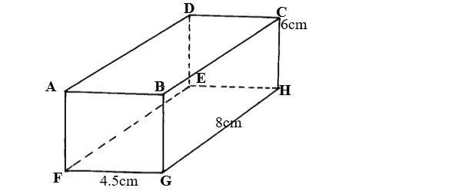
(a) Calculate the length FC (2mrks)

(b) (i) The size of the angle between the lines FC and FH (2mks)

(ii) Size of the angle between the line AB and FH. (2mks)

(c) The size of the angle between the planes ABHE and the plane FGHE.(2mks)

(d) The total surface area of the cuboid (closed) (2mks)

20. Complete the table below, giving all your values correct to 2 d. p. for the functions y = cos x and y = 2cos (x + 30)⁰
x⁰ | 0⁰ | 60⁰ | 120⁰ | 180⁰ | 240⁰ | 300⁰ | 360⁰ | 420⁰ | 480⁰ | 540⁰
Cos x | 1.00 |  |  | -1.00 |  | 0.50
2cos(x + 30) | 1.73 |  | -1.73 |  | 0.00

(b) For the function y = 2cos (x + 30)⁰
State:
(i)The period (1mk)

(ii)Phase angle (1mk)

(c) On the same axes draw the waves of the functionsy = cos x and y = 2cos (x + 30)⁰ for 0⁰ ≤ x ≤ 540.Use the scale 1cm rep 30⁰ horizontally and 2cm rep 1 unit vertically. (4mks)

(d)Use your graph above to solve the inequality 2cos (x + 30º) ≤ cos x (2mks)

21. A teacher had 5 red, 6 black and 9 blue pens in a box. The pens were all identical except for the colour.
(a) If one pen is picked from the box, what is the probability that it is
(i) Red. (1mk)

(ii) Not black. (1mk)

- The teacher asked a student to pick two pens from the box, one at a time, without replacement. Find the probability that
(i) Both pens are of the same colour. (3mks)

(ii) They are of different colours. (2mks)

- If the first student was allowed to take away two blue pens and another student was asked to pick two pens without replacement. What is the probability that the second student picked pens of same colour? (3mks)

22. In the figure below, PQR is the tangent to the circle at Q. TS is a diameter and TSR and QUV are straight lines. QS is parallel to TV. Angle SQR = 35° and TQV = 60°.
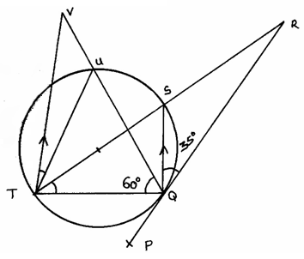
- Find the following angles, giving reasons for each answer.
(i) QTS. (2mks)

(ii) QRS. (2mks)

(iii) QVT. (2mks)

(iv) UTV. (2mks)

(v) QUT. (2mks)

23. Use ruler and a pair of compasses only in this question
a) Construct triangle ABC such that AB = 6cm, AC=BC and angle ACB = 135$°$ 4mks

b) On one side only construct the locus of P such that:
i) < APB = 67.5° 1mk
ii) area of triangle , APB = 9cm² 3mks
c) i) Locate P1 and P2 the two possible positions of P which satisfy the two conditions above 1mk
ii) Measure the distance between P1 and P2. 1mk

24. An arithmetic progression has the first term a and the common difference d.
(a) Write down the third, ninth and twenty – fifth terms of the progression. (3 Mks)

(b) The progression is increasing and the third, ninth and twenty-fifth terms form the first three
Consecutive terms of a geometric progression. If the sum of the seventh term and twice the sixth term of the arithmetic progression is 78.
Calculate
(i) The first term and the common difference (5 Mks)

(ii) The sum of the first nine terms of the arithmetic progression (2 Mks)



ALLIANCE GIRLS 2025 PREDICTION
POSSIBLE KCSE EXAM
451/1
COMPUTER STUDIES
PAPER 1
TIME: 2½ HOURS

NAME……………………………………………………………………………………….
SCHOOL……………………………………………… SIGN………………………..
INDEX NO……………………………………………. ADM NO……………………

Kenya Certificate of Secondary Education.
INSTRUCTIONS TO CANDIDATES
- Write your Name, Class, Admission Number and Index Number in the spaces provided.
- Answer ALL the questions in section A
- Answer question 16 (Compulsory) and any other three questions from section B.
Question | Maximum score | Actual score
1-16
17
18
19
20
TOTAL SCORE
For Official Use Only

SECTION A: (40 MARKS)
Answer ALL Questions in This Section
1. During a visit to the typing room, Jane a computer student observed a type of printer that uses a beam to create an image on a rotating drum. As the beam hits the drum, some regions attract ink toner particles. The toner is then fused onto a piece of paper.
- State the name of this type of printer and indicate whether it is an impact or non-impact printer. (1mark)
___________________________________________________________________
___________________________________________________________________
- List two advantages of using the printer mentioned in a. above. (2marks)
___________________________________________________________________
___________________________________________________________________
___________________________________________________________________

2. Bunam Water Company sends out field officers to take consumer meter readings. The data collected by the officers is then keyed into the computer. The system then generates utility bills which are printed and sent to the consumers.
i. State two transcription errors that are likely to occur during meter reading or input. (1 mark)
__________________________________________________________________
_________________________________________________________________
ii. State two ways such errors can be avoided. (1 mark)
__________________________________________________________________
___________________________________________________________________

3. Highlight the dangers associated with the following in a computer laboratory set up:
- Purchasing software before assessing requirements. (1 mark)
___________________________________________________________________
___________________________________________________________________
- Using foreign flash disks on the computer. (1 mark)
___________________________________________________________________
___________________________________________________________________

4. To process an instruction, the CPU goes through a cycle of three stages. Name each of the stages. (3 marks)
___________________________________________________________________
___________________________________________________________________
___________________________________________________________________
___________________________________________________________________
5. Explain the importance of the following spreadsheet operations. (2 marks)
(i) Freezing columns
___________________________________________________________________
___________________________________________________________________
(ii) Data validation
__________________________________________________________________
__________________________________________________________________

(b) Name two types of relationships that can be applied in database design. (1 mark)
__________________________________________________________________
___________________________________________________________________
__________________________________________________________________
6. Briefly explain any Four block operations that can be performed on data in word processing (4 marks)
__________________________________________________________________
___________________________________________________________________
__________________________________________________________________
__________________________________________________________________

7. (a) Mutiso wanted to upgrade the RAM of his computer. State two factors Mutiso should consider when purchasing a RAM module. (1 mark)
____________________________________________________________________
____________________________________________________________________

(b) Define the following terms: (2 marks)
(i) Computer Port
______________________________________________________________
______________________________________________________________
(ii) Power supply unit
_____________________________________________________________
_____________________________________________________________

8. Mkulima Bora is a society that embraced E-Commerce recently. The manager is convinced that
there is illegal access to the company’s system. State TWO ways in which the society can
overcome this problem. (2 marks)
___________________________________________________________________________
______________________________________________________________________________________________________________________________________________________
___________________________________________________________________________

9. (a) Study the diagram below and answer the questions that follow.

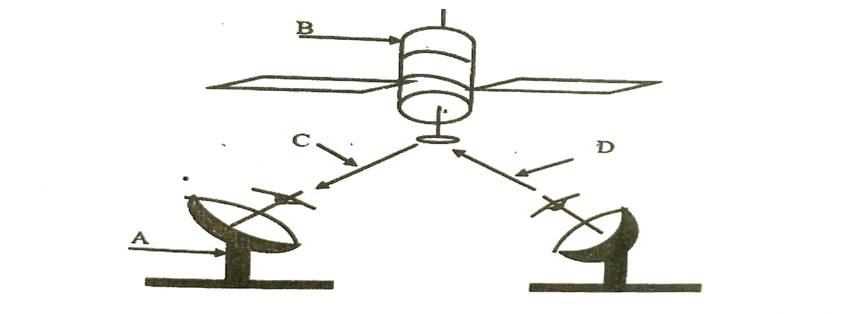
(i) Name the communication media depicted in the above diagram (1 mark)
________________________________________________________________________

(ii) Name the parts labelled A, B, C, and D (3 marks)
A_____________________________________________________________________
B _____________________________________________________________________
C ______________________________________________________________________
D ______________________________________________________________________

10. In a desktop publishing document, an image embedded can be transformed in various ways.
Name any three ways one can use to make the image fit in a designated area. (3 marks)
__________________________________________________________________________
______________________________________________________________________________________________________________________________________________________
___________________________________________________________________________
11. Differentiate between source program and object program. (2 marks)
__________________________________________________________________________
_____________________________________________________________________________________________________________________________________________________

12. Differentiate between the following terms in Internet (4 marks)
(i) Drafts and outbox
____________________________________________________________________
____________________________________________________________________
(ii) cc and bcc
___________________________________________________________________
___________________________________________________________________
13. State two characteristics of a computer that is infected by computer viruses. (2 marks)
_____________________________________________________________________
_____________________________________________________________________
_____________________________________________________________________
_____________________________________________________________________
14. Identify each of the following symbols as used in system flowchart. (1 mark)
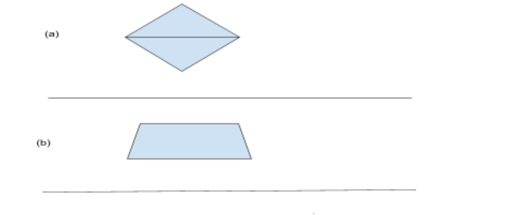
15. Differentiate between bullets and numbering as used in DTP (2 marks)
_____________________________________________________________________
_____________________________________________________________________
_____________________________________________________________________
_____________________________________________________________________

SECTION B (60 marks)
Answer question 16 and any other three questions from this section in the spaces provided.

16. a) State any three activities that occur in a program compilation process. (3 marks)
_____________________________________________________________________
_____________________________________________________________________
_____________________________________________________________________
_____________________________________________________________________
b) A program is needed for calculating the average age of students in a class. Write a pseudocode that will read the age of the students and calculate the average age. The program should terminate if the value of 999 is entered for age and output the number of times the statements within the loop were executed. (10 marks)
_____________________________________________________________________
_____________________________________________________________________ _____________________________________________________________________
_____________________________________________________________________
_____________________________________________________________________
_____________________________________________________________________ _____________________________________________________________________
_____________________________________________________________________
_____________________________________________________________________
_____________________________________________________________________ _____________________________________________________________________
_____________________________________________________________________
_____________________________________________________________________
_____________________________________________________________________ _____________________________________________________________________
_____________________________________________________________________
_____________________________________________________________________
_____________________________________________________________________ _____________________________________________________________________
_____________________________________________________________________

c) Give two types of errors that may be detected during program testing. (2 marks)
_____________________________________________________________________
_____________________________________________________________________ _____________________________________________________________________
_____________________________________________________________________

17. a) State four functions which are specific to Network Operating Systems. (4 marks)
b)State two advantage of using fibre optic cables over satellite in data communication.(2 marks)
c) (i) The figure below shows how data is transmitted through a public telephone . (4 marks)

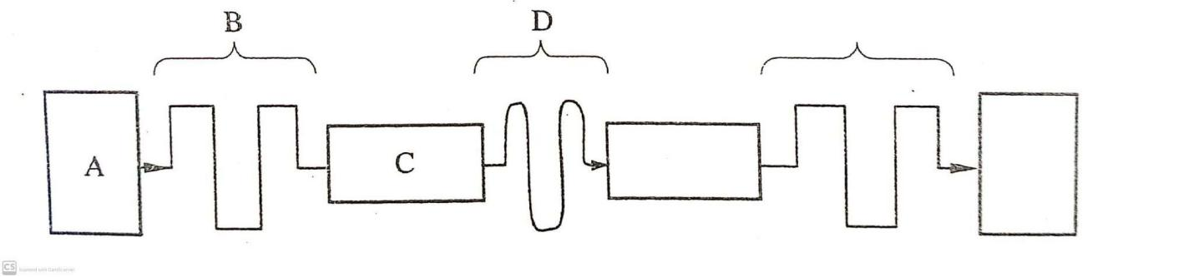
Name A, B, C, and D
d) (i) List any two items that may be referred to as data terminal equipments in a network (2 mks)
(ii) Write the acronym MODEM in full (1 mark)
(iii) Explain the purpose of a modem when connecting to the internet. (2 marks)
18. (a) State three roles of a programmer in system development life cycle. (3 marks)
(b) State four activities that may be carried out when disposing off an old system in an
organization (4 marks)
(c) Distinguish parallel changes over from straight change over as used in system implementation. (2 marks)
(d) Discuss any two fact finding methods. (4 marks)
(e) Differentiate between an open system and a closed system. (2 marks)

19. a) State three standard coding scheme used computing and electronic systems. (3 marks)
b) Convert each of the following numbers
i) 1001.001₂ to octal. (2 marks)
ii) 125.5₁₀ to hexadecimal. (3 marks)
iii) Add 1100.011₂ to 11001.0101₂ and leave your answer in decimal (3 marks)
c) Using two compliment perform the following arithmetic leaving your answer in binary form. (4 marks)
13₁₀ - 15₁₀
20. (a) Distinguish between axis labels and data labels as used in spreadsheets. (2 marks)
(b) Name an electronic spreadsheet feature that allows one to perform the following actions. (4 marks)
Action | Feature
Provide pictorial summary of data
Make one cell out of many
List items from Highest to lowest or vice versa
Make many cells out of one
(c) Explain the difference between the printing of multiple pages and multiple copies as used in word processing. (2 marks)
(d) Describe the following categories of software (4 marks)
i) Firmware
ii) Proprietary software
(e) Explain the meaning of solid state storage media giving two examples of it.
(3 marks)


ALLIANCE GIRLS 2025 PREDICTION
POSSIBLE KCSE EXAM
451/2
COMPUTER STUDIES
PAPER 2
TIME: 2½ HOURS

NAME……………………………………………………………………………………….
SCHOOL……………………………………………… SIGN………………………..
INDEX NO……………………………………………. ADM NO……………………

Kenya Certificate of Secondary Education.

Instructions to candidates
- Write your name and Index number at the right hand corner of each print out.
- Write your name and Index number on the CD provided.
- Write the name and version of the software used for each question attempted in the answer sheet
- Answer all the questions
- Passwords should not be used while saving in the CD provided.
- All answers must be saved in your CD provided.
- Arrange your printouts and staple them together
- Hand in all the printouts and the CD used

QUESTION 1
- Use DTP software to design the following business card using the following layout specifications:
  - Paper size A4 portrait. (2 marks)
  - Set the margins to 0.5 inches all round. (2 marks)
  - Divide the page into TWO columns (2 marks)
  - The border should occupy the first column (2 marks)
- Prepare the publication as exactly as it appears and save it as Business card. (10 marks)

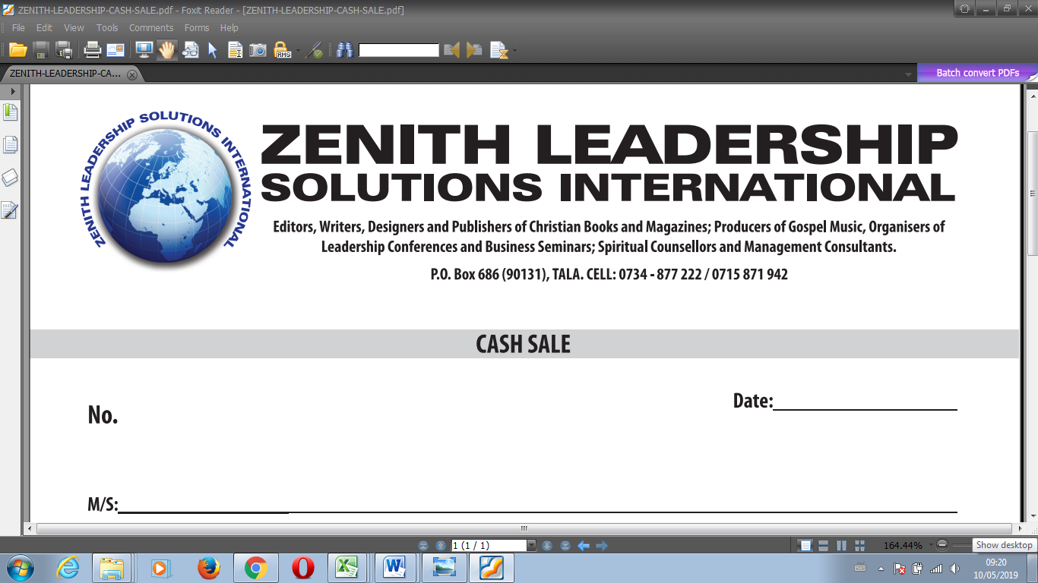
Service Beyond The Ordinary
- Insert your full name above the heading “ZENITH LEADERSHIP…” and centre it across(5 marks)
- Create the logo to occupy between 0.8” to 1.80” left and 0.70” to 1.85” from top. (5 marks)
- The title should occupy between 1.70” to 7.50” across and 0.75” to 1.45” from top. Font Arial black with italics and fill effect pattern of dark horizontal. (5 marks)
- The words “ZENITH LEADERSHIP” should occupy 2.50” to 5.70” across and 1.50” to 2.00” from top. Font Book antique size 26, bold and centered. (4 marks)
- The rest of the text is in font Bodoni MT size 12. (2 marks)
  - Align all the text as shown. (2 marks)
  - Group the publication as one. (2 marks)
  - Fit FOUR copies of the design into a single page. (2 marks)
- Include a page header with your index number. (2 marks)
- Save as Updated Business card. (1 mark)
- Print the publication Business card and Updated Business Card. (2 marks)

Question 2
The table below shows records extracted from Motors Sales Company Database. Create a database and name it MOTOR SALES. (1 mark)
Customer  Name | Customer  Address | Customer  Town | Car  Reg No | Car  Type | Car  Make | Car  price | Customer  ID | Amount  paid
Ogutu | 254 | Nakuru | KBJ 001T | Truck | Nissan | 1,100,000 | B001 | 800,000
John | 678 | Eldoret | KCM 002M | Bus | Mazda | 2,400,000 | B002 | 2,000,000
Uhuru | 963 | Nairobi | KBB 003V | Saloon | Toyota | 800,000 | B003 | 800,000
Ogutu | 147 | Nakuru | KCJ 004B | Pick up | Peugeot | 1,000,000 | B004 | 700,000
Chumba | 456 | Bungoma | KCH 678B | Lorry | Isuzu | 3,000,000 | B005 | 2,000,000
Kariuki | 789 | Webuye | KBB 006N | Pick up | Toyota | 1,800,000 | B006 | 1,600,000
John | 678 | Eldoret | KBJ 007D | Bus | Scania | 7,500,000 | B002 | 7,500,000
Uhuru | 963 | Nairobi | KCC 678G | Truck | Toyota | 1,800,000 | B003 | 1,800,000
Phillip | 159 | Kisumu | KCJ 009H | Saloon | Nissan | 9,00,000 | B007 | 900,000
Ogutu | 254 | Nakuru | KCH 010L | Pick up | Isuzu | 1,500,000 | B001 | 1,200,000
Uhuru | 357 | Kisumu | KCJ 011J | Saloon | Peugeot | 600,000 | B008 | 600,000
Kariuki | 789 | Webuye | KBG 012B | Bus | Isuzu | 10,000,000 | B006 | 9,500,000
Ogutu | 147 | Nakuru | KDA 013A | Truck | Nissan | 2,700,000 | B004 | 2,700,000

- Using the data above, create a table that will hold Car details and another table to hold Customer details. Name them TABLECAR and TABLECUSTOMER respectively and set appropriate primary keys.
(4 marks)
- Enforce referential integrity between two tables. (2 marks)
- Create different input forms for each table. Name them FORMCAR and FORMCUSTOMER. Use them to enter data into the tables. (12marks)
- Display a report only showing the details of the Customers who have cleared paying for the Car. Name the report REPORTCLEARED. Add “CLEARED CUSTOMERS’’ as the title of the report. (7 marks)
- Using the two tables create an outlined report showing the customer details, the total amount paid by each customer and the total amount received by the company. Name the report SUMMARY and the title as “OVERALL CUSTOMERS REPORT.’’ (8 marks)
- Create a query to display the Car details with balances of less than 300,000. Name the query as BALQUERY. (4marks)
- Create a report showing the Car type, the total sales for each car type and the grand total. Name the report as REPORTGRAND. (6 marks)
- Using landscape orientation, print REPORTCLEARED, SUMMARY and REPORTGRAND with footers bearing your lastname and index number at the center of the page. (6 marks)



ALLIANCE GIRLS 2025 PREDICTION
POSSIBLE KCSE EXAM
441/1
HOME SCIENCE
PAPER 1
TIME: 2½ HOURS

NAME……………………………………………………………………………………….
SCHOOL……………………………………………… SIGN………………………..
INDEX NO……………………………………………. ADM NO……………………

Kenya Certificate of Secondary Education.

INSTRUCTIONS TO CANDIDATES
- This paper contains 3 sections: A, B and C
- Answer ALL questions in section A and B and ANY TWO section C
- Write your name and admission number in the spaces provided above.
- Sign and write your name in the spaces provided above.
- Answer ALL QUESTIONS
- All answers should be written in the spaces provided on the question paper.
For official Use Only
SECTIONS | QUESTION | MAX. SCORE | ACTUAL SCORE
A | 1 – 40 | 40 MARKS
B | 41 | 20 MARKS
C | 42,43,44 | 40 MARKS
TOTAL

SECTION A (40 MARKS)
Answer all questions in the spaces provided

1. What is a dessert? Give one example (1mk)
……………………………………………………………………………………………………………………………………………………………………………………………………………………
2. Identify two types of vacuum cleaners. (1mk)
……………………………………………………………………………………………………………………………………………………………………………………………………………………
3. Mention two types of electronic money transfer used to pay for goods and services. (1mk)
……………………………………………………………………………………………………………………………………………………………………………………………………………………

4. State two symptoms of a person suffering from scurvy (2mks)
………………………………………………………………………………………………………………………………………………………………………………………………………………………………………………………………………………………………………………………………

5. List four types of fabrics that are drip dried during laundry. (2mks)
…………………………………………………………………………………………………………………………………………………………………………………………………………………………………………………………………………………………………………………………………………………………………………………………………………………………………………

6. Suggest two points to bear in mind when attaching buttons. (2mks)
………………………………………………………………………………………………………………………………………………………………………………………………………………………………………………………………………………………………………………………………

7. State two advantages of owning a home. (2mks)
………………………………………………………………………………………………………………………………………………………………………………………………………………………………………………………………………………………………………………………………

8. Mention two importance of melanin in the body. (2mks)
…………………………………………………………………………………………………………………………………………………………………………………………………………………………………………………………………………………………………………………………………………………………………………………………………………………………………………

9. Give two reasons why lampshades are popular. (2mks)
………………………………………………………………………………………………………………………………………………………………………………………………………………………………………………………………………………………………………………………………

10. What is the meaning of haberdashery (1mk)
……………………………………………………………………………………………………………………………………………………………………………………………………………………

11. Outline four ways of preventing cholera outbreak (2mks)
…………………………………………………………………………………………………………………………………………………………………………………………………………………………………………………………………………………………………………………………………………………………………………………………………………………………………………

12. Identify two practices necessary for successful steaming in cookery (2mks)
………………………………………………………………………………………………………………………………………………………………………………………………………………………………………………………………………………………………………………………………
13. What is the role of a ‘U/S’ bend in concealed drainage system (1mk)
………………………………………………………………………………………………………………………………………………………………………………………………………………………………………………………………………………………………………………………………

14. Highlight two dangers of excess weight gain during pregnancy (2mks)
………………………………………………………………………………………………………………………………………………………………………………………………………………………………………………………………………………………………………………………………

15. Identify four fabrics that should not be wrung. (2mks
……………………………………………………………………………………………………………………………………………………………………………………………………………………………………………………………………………………………………………………………………………………………………………………………………………………………………………………………………………………………………………………………………………………

16. List four fastenings suitable for a toddlers garment. (2mks
…………………………………………………………………………………………………………………………………………………………………………………………………………………………………………………………………………………………………………………………………………………………………………………………………………………………………………

17. Highlight two benefits of studying home science to the community. (2mks)
……………………………………………………………………………………………………………………………………………………………………………………………………………………………………………………………………………………………………………………………………………………………………………………………………………………………………………………………………………………………………………………………………………………

18. State two reasons for blanching vegetables. (2mks)
………………………………………………………………………………………………………………………………………………………………………………………………………………………………………………………………………………………………………………………………

19. Give two example of builders added to detergents during manufacture. (1mk)
………………………………………………………………………………………………………………………………………………………………………………………………………………………………………………………………………………………………………………………………

20. State four advantages of regular cleaning of household items. (2mks)
……………………………………………………………………………………………………………………………………………………………………………………………………………………………………………………………………………………………………………………………………………………………………………………………………………………………………………………………………………………………………………………………………………………

21. Distinguish between raglan and kimono sleeve. (1mk)
………………………………………………………………………………………………………………………………………………………………………………………………………………………………………………………………………………………………………………………………

22. State two characteristics of incomplete or second class proteins. (1mk)
………………………………………………………………………………………………………………………………………………………………………………………………………………………………………………………………………………………………………………………………

23. Identify two immunizable diseases caused by viruses. (1mk)
………………………………………………………………………………………………………………………………………………………………………………………………………………………………………………………………………………………………………………………………

24. Identify two situations when a lactating mother produces little or no milk at all. (1mk)
………………………………………………………………………………………………………………………………………………………………………………………………………………………………………………………………………………………………………………………………

25. Name two areas in the house where light fixtures can be found. (1mk)
………………………………………………………………………………………………………………………………………………………………………………………………………………………………………………………………………………………………………………………………
26. Define the following in relation to weaning. (1mk)
(a) Basic mix
……………………………………………………………………………………………………………………………………………………………………………………………………………………………………………………………………………………………………………………………...
(b) Multi mix
………………………………………………………………………………………………………………………………………………………………………………………………………………………………………………………………………………………………………………………………

SECTION B
COMPUSORY
27. Your sister has invited you to a stay with her over the holiday and she has an eight months old baby.
Write down the procedure of carrying out the following activities at her home.
- Prepare a cot for her baby (10mks)
- Clean her baby’s plastic feeding bottle. (5mks)
- Thoroughly clean her calabash that she uses to serve porridge. (5mks)

SECTION C (40 MARKS)
Answer any two questions from this section in the spaces provided
- a) Explain 6 dangers of land pollution to mankind (6 marks)
b) The diagram below shows a longitudinal section of a wheat grain
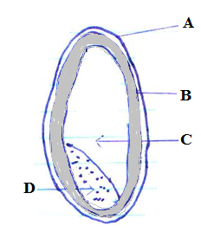

- Label parts A,B,C,D (4 marks)
- Name two nutrients found in part A and two found in part D (4 marks)
c) Outline 6 advantages of proper ventilation in a house (6 marks)

- (a) Name 4 agencies that protect consumers and their functions ( 4marks )
(b) Outline 4 preparations that one needs to carry out on a sewing machine in readiness for stitching
(4marks)
(c) Explain 3 nutritional needs of the elderly (6marks)
(d) Describe 3 factors to consider when choosing a seam in garment construction (6marks)

- (a) Explain three factors you would consider when choosing flowers for a flower arrangement
(6marks)
(b) Outline four practices to safeguard against occurrence of food spoilage and poisoning in the home
(4marks)
(c) Describe 4 qualities of well made gathers (4marks)
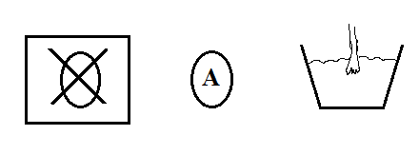
(d) (i) Interpret the following care label symbols (3marks)

(ii) Explain three things to show the importance of advertisements to consumers (3marks)



ALLIANCE GIRLS 2025 PREDICTION
POSSIBLE KCSE EXAM
441/2
HOME SCIENCE
(Clothing Construction)
PAPER 2
TIME: 2½ HOURS

SCHOOL……………………………………………… SIGN………………………..

Kenya Certificate of Secondary Education.

CONFIDENTIAL
- Plain light weight cotton fabric 50 cm by 90 cm wide.
- Sewing thread to match the colour of the fabric.
- One large A4 envelope



ALLIANCE GIRLS 2025 PREDICTION
POSSIBLE KCSE EXAM
441/2
HOME SCIENCE
PAPER 2
TIME: 2½ HOURS

NAME……………………………………………………………………………………….
SCHOOL……………………………………………… SIGN………………………..
INDEX NO……………………………………………. ADM NO……………………

Kenya Certificate of Secondary Education.
441/2
HOME SCIENCE
CLOTHING CONSTRUCTION
Paper 2
Time: 2 ½ hours

A pattern of a girl’s blouse is provided. You are advised to study the sketch, the question and the layout before the test.
MATERIALS PROVIDED
1. Pattern pieces
A - BLOUSE FRONT
B - BLOUSE BACK
C - FRONT YOKE
D - FRONT FRILL
E - BACK FRILL
F - BACK NECK FACING

2. Plain light weight cotton fabric 50 cm by 90 cm wide.
3. Sewing thread to match the colour of the fabric.
4. One large envelope.
THE TEST
Using the materials provided, cut out and make up the RIGHT HALF of the child’s blouse to show the following.
1. Cutting out. (13 marks)
2. The making of the double pointed dart. (5 ½ marks)
3. Making of the shoulder seam using double stitched seam. (7 ½ marks)
4. Joining the back facing to front facing and neatening the free edge. (8 marks)
5. Neatening the neckline using the joined facings. (4 marks)
6. Joining the front yoke to the blouse front using overlaid seam. (11 marks)
7. Working the side seam using an open seam. (6 marks)
8. Preparation of the frill to include:
(a) Joining the back and front frill using a French seam. (7 marks)
(b) Control of fullness. (3 marks)
(c) Attachment of the frill to the lower part of the blouse using a plain seam.
(Do not trim; Do not neaten) (7 marks)
9. Working of buttonhole using hand-worked stitches. (6 marks)
10. Management of the hem and holding it using long and short tacking. (6 marks)
11. Presentation. (6 marks)

NOTE:

At the end of the examination, firmly sew on a single fabric a label bearing your name and index number, Remove the needles and pins from your work then fold your work neatly and place it in the envelope provided. Do not put scraps of fabric with your work.

LAYOUT – NOT DRAWN TO SCALE
90 cm

S e l v e d g e

CB
E

50 cm
A

B
CF
D

F

CF
C

VIEW
FRONT VIEW BACK VIEW



ALLIANCE GIRLS 2025 PREDICTION
POSSIBLE KCSE EXAM
441/3
HOME SCIENCE
PAPER 3
TIME: 1¾ HOURS

NAME……………………………………………………………………………………….
SCHOOL……………………………………………… SIGN………………………..
INDEX NO……………………………………………. ADM NO……………………

Kenya Certificate of Secondary Education.
PAPER 3
FOODS AND NUTRITION
(PRACTICAL)
INSTRUCTION TO THE CANDIDATES
PLANNING SESSION: 30 MIN
PRACTICAL TEST SESSION: 1 ¼ HOURS
- Text books and recipe may be used during the planning session as reference materials.
- You will be expected to keep to your order of work during the practical session.
- You are only allowed to take away your reference materials at the end of the planning session.
- You are not allowed to bring additional notes to the practical session.
- Previously written plans are not allowed into the examination room.
- Candidates should answer the question in English.

TEST
Using the ingredients listed below, prepare, cook and present a two course meal for you and your elder sister who is coming home from college over the weekend.
INGREDIENTS
- Fat/ oil
- minced meat/beef/chicken
- Salt
- Onion
- pineapple
- Wheat flour/ Irish potatoes/Rice
- Tomatoes
- Coriander
- lemon
- Spice of your choice
- Milk
- melon
- Capsicum
- Sugar
- Ripe bananas
- cabbage
PLANNING SESSION – 30 MINUTES
Use separate sheets of paper for each task below and carbon paper to produce duplicate copies. Then proceed as follows
- Identify the dishes and write down their recipes.
- Write down your order of work.
- Make a list of the food stuffs and equipment you will require.



ALLIANCE GIRLS 2025 PREDICTION
POSSIBLE KCSE EXAM
314/1
ISLAMIC RELIGIOUS EDUCATION
PAPER 1
TIME: 2½ HOURS

NAME……………………………………………………………………………………….
SCHOOL……………………………………………… SIGN………………………..
INDEX NO……………………………………………. ADM NO……………………

Kenya Certificate of Secondary Education.
314/1
ISLAMIC RELIGIOUS EDUCATION
Paper 1 2 ½ hours
Instructions to candidates
a) Write your name and index number in the spaces provided above. b) Sign and write the date of examination in the spaces provided above c) This paper consists of SIX questions d) Answer any FIVE questions in the spaces provided at the end of question six e) Candidates should check the question paper to ascertain that all the questions are available f) Candidates should answer the questions in English
For Examiner’s Use Only
Question | 1 | 2 | 3 |  | 4 | 5 | 6 | Total score
Candidate’s score

QUESTIONS
- (a) State the teachings a Muslim can learn from surah Nasir (Q:110) (5 mks)
(b) Explain the circumstances that led to the revelation of Surah An Nur (Q.24). (5 mks)
(c) Give reasons why the nature of the Quran changed from short to long verses when it was
revealed in Madina (10 mks)

- (a) State the teachings of Ayatul Qursi on the attributes of Allah. (5 mks)
(b) Explain five problems in translating the Quran into other languages. (5 mks)
(c) Describe the language of Quran. (10 mk

- (a) Name the main shia collections of Hadith. (4 mks)
(b) Explain the methods used by Imam Bukhari in collecting and compiling Hadith. (6 mks)
(c) Discuss the effect of anger. (10 mks)

- (a) Outline four differences between Sharia and fiqh. (4 mks)
(b) Discuss the contribution made by Imam Abu Hanifah to Islam. (8 mks)
(c) Describe the benefit of Tawba. (8 mks)

- (a) Describe the undesirable act s in prayers. (5 mks)
(b) State the difference between Zakatul Mal and Zakatul fitr. (5 mks)
(c) Discuss how Hajj helps a Muslim to advance spiritually. (10 mks

- (a) Outline the qualities of an Imam according to the shia belief. (5 mks)
(b) Discuss the significance of believing in Qadar (predestination). (7 mks)
(c) State the characteristics of the revealed scriptures. (8 mks)



ALLIANCE GIRLS 2025 PREDICTION
POSSIBLE KCSE EXAM
314/2
ISLAMIC RELIGIOUS EDUCATION
PAPER 2
TIME: 2½ HOURS

NAME……………………………………………………………………………………….
SCHOOL……………………………………………… SIGN………………………..
INDEX NO……………………………………………. ADM NO……………………

Kenya Certificate of Secondary Education.
314/2
ISLAMIC RELIGIOUS EDUCATION
Paper 1 2 ½ hours
Instructions to candidates
a) Write your name and index number in the spaces provided above. b) Sign and write the date of examination in the spaces provided above c) This paper consists of SIX questions d) Answer any FIVE questions in the spaces provided at the end of question six e) Candidates should check the question paper to ascertain that all the questions are available f) Candidates should answer the questions in English
For Examiner’s Use Only
Question | 1 | 2 | 3 |  | 4 | 5 | 6 | Total score
Candidate’s score

1. (a) Identify any five activities that would lead to Muunkarat. (5 mks)
(b) Explain the basic beliefs on which Islamic morality is based. (8 mks)
(c) State seven main objectives of practicing Husunul khulug. (7 mks)

2. (a) State five types of sexual perversion according to Islam. (5 mks)
(b) Identify the identities a muslim should retain in a changing society. (5 mks)
(c) Discuss the measures put forward by Islam to curb the spread of HIV/AIDs. (10 mks)

3. (a) Discuss reasons why the family is considered the bedrock of Islamic society. (8 mks)
(b) Outline six duties of a husband in a Muslim family. (6 mks)
(c) Highlight the position of a woman in Islam. (6 mks)

4. (a) Give eight factors that may invalidate an Islamic contract. (8 mks)
(b) Discuss ways of eliminating corruption in the society. (12 mks)

5. (a) State the significance of the two covenants of Al-Agaba entered between the prophet (P.B.U.H) and Madinans. (5 mks)
(b) Explain any five events that led to the formation of the khawarij movement. (10 mks)
(c) Describe the factors that influenced the spread of Islam in North Eastern Kenya. (5 mks)

6. (a) Discuss the contribution of Sheikh Abdallah Al-Farsy to education in East Africa. (10 mks)
(b) Discuss the views of Ibn Khaldun on eduction. (10 mks)

THE END

FOR THE FOLLOWING;
- ONLINE TUITION
- REVISION NOTES
- SCHEMES OF WORK
- SETBOOKS VIDEOS
- TERMLY EXAMS
- QUICK REVISION KITS
- KCSE TOPICALS
- KCSE PREMOCKS
- TOP SCHOOLS PREMOCKS
- JOINT PREMOCKS
- KCSE MOCKS
- TOP SCHOOLS MOCKS
- JOINT MOCKS
- KCSE POSTMOCKS
- TOP SCHOOLS PREDICTIONS
- KCSE PREDICTIONS
- KCSE REVEALED SETS

CALL/TEXT/WHATSAPP

0746-222-000
0742-999-000

mwalimuconsultancy@gmail.com

This is a Copyright Property of Mwalimu Consultancy Ltd.

Powered By Mr Isaboke

